Overview 4

Types of Computer System 6

Processor and Memory 9

Input Devices 15

Output Devices 18

Backing Storage 21

Low Level Systems 31

Buses 38

Data Representation 43

Security Precautions 72

Environmental Impact 76

Throughout this booklet you will come across several symbols to tell you how to use it the symbols are as follows

|  |  |
| --- | --- |
|  | This symbol means you will make or draw something |
|  | This symbol means you will complete a multiple choice quiz |
|  | This symbol means you will have to answer some questions |
|  | This symbol means that you will read for information |
|  | This symbol means you have an activity to perform |
|  | This symbol means that you have a task to complete on the computer |

Computer Structure

Learning Intentions

* To be able to identify the different sections of a computer system.
* To be able to explain the purpose of each section.
* To be able to compare different devices in regards to their suitability for a task.
* To understand how the different sections of a computer system connect with each other.

Computer Systems

Computers come in all shapes and sizes, ranging from credit card sized mobile phones to building sized supercomputers. A computer system is made up of two parts working together – hardware and software.

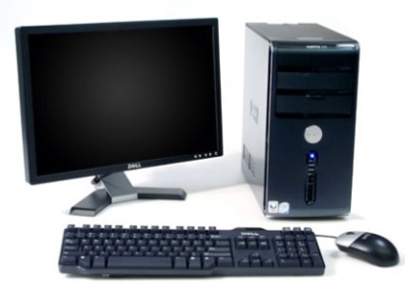

Software is the programs that run on the computer like Windows or Excel

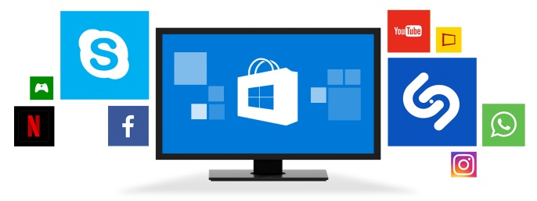

Hardware is the physical components that make up the system like keyboards and hard disks

All computers regardless of their size share a common design made up of 4 main categories of hardware.

1. **Processor and memory**

The processor carries out the instructions it is given. The memory holds the information and instructions that are currently being used.

1. **Input Devices**

Allow instructions and data to be entered into the computer

1. **Output Devices**

Allows information out of the computer

1. **Backing Storage**

Saves files and programs when the computer is not using them

This is commonly represented using the following diagram. The arrows show how information moves around the system

Input Devices

Input

Devices

Output

Devices

Backing Storage

Processor

Memory

Task 1

Write the heading **Block Diagram of a Computer System** in your jotter and copy the diagram above.

Crossword 1

Complete **Computer Systems 1 Crossword**

Types of Computer Systems

You have probably already used several different types of computer system in your life. Here are the ones that are most relevant to the course.

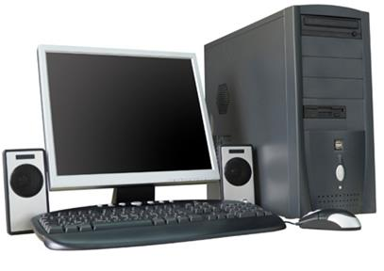**Desktop Computer**

This is the type of computer that we use in school many of you might have one at home. They usually use a keyboard and mouse as the main input device and a monitor and speakers as the main output device.

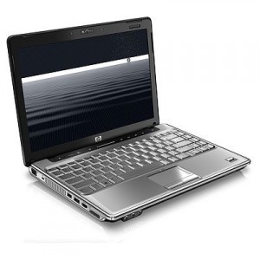**Laptop Computer**

Laptop computers are very popular as they allow people to easily carry them around and work in different locations. They have the same input devices as a desktop computer although the speakers and monitor are built into the laptop. They use a keyboard as an input device but instead of a mouse they usually use a track pad instead.

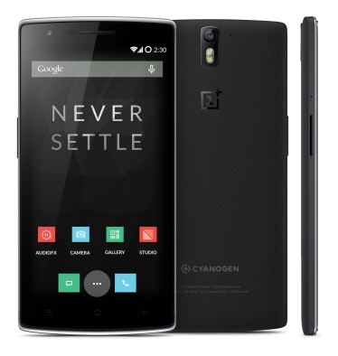**Smartphone**

Smartphones are the most common form of computer system. Since 2011 more smartphones have been sold than all other types of computer system combined. They use a small lightweight monitor and speakers for output devices and have a range of input devices, the main one being the touchscreen. They have location services using GPS and can also be used to make phone calls.

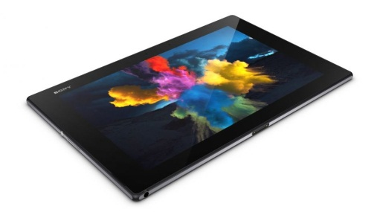**Tablet Computer**

Tablet computers have been growing in popularity along with smartphones. Most tablet computers are enlarged versions of smartphones without the ability to make phone calls. They mostly use the same input and output devices as smartphones.

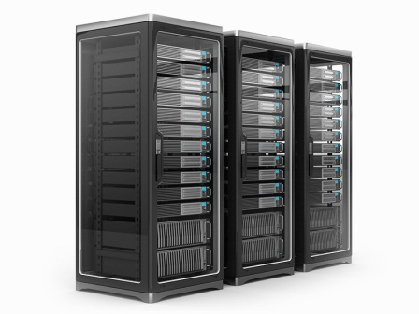**Server**

Servers are used when joining computers together in a network. They can be used for a variety of purposes but are mostly used for sharing files and storing webpages. Servers are unusual as computer systems because they often have no input or output devices, server administrators normally log in remotely to make changes to them.

**Supercomputer**

Super computers are very large and enormously powerful computers. They are used to study complex scientific information such as weather patterns or nuclear explosions. An annual list of the most powerful supercomputers is published each year. The current winner is the Sunway TaihuLight in the [National Super Computer Centre in Guangzhou](http://www.top500.org/site/50365), China. It is about as powerful as 200,000 of our school computers.

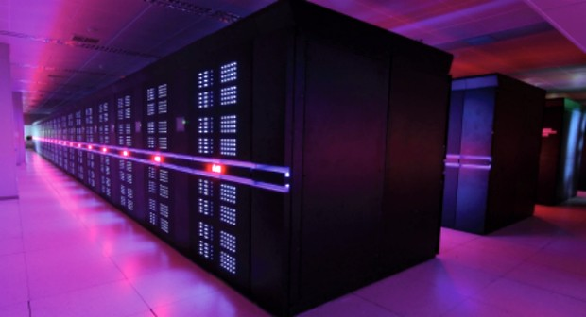

Quiz 1

Complete the Computer Systems Quiz



Types of System Questions

Different computers are used for different purposes. Answer the following questions in your jotter in sentences.

1. Name three pieces of computer software that you have used in school.
2. Compare a smartphone and a desktop.
3. Explain what is meant by computer hardware.
4. Explain what is meant by computer software.

Processor and Memory

The processor and the memory work together to function like the brain of the computer. Together they are responsible for holding all the information and the programs the computer is using and performing all the calculations necessary for the computer to work properly.

Processor

There are lots of different types of processor available to use in computers. It can be quite hard to tell how good a processor is. A processors clock speed is one way of deciding how good a processor is. The clock speed tells you how many calculations the processor can perform every second and is measured in Hertz(Hz).

|  |  |
| --- | --- |
|  | This is the Apollo Guidance Computer that was used to safely transport people to the moon and back. It has a clock speed of around 2 million Hertz (2 Megahertz, MHz) meaning that it could perform about 2 million calculations per second. It cost about £100,000, weighed 32 kg and was about 3 times the size of the computers we use in school. |
|  | This is a Raspberry Pi computer; it is used for learning basic programming. It has a clock speed of 700 Megahertz (MHz) meaning that it can perform round 700 million calculations per second. It cost about £20, weighs 45g and is about the size of 2 post it notes. |
|  | This is the AMD FX-9590 processor; it is used in computers similar to the ones we use in school. It has a clock speed of 5 billion hertz (5 Gigahertz, GHz) meaning that it can perform around 5 billion calculations every second. It has the highest clock speed of any processor available to buy. |

Most computers today have clock speeds of between 1 and 4 GHz.

Looking at the amount of bits it processes is the other main way to tell how good a processor is. Most modern processors work in 64 bits, although some still work in 32 bits. The more bits a computer can process at a time the more powerful it is.

The iPhone 5S was the first phone to have a 64 bit processor.

Computer Activity

Visit the website PC Partpicker <https://uk.pcpartpicker.com/>

Find the name and clock speed (in GHz) of the fastest and slowest processor you can find. Record your results in your jotter.

Sorting Activity

Use Google to find out how many bits each of the consoles process. Sort them into order on your sheet and glue them into place.

Memory

Computers use their memory to hold all the information and programs that they are working on. The more memory a computer has the more information it can work on at a time. Memory is often confused with backing storage, especially when looking at smartphones.

This is the iPhone 5S it is advertised as having 64 gigabytes of memory. In reality the iPhone has 1 gigabyte of memory; the 64 gigabytes advertised are actually used for backing storage.

Backing storage is used to save information when it is not being used.

All computers have two different types of memory RAM and ROM

ROM

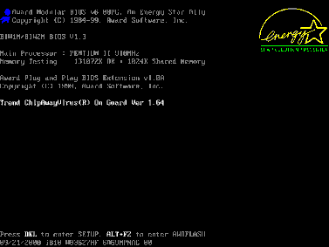ROM stands for Read Only Memory. This memory is only used to store the basic instructions that the computer needs to start up and load its operating system. You will only ever be aware of the ROM when you initially turn on your computer, your display will look something like this.

RAM

RAM stands for Random Access Memory. This is the memory that the computer uses for holding the information and programs that it is working on. Smartphones have a memory capacity of between 512 Megabytes (MB) and 6 Gigabytes (GB). Most computers have a memory capacity of between 4 Gigabytes (GB) and 32 Gigabytes (GB). Increasing the amount of RAM in a computer is one of the easiest ways to increase its performance.

Having more RAM allows a computer to hold more data and programs to work on at one time, if a computer uses all of its RAM it will slow down because it will have to keep clearing and loading information from storage.

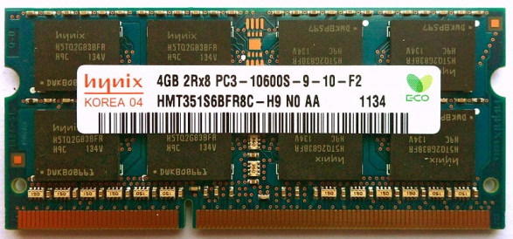This is 4 gigabytes of memory for use in a laptop computer. The dark grey rectangles are the memory chips that hold the information. The green board allows them to be connected together and the gold pins at the bottom connect it to the computer.

Quiz 2

Complete the Processor and Memory Quiz



Processor and Memory Questions

Laptop 1 Laptop 2

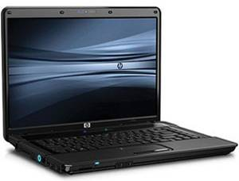 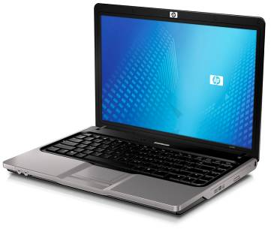

|  |  |  |  |  |  |
| --- | --- | --- | --- | --- | --- |
| Clock Speed | 3.2 GHz Processor |  | | Clock Speed | 2.0 GHz Processor |
| Memory | 2Gb RAM |  | | Memory | 4Gb RAM |
|  |

Answer the following questions in your jotter in sentences.

1. Compare these two systems in terms of performance.
2. State what the abbreviation GHz stands for.
3. State what the letters RAM and ROM stand for.
4. Explain why you would not store your personal files in ROM.

Computer Activity

Copy the Block Diagram of a Computer System PowerPoint from the Our School > Departments > Computing > Departmental > Pupil > National 4 and 5 > Systems folder to your S3 computing folder.

Open the PowerPoint and navigate to the processor and memory pages. Use the Internet to get a picture of a processor and a memory chip to insert into the PowerPoint. Use the word bank to complete the missing spaces in each paragraph.

Sorting Activity 2



Copy and complete the following diagram into your jotter. The first answer has been completed for you.

RAM A temporary storage place

This is also known as main memory

Used to store something permanently

ROM

Stores the instructions for the computer to start

Contents can be changed

Content is lost when the computer is turned off

Having more of this will make your programs run faster

Input devices

Input devices are used to get instructions or information into the computer. The most common input devices used are the **keyboard** and **mouse**.

**Keyboards**

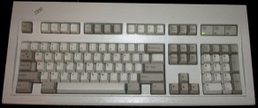Keyboards allow you to input text and instructions into a computer system. They require a flat surface to rest on to allow people to type properly.

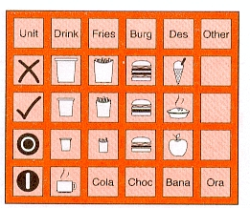**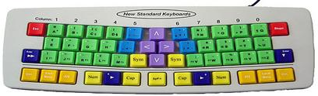Concept keyboards** have been produced that allow users with additional support needs to interact better with computer systems. **Concept keyboards** may have enlarged keys for users with fine motor difficulties or fewer buttons linked to pictures to allow users with communication difficulties to express themselves.

**Pointing Devices**

Pointing devices are used to input instructions into a computer system.

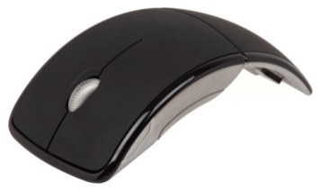The **mouse** does not input information but is used to issue instructions to move a pointer around screen and interact with icons, menus and manipulate data.

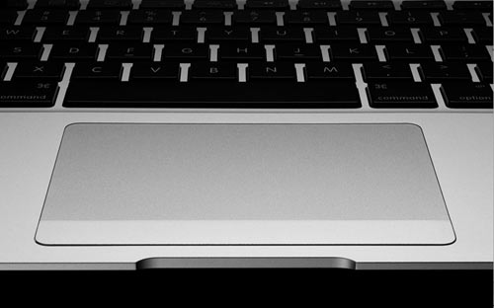A **mouse** allows the user a high level of precision over the movement of the pointer but it does require a free flat surface – desk space- to move freely.

On laptops there is no guarantee that you will have an available desk to use a mouse so laptops use **track pads** to let you move the cursor by dragging your finger across it.

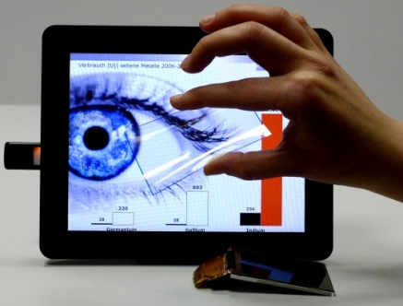As smartphones and tablets have become more popular the use of **touch screens** as input devices has increased. A good **touchscreen** can combine the benefits of keyboards and track pads by using virtual keyboards that are displayed on the screen.

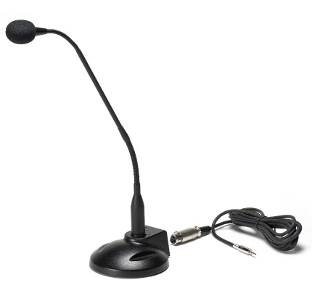**Microphones**

**Microphones** are used to input sound into a computer system. This used to mean recording music or voices to be played back or edited later but voice recognition software like Apple’s Siri can allow the microphone to be used to control a computer. A lot of cameras also include a microphone

**Imaging**

Imaging devices input visual data (pictures or videos) into a computer system.

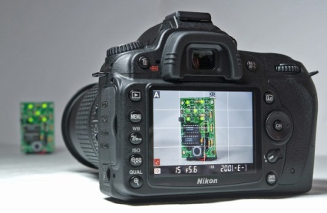**Digital cameras** use an array of sensors to capture pictures which can be inputted into a computer. The quality of a picture is usually measured by the resolution of the camera; this is normally given in megapixels.

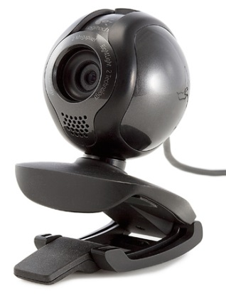**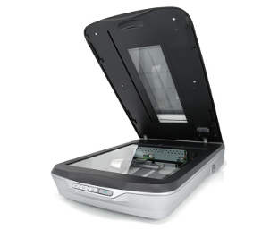Webcams** function like very basic digital video cameras. They are generally of very low quality because it is hard to send video across the internet. As Internet speeds have increased the resolution of webcams has also increased.

S**canners** are used to input images or text from paper into a computer system. **Optical Character Recognition OCR** software allows scanned text to be able to be edited in word processors like Microsoft word.

Computer Activity 3

Open the Block Diagram of a Computer System PowerPoint.

Navigate to the input devices pages. Use the Internet to get a picture of each input device to insert into the PowerPoint. Use the word bank to complete the missing spaces in each paragraph.

Crossword 2

Complete **Computer Systems 2 – Input Devices Crossword**

Quiz 3

Complete the Input Devices Quiz



Input Devices Questions

Answer the following questions in your jotter. Remember to answer in sentences.

1. Name three different input devices and give an example of where they might be used.
2. Explain why a smartphone would not use a mouse as an input device.
3. Describe one advantage and one disadvantage of touch sensitive screens.
4. Explain a disadvantage of speech recognition.

Output Devices

Output devices are used to get information out of a computer.

**Displays**

Displays output visual information from a computer system; this can be graphics, text or video

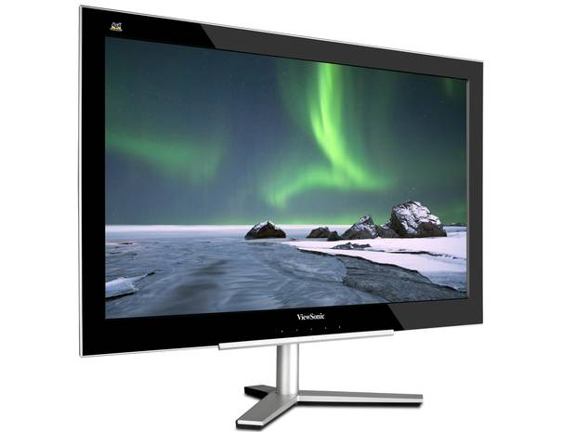The main output device on every computer you use will be the **monitor** or screen. The monitor is made up of a grid of very small dots called pixels. Each pixel can be set to a different colour and can change colours quickly. This allows still images and video to be displayed on the monitor.

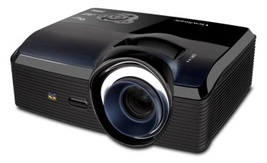

**Projectors** function in a similar way to monitors but they will generally display a much larger image that can be used for presentations to groups of people.

**Sound**

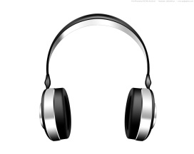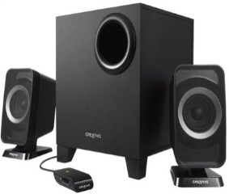**Speakers** and **headphones** are used to output sound out of a computer system. Computers usually have sound cards which are used to process sound information as it is sent to speakers and headphones and received from microphones.

**Printers**

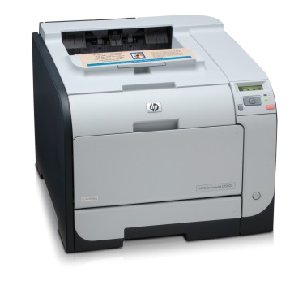The **laser printers** that we use in school can print pages very quickly and cheaply making them very useful for a school or an office although they can be quite expensive to buy. Laser printers use lasers to attach a very fine powder called toner onto a sheet of paper to make up images and text.

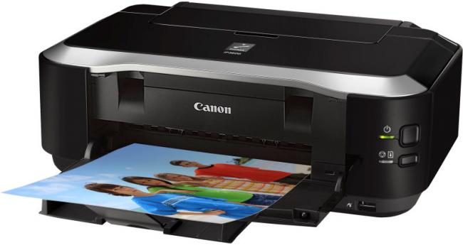If you own a printer at home it is most likely an **inkjet printer**. These printers are generally quite slow and are very expensive to run. However they are cheap to buy and can print high quality colour photographs. Inkjets work by spraying a very fine mist of ink onto paper as it passes through the printer.

**3D printers** are used to build a solid object, normally out of plastic, from information stored on a computer system. In a 3D printer material is either cut away from a block or built up layer by layer to create a final 3D model. £d printers are often used by companies and individuals wanting to make prototypes of new inventions.

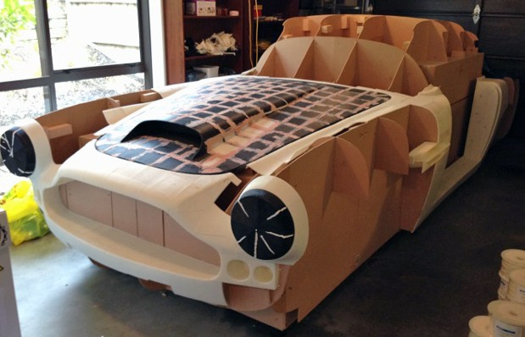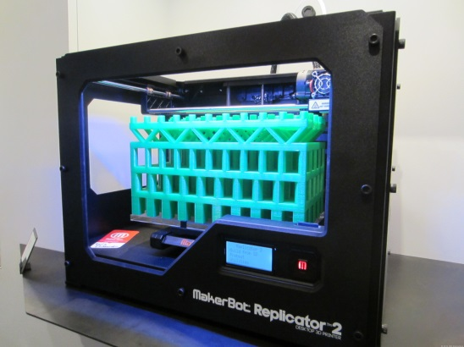

Computer Activity 4

Open the Block Diagram of a Computer System PowerPoint.

Navigate to the output devices pages. Use the Internet to get a picture of each output device to insert into the PowerPoint. Use the word bank to complete the missing spaces in each paragraph.

Crossword 3

Complete **Computer Systems 3 – Output Devices Crossword**

Quiz 4

Complete the Output Devices Quiz



Output Devices Questions

Answer the following questions in your jotter. Remember to answer in sentences.

1. Name the three main types of printer.
2. State the name of the dots that make up a picture on a computer screen.
3. Explain the circumstances in which you would use a projector rather than a monitor as an output device.
4. Compare the functions of laser and inkjet printers.

Backing Storage

Backing storage is used to save information and programs when they are not being used by a computer. There are 3 main types of backing storage - **magnetic**, **optical** and **solid state** - that fit into 3 different categories – **internal**, **external** and **portable**.

**Magnetic Storage**

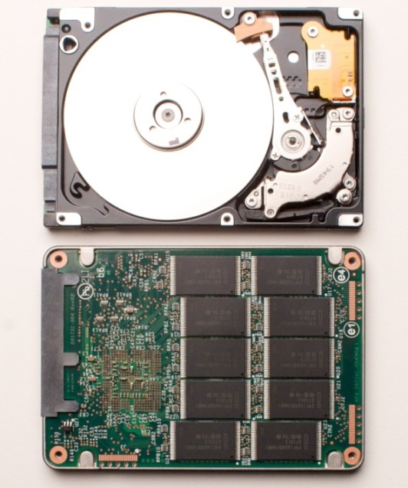This uses magnetic disks or tape to record information - it is the oldest type of backing storage still being used today.

Hard Disk

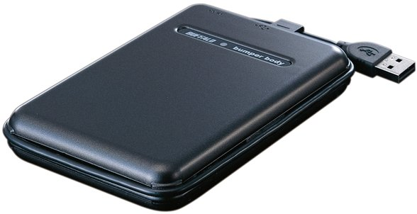Hard disks are the most common type of backing storage in desktops and laptops. They have **high storage capacity** and are quite **cheap** to buy. Their main disadvantages are that they are **not very robust** – they will break if you drop them – and their transfer speeds are **not as fast** as more modern storage devices.

Magnetic Tape / DAT tape

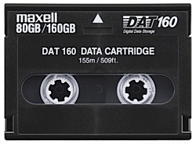Magnetic tape is a **very slow** backing storage medium but it **is very cheap** and has **high storage capacity**. It takes a long time to find anything on tape because you need to read through the whole tape to find what you are looking for, with all other types of backing storage you can jump directly to the information you need. Due to its slow speed magnetic tape is only really used for large backups. Music masters are sometimes still stored on DAT tapes.

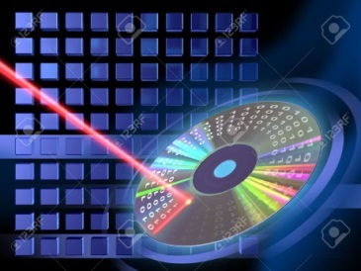**Optical Storage**

Optical storage involves storing information in a **reflective disk**. That information can be read from or written to the disk using different types of **laser**.

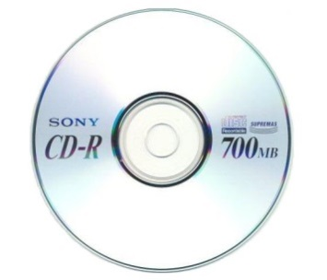**Compact Disks**

CDs were the first successful optical storage and are still being used today. Due to their relatively **small storage capacitie**s and **slow speeds** they mostly used for storing music

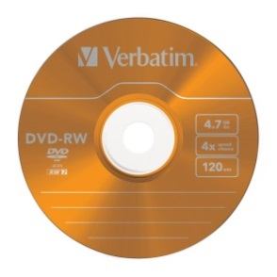**Digital Versatile Disks**

DVDs improved on CDs by having **faster** **transfer speeds** and **higher storage capacities**, this allowed them to become very popular for storing movies.

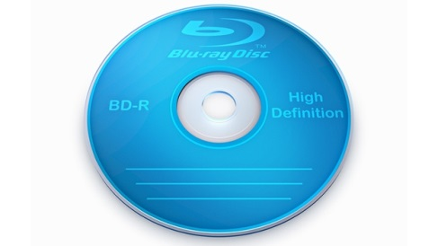**Blu Ray Disks**

Blu-Ray is the most recent commercial optical storage technology; it offers **higher transfer speeds** and **storage capacities** than DVDs and are commonly used for storing HD videos and console games.

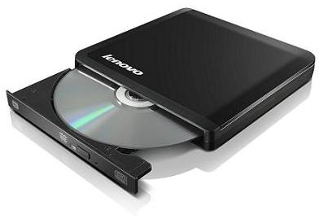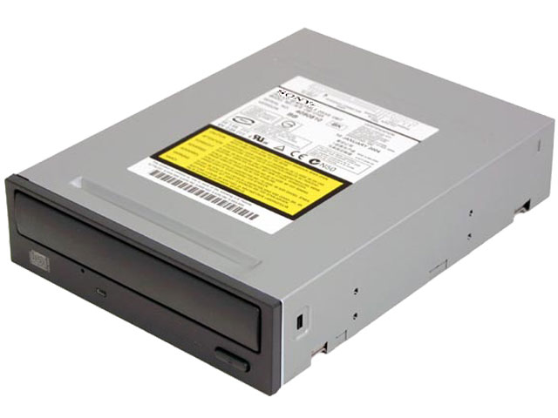

Computer Activity 5

Open the Block Diagram of a Computer System PowerPoint.

Navigate to the backing storage pages. Use the Internet to get a picture of each type of magnetic and optical storage and insert into the PowerPoint. Use the word bank to complete the missing spaces in each paragraph.

Crossword 4

Complete **Computer Systems 4 – Backing Storage 1 Crossword**



Backing Storage 1 Questions

Answer the following questions in your jotter. Remember to answer in sentences.

1. Explain why magnetic tape is still in use.
2. State what the letters DVD stand for.
3. Explain why mobile phones do not use magnetic hard disks as a storage medium.
4. Compare CDs and Blu-Rays as backing storage mediums.

**Solid State**

Solid state storage stores information on electronic **flash memory chips**. Unlike optical and magnetic storage solid state storage has **no moving parts** – this means it is **more robust** (harder to break), uses **less energy** and can allow it to have much **faster data transfer rates**.

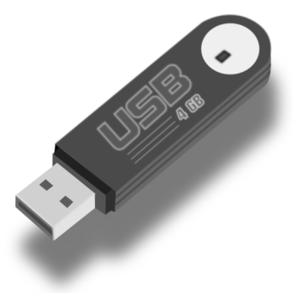

**USB Flash Drive**

Flash drives allow people to transfer large amounts of files in an extremely easy to carry device. They connect using a USB port so almost every modern computer on the planet should be able to use them.

**IMPORTANT**  these are NOT called USBs. They are called flash drives. They connect to computers through USB ports. This does not make them USBs.

**Solid State Drive**

High end PCs and laptops generally use SSDs because of their extremely fast **transfer rates. Lower end devices generally use magnetic storage as it is much** cheaper, especially at high capacities.

**Memory Card**

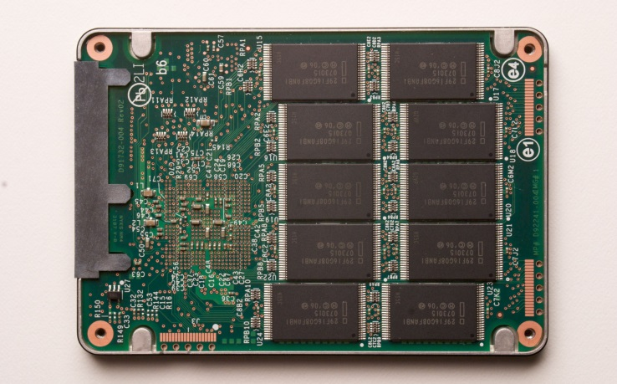These cards allow information to be transferred easily between devices. They are most commonly used in digital cameras and smartphones

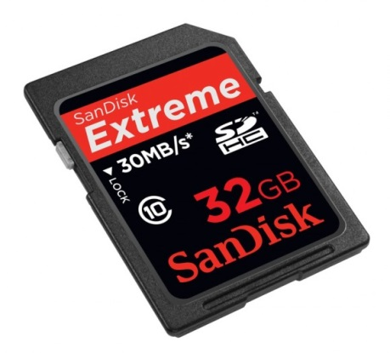

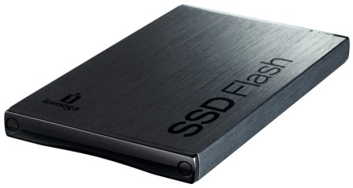

As network technologies improve we also have the options of using network based storage.

Cloud storage means that your information is being stored on a server on the internet and you can get access to it whenever you want.

Most cloud storage will offer users some free space but then start charging them once they have filled it.

Cloud storage’s main disadvantages are that access speeds are dependent on the quality of your Internet connection; if you have a poor Internet connection it will take you a long time to get access to your files, if you don’t have an Internet connection you won’t get any access.

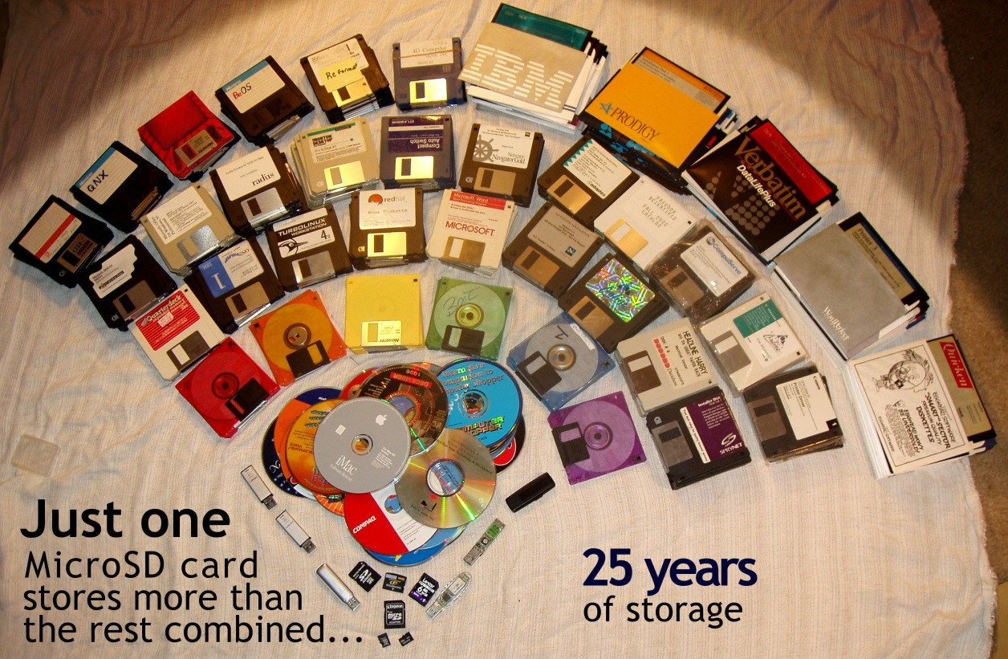

Computer Activity 5

Open the Block Diagram of a Computer System PowerPoint.

Navigate to the backing storage pages. Use the Internet to get a picture of each type of solid state storage to insert into the PowerPoint. Use the word bank to complete the missing spaces in each paragraph.

Crossword 4

Complete **Computer Systems 5 – Backing Storage 2 Crossword**

Quiz 5

Complete the Backing Storage Quiz



Backing Storage 2 Questions

Answer the following questions in your jotter. Remember to answer in sentences.

1. Explain why magnetic tape is still in use.
2. State what the letters DVD stand for.
3. Explain why mobile phones do not use magnetic hard disks as a storage medium.
4. Most mobile phones used to have expandable storage using microSD cards. Explain why mobile phone companies do not feel this is as important as it used to be

Building Activity

Your teacher will supply the class with a complete computer system. As a class you will

1. Identify the components
2. Disassemble the computer
3. Reassemble the computer

When finished your teacher will provide you with a photograph of the computer internals and ask you to label each of the parts.

Computer Systems Comparison Exercise

Study the computer adverts below then answer the questions which follow in your jotter. Remember to answer in sentences.

|  |  |
| --- | --- |
| Jazz Senior | Jazz Junior |
| http://www.mindsetcomputerrepairs.com/graphics/HP-desktop-computer-repair.jpg | http://images.techhive.com/images/article/2012/12/razer20laptop-large-100016095-large.jpg |
| Wintel 3.5 GHz | AND 2.0GHz |
| 64bit | 32 bit |
| Lindows 9.7 OS | Winux 3.6 OS |
| 500Gb HDD | 120Gb SSD |
| 8GB RAM | 4GB RAM |
| DVD-RW drive | No optical drive |
| 24” Screen | 14” Screen |



1. State the memory capacity of the Jazz Senior.
2. Describe the input devices the Jazz Junior is likely to have.
3. Explain which system would be best used by a travelling salesman.
4. Assess which system has the best backing storage solution.

Exam Questions

Answer the following questions in your jotters

Q1

Explain why a database should not be stored in ROM memory. – 1 mark

Q2

Sue checks the specification for her tablet PC.

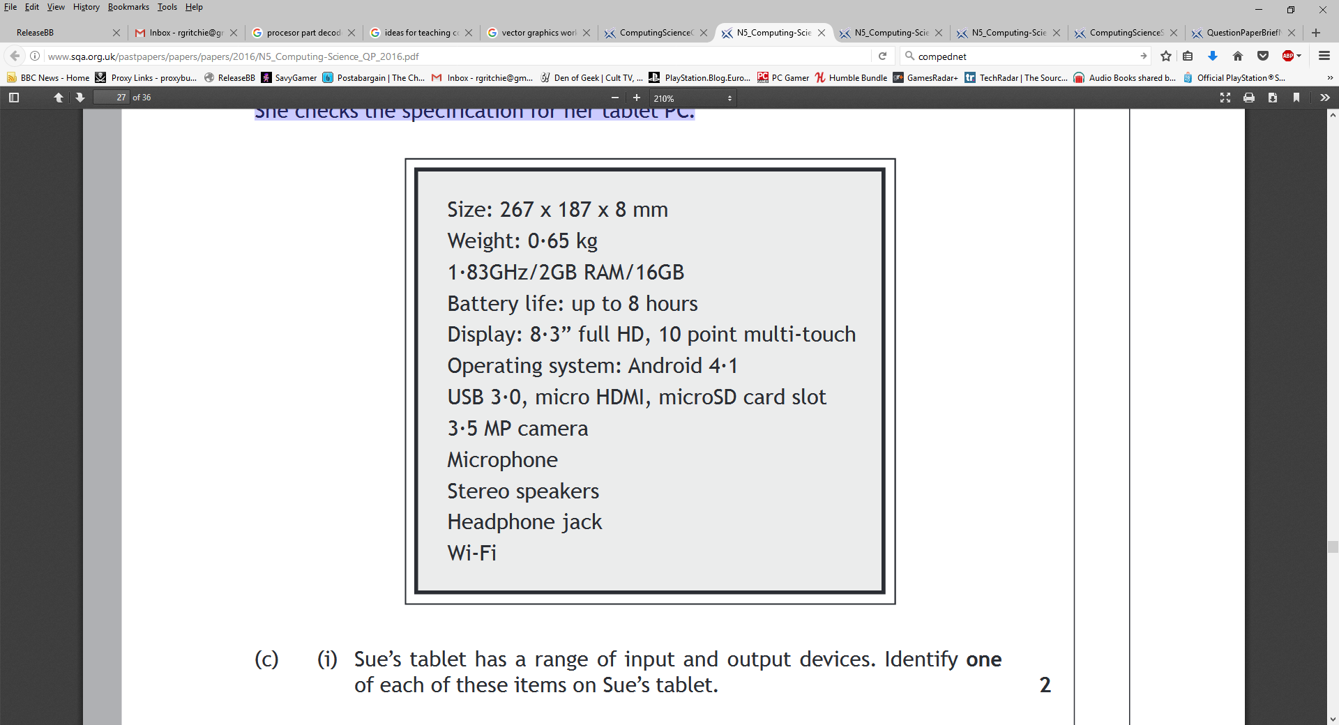

Sue’s tablet has a range of input and output devices. Identify one of each of these items on Sue’s tablet.

Input device

Output device

- 2 marks

Q3

Businesses and individuals are now making use of cloud services instead of local storage for storing their data.

State one benefit of using cloud based storage instead of local storage.

- 1 mark

Q4

Copy and complete the table below to show which type of storage (magnetic, optical or solid state) is most appropriate for each of the following uses and why.

|  |  |  |
| --- | --- | --- |
|  | Type of storage | Reason |
| Smartphone storing the app |  |  |
| Web server storing the website |  |  |
| Collection of video recipes stored on DVD |  |  |

- 3 marks

Q5

The minimum amount of RAM required to run the app is 1 Gigabyte. State what RAM stands for.

- 1 mark

Low Level Systems

Learning Intentions

* To be able to identify the different sections of the central processing unit
* To be able to explain the purpose of each section
* To be able to identify the different connections between the CPU and the memory
* To be able to explain the purpose of each connection
* To understand and explain the steps in the fetch execute cycle

Low Level Processor Operations

The most complicated part of a computer system at this level is the processor, memory and how they are **connected** together.

|  |  |  |
| --- | --- | --- |
| Processor | Address Bus | Memory |
|  |
|  |
|  |
|  |
| Data Bus |
|  |
|  |
|  |
|  |
|  |
|  |
| Control Lines |
|  |
|  |
|  |

Buses

There are 2 **buses** connecting the processor and memory; the **data bus** and the address bus. There is a third connection called the control lines, some people class this as a bus as well.

**Address Bus**

The computer’s memory is a series of **locations** which hold **information** or **instructions**. Each location has its own **unique address** to let the computer find it. The address bus is used for **selecting the address** of the memory location you are using. Information only moves one way, it is uni-directional.

**Data Bus**

The data bus **transfers information** and instructions. The information and instructions can be **transferred from the memory to the processor** or from the **processor to the memory**. These are known as **memory read** and **memory write** operations. Information moves both ways, it is bi-directional.

**Control Lines**

The control lines **organize** the flow of information between the processor and the memory. They will say whether memory is being **read from** or **written to** and they will also make sure that everything is working at the **correct time**. The control lines determine the **clock speed** of a processor.

Memory Addresses

When the processor fetches instructions and data from the memory it must know where to find them. The memory in a computer is **organised** into separate storage locations.

Each location is given a **unique binary number** to identify it. This is called **addressability**

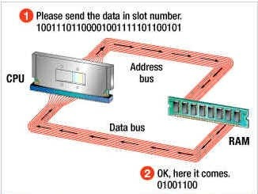

In a single RAM module there may be millions of memory locations each one containing a **program instruction**, **memory address**, or an **item of data**.

Crossword 5

Complete the **Computer Systems 6 – Buses Crossword**

Quiz 6

Complete the Buses Quiz



Buses Questions

Answer the following questions in your jotter. Remember to answer in sentences.

1. Name the bus that selects memory locations.
2. State the reason for all memory locations having their own unique address.
3. Explain why the data bus is classed as bi-directional.
4. Explain why all three connections are needed to write a value to memory.

Processor Components



A computer processor has three main components; the **ALU** (Arithmetic & Logic Unit), the **Registers** and the **Control Unit.**

Registers

Registers

Registers are memory locations built into the processor in order to store temporary data during processing.

Temporary storage is required as it make take a processor several steps to complete a task.

ALU

Registers can store instructions, text or numbers. These are all represented using binary numbers

For example, if the processor was performing the following calculation (5+4) - (6+1), it would…

* add the 5+4 first and store the answer 9 in one of the registers

Control Unit

* add 6+1 and store 7 in one of the registers
* fetch the two stored values from the registers
* subtract the 9-7 to calculate the final result.

#### Arithmetic Logic Unit

The second part of the processor carries out any calculations (arithmetic) required and makes decisions (logic).

Decisions often involve doing some sort of comparison. For example:

Display message - “You have failed

and must study harder.”

If score<16

Display Message “ Congratulations you have passed”

A computer program for the above example would have two sets of instructions (one for each message). The ALU would compare the “score” with the number 16 to decide which set of instructions should be processed next.

#### Control Unit

The control unit is responsible for the timing of events within the processor. It does this by means of a clock pulse or by stopping and starting different processes.

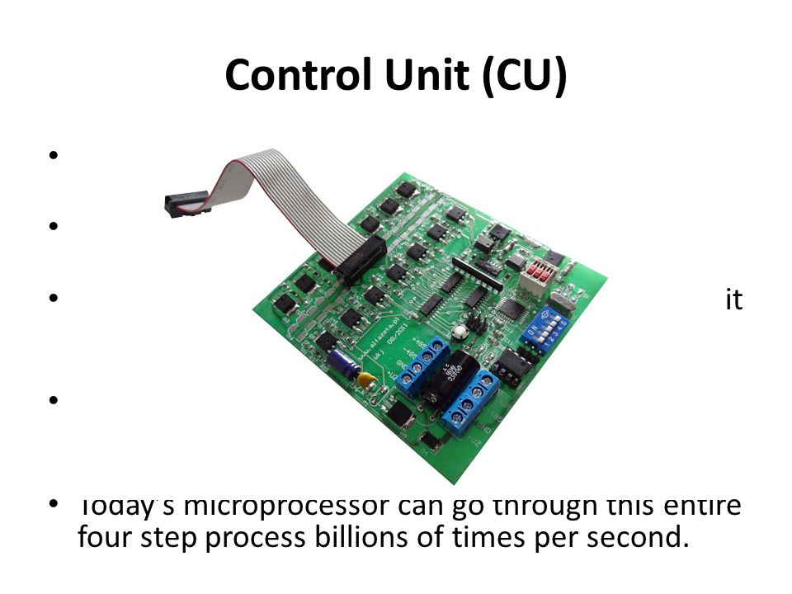Modern computers are capable of performing billions of calculation every second. At these speeds it is import that all the events occur within a processor in the correct order. It also contains the instructions to read from or write to memory locations.

Crossword

Complete the **Computer Systems 7 - Processor Crossword**

Quiz 7

Complete the Processor Quiz



Processor Questions

Answer the following questions in your jotter. Remember to answer in sentences.

1. Name the part of the processor that processes IF statetments
2. State what the letters ALU stand for.
3. Explain why the clock pulse is important in the control unit.
4. State 3 types of information that could be stored on a register.

The Role of Buses in Processing

When instructions and data are transferred from the memory to the processor the following steps are carried out.

#### Memory Read

1. 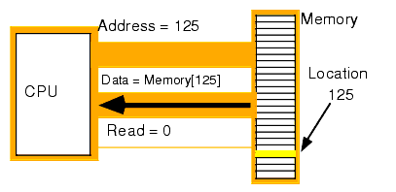The address bus is used to select the address of the desired memory location.
2. The control bus sends a signal to activate the transfer.
3. The machine code instruction (or data) in the selected location is sent along the data bus to the processor.

When data is transferred from the processor back to the memory the following steps are carried out.

#### Memory Write

1. The address bus is used to select the desired memory location.
2. The control bus sends a signal to activate the transfer.
3. The data is sent along the data bus to the selected location.

Note - The address bus is one directional as it only ever sends address information from the processor to the memory. The data bus is bi-directional as data can travel to and from the processor.

Fetch-execute cycle

If a program is running, its instructions (the lines of code that have been translated into machine code) will be held in a series of storage locations in memory

The processor starts with the first instruction. It specifies the instruction’s address (where the instruction is) using the address bus

The instruction is transferred to the processor via the data bus

The processor **executes** the instruction and then **fetches** the next instruction. A program counter keeps track of which instruction the processor is on

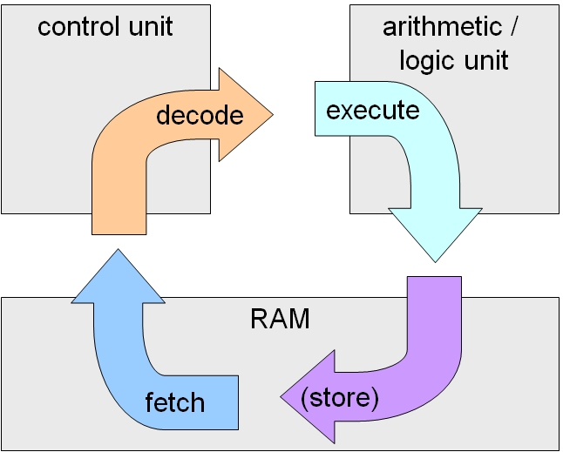

Crossword

Complete the **Low Level Machines Crossword**

Quiz

Complete the Low Level Machines Quiz



Low Level Machines Questions

Answer the following questions in your jotter. Remember to answer in sentences.

1. Name and describe the function of the following internal processor components:
   * Arithmetic Logic Unit, Control Unit, Registers
2. State two differences between the data bus and the address bus.
3. Explain the need for each storage location in memory to be allocated a unique address.
4. Name the three main roles of the control unit.



**Model Building for the Fetch Execute Cycle**

In groups you will assemble a model showing the different sections of the processor, the memory and the buses connecting them



**Role Play Exercise**

Now that your models are finished your teacher will give you a series of instructions. You are to follow these instructions, in your groups using your processor models.

Data Representation

Learning Intentions

* To understand the binary number system
* To demonstrate how numbers can be converted from binary to denary and vice versa
* To understand and explain the different ways graphics can be stored in a computer system
* To understand and explain the different ways sounds can be stored by a computer system
* To understand and explain the different ways text can be stored by a computer system

Binary

People understand numbers using the denary number system.

This means that all the numbers we use are represented using 10 characters; 0, 1, 2, 3, 4, 5, 6, 7, 8 and 9.

Computers understand numbers using the binary number system.

This means that all the numbers computers use are represented using 2 characters; 0 and 1

Advantages

* Binary numbers can be easily represented using on/off or high/low voltages – this means that computers do not get confused over numbers easily.
* Binary mathematics has much fewer rules than denary mathematics. This allows computer processors to be smaller

Disadvantage

* Binary is confusing for people



View the How Binary Numbers Work PowerPoint, and then answer the following questions in your jotter. Remember to answer in sentences

1. State the number of rules needed for binary addition.
2. State the number of rules needed for denary addition.
3. State the first 8 place values for a binary number

Units of Binary

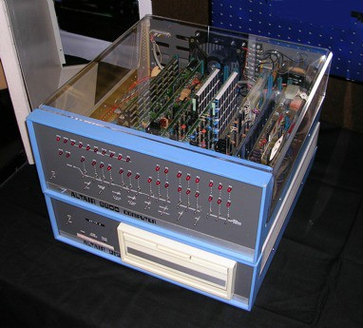The software we use on the computer and the data we work with is represented as **bits** within the main memory. Early computers, like the 1975, Altair 8800 shown on the right, typically worked with groups of 8 bits (known as a **byte**) at a time.

When referring to memory and storage capacities, **bytes** became the basic unit of measurement. Computers today can process and store billions of bytes every second this makes it impractical to refer to the number of bytes needed by a computer so we have to use new units of measurement.

If we were working with distance then we would change from measuring lengths in meters to kilometers as the distances got larger. The prefix kilo means 1000 so 1 kilometer is the same as 1000 meters.

Computers, working in binary, don’t use quite the same prefixes as other units of measurement. Instead of increasing the prefix for every multiple of 1000; kilo-, mega- giga-, etc., computers increase the prefix for multiple of 210 or 1024. This gives us the units kibibyte, mebibyte, gibibyte and tebibyte – abbreviated to KiB, MiB, GiB and TiB.

Until very recently we still used the prefixes kilo, mega giga and terra so you will still see these terms used on almost all advertising and shopping sites – **DO NOT USE THEM IN THE EXAM**

Changing From One Unit to Another

As well as knowing the order of the units (bits, bytes, KiB, MiB, GiB, TiB) it is important, when doing calculations in computing, to be able to change from one unit to another.

For example:

A high definition movie might require 1,717,986,918 bytes of storage space.

If you were telling your friend that you had downloaded the above movie last night. You would be far more likely to say that the movie you downloaded was 1.6 Gb in size.

Using appropriate units is important. A rough guide is that you will be using appropriate units when the main part of your number is between 1 and 1000

To covert a small unit to a larger one we divide (for example changing bytes to MiB). To convert a large unit to a smaller one we multiply (for example TiB to MiB)

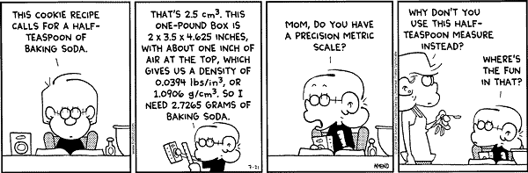

What you multiply and divide by, depends on the number of places you are moving up or down. You can use the chart below to help.

|  |  |  |  |  |  |  |  |  |  |  |
| --- | --- | --- | --- | --- | --- | --- | --- | --- | --- | --- |
| Bits |  | Bytes |  | KiB |  | MiB |  | GiB |  | TiB |
|  | 8 |  | 1024 |  | 1024 |  | 1204 |  | 1024 |  |

Divide by Multiply By

Kb to Gb would be two places to the right so you would divide by 1024 twice.

Example 1: Convert 4 MiB into bytes. We are moving two steps to the left 4 x 1024 x 1024 = 4,194,304 bytes

Example 2: Convert 4096 GiB in TiB. We are moving one step to the right 4096 / 1024 = 4 TiB

Example 3: Convert 3.5 MiB into bits. We are moving three steps to the left 3.5 x 1024 x 1024 x 8 = 29,360,128 bits

Example 4: Convert 68,719,476,736 bits into GiB. We are moving four steps to the right 68,719,476,736 / 8 / 1024 / 1024 / 1024 = 8 Gb

Unit Conversion Questions

Answer the following questions in your jotter. Remember to use the conversion table on the previous page if you get stuck

Q1 How many bytes are there in 64 bits?

Q2 How many KiB are there in 8,192 bytes?

Q3 How many MiB are there in 2 GiB?

Q4 How many bits are there in 256 bytes?

Sometimes the same questions are worded differently.

Q5 Convert 4096 MiB into KiB.

Q6 Convert 1,048,576 KiB into GiB.

Q7 Convert 4 TiB into MiB.

Q8 Convert 12 KiB into bits.

The next set of questions require a bit of problem solving as well.

Q9 Dave is offered two USB flash drives for £10 each. One is 10,240 MiB in size and the other is 12 GiB.

Which one should he buy?

Q10 Wendy wishes to store 20 graphics, each of which 512 KiB in size.

How many MiB of storage will she need to store all the files

Q11 Which is larger 163,840 bits or 22 KiB?

Using Binary to Store Integers

An integer is a positive or negative whole number. We have been using integers since primary school but we have always used the denary number system.

|  |  |  |  |  |
| --- | --- | --- | --- | --- |
| Place Value | 100s | 10s | Units |  |
| Denary Value | 3 | 7 | 4 | = 3*100 + 7*10 + 4*1 = 347 |

Using binary means that we only use 2 numbers 0 and 1 instead of 10. This means that the place values are not multiples of 10 but multiples of 2

|  |  |  |  |  |  |  |  |  |
| --- | --- | --- | --- | --- | --- | --- | --- | --- |
| Place Value | 32s | 16s | 8s | 4s | 2s | Units |  |  |
| Denary Value | 1 | 0 | 1 | 0 | 1 | 0 |  |  |
|  |

= 32*1 + 16*0 + 8*1 +4*0 + 2*1 +1*0

=32 + 8 + 2 = 42

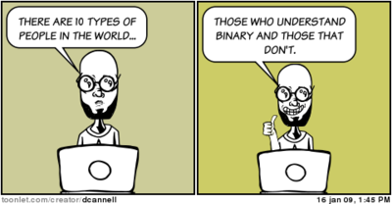

Converting Binary to Denary

In the exam you may be asked to convert a binary number into denary. The binary number will have 8 bits giving you the place values

|  |  |  |  |  |  |  |  |
| --- | --- | --- | --- | --- | --- | --- | --- |
| 128 | 64 | 32 | 16 | 8 | 4 | 2 | Units |

All you have to do is write down your place values, write the binary number underneath then add up the place values with a one underneath

|  |  |  |  |  |  |  |  |
| --- | --- | --- | --- | --- | --- | --- | --- |
| 128 | 64 | 32 | 16 | 8 | 4 | 2 | Units |
| 1 | 1 | 0 | 0 | 1 | 1 | 0 | 1 |

=128 + 64 + 8 + 4 + 1

=205



Data Conversion Questions

Converting Binary to Denary

In your jotters convert the following binary numbers to denary

1. 11001011

2. 00110101

3. 10000011

4. 10001111

5. 11100011

6. 00000100

7. 00010010

8. 00111111

9. 10101010

10.01010101

Converting Denary to Binary

You may also be asked to convert a denary number to binary. This is slightly more complicated

Let’s look at the example 207

Start by writing down your binary place values

|  |  |  |  |  |  |  |  |
| --- | --- | --- | --- | --- | --- | --- | --- |
| 128 | 64 | 32 | 16 | 8 | 4 | 2 | Units |

Next find the largest place value that is smaller than your denary number. In this case it would be 128.

Write a 1 under 128 then take 128 away from your original denary number

|  |  |  |  |  |  |  |  |
| --- | --- | --- | --- | --- | --- | --- | --- |
| 128 | 64 | 32 | 16 | 8 | 4 | 2 | Units |
| 1 |  |  |  |  |  |  |  |

207 – 128 = 79

Now find the next largest number that is smaller than your new denary number. In this case it would be 64.

Write a 1 under the 64 then take 64 away from your denary number

|  |  |  |  |  |  |  |  |
| --- | --- | --- | --- | --- | --- | --- | --- |
| 128 | 64 | 32 | 16 | 8 | 4 | 2 | Units |
| 1 | 1 |  |  |  |  |  |  |

79- 64 = 15

Repeat this process until you get to zero

|  |  |  |  |  |  |  |  |
| --- | --- | --- | --- | --- | --- | --- | --- |
| 128 | 64 | 32 | 16 | 8 | 4 | 2 | Units |
| 1 | 1 |  |  | 1 |  |  |  |

15 – 8 = 7

|  |  |  |  |  |  |  |  |
| --- | --- | --- | --- | --- | --- | --- | --- |
| 128 | 64 | 32 | 16 | 8 | 4 | 2 | Units |
| 1 | 1 |  |  | 1 | 1 |  |  |

7 – 4 = 3

|  |  |  |  |  |  |  |  |
| --- | --- | --- | --- | --- | --- | --- | --- |
| 128 | 64 | 32 | 16 | 8 | 4 | 2 | Units |
| 1 | 1 |  |  | 1 | 1 | 1 |  |

3-2 = 1

|  |  |  |  |  |  |  |  |
| --- | --- | --- | --- | --- | --- | --- | --- |
| 128 | 64 | 32 | 16 | 8 | 4 | 2 | Units |
| 1 | 1 |  |  | 1 | 1 | 1 | 1 |

1 - 1 =0

Now fill any blank space you have left with zeros

|  |  |  |  |  |  |  |  |
| --- | --- | --- | --- | --- | --- | --- | --- |
| 128 | 64 | 32 | 16 | 8 | 4 | 2 | Units |
| 1 | 1 | 0 | 0 | 1 | 1 | 1 | 1 |

Your final binary number is 1100 1111



Data Conversion Questions

Converting Denary to Binary

In your jotters convert the following denary numbers to binary

1.213

2.9

3. 67

4. 99

5. 23

6. 143

7. 6

8. 1

9. 197

10. 252

Using Binary to Store Real Numbers

Real numbers, or numbers with decimal places are stored using scientific notation. For example, the number 345.765 would be stored as:

3.45765 x 102

The computer then stores two separate integers with a set number of bits.

The **mantissa 3.45765** x 102 The **exponent** 1010001100101010

The complete number is then stored as one long integer - 101000110010101000000010

Note that the number of bits that a computer uses to store the mantissa and exponent has an effect on the number stored.

#### Accuracy

By reducing or increasing the numbers of bits used to store the mantissa we can affect the accuracy of the number. With increased bits, more decimal places can be stored.

|  |  |
| --- | --- |
| 8 bits | 3.45 |
| 16 bits | 3.45765 |
| 32 bits | 3.45765234323 |

#### Size

By reducing or increasing the numbers of bits used to store the exponent we can affect the size of the number we can store.

|  |  |  |
| --- | --- | --- |
| 4 bits | range of 0-15 | 100 to 1015 |
| 8 bits | range of 0-255 | 100 to 10255 |

Using Binary to Store Text

Storing numbers using binary is easy as binary is a counting system for numbers. To store text characters we have to come up with a different solution.



Binary Text Activity

Split into pairs and collect a piece of scrap paper from your teacher. Your task is as follows:

1. Design a method of storing a single character (A, v, Z etc) using a pattern of 1s and 0s.
2. Once you’ve decided how to store your characters, use your method to write a three letter binary message for your partner. Give you partner the coded binary message.
3. Now try to decode each other’s binary messages. Could you decode the other person’s message?

Unless you are extremely good at decoding messages (and very lucky) you will have discovered that it is nearly impossible to decode the message without knowing the method your partner used.

This exercise simulates what happened in the early days of computing when methods of storing text were developed. The problem with everyone deciding how each character will be stored is that nobody can understand anybody else’s codes. Any text you save can’t be viewed by anyone using a different code.

As with many developments in technology, eventually most of the methods died out leaving only a few. From those few, one main method Is used at National 5 level.

ASCII (American Standard Code for Information Interchange)

ASCII uses 8 bit binary numbers to represent text characters. An 8 bit code allows 256 different characters to be stored:

* A-Z - 26 characters
* a-z - 26 characters
* Control Characters (return, tab etc) - 32 characters
* 0-9 - 10 characters
* Punctuation - approximately 20 characters
* Mathematical Symbols - approximately 50 characters

The remaining spaces in the 256 character code are used to store foreign alphabet letters.

#### UNICODE

Sometimes even 256 characters are not enough. Another commonly used standard for storing text is the 16 bit Unicode, capable of storing 65,536 different characters.

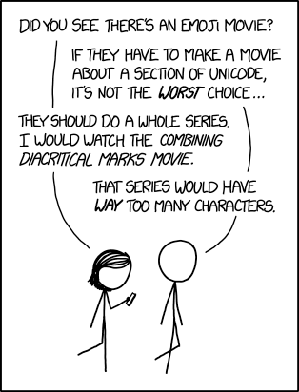

ASCII File Size Questions

In your jotter calculate how much storage space would be needed to store the following. Remember that every ASCII character is represented by 8 bits including spaces and punctuation.

1. Hello world!
2. My brain hurts.
3. How much wood would a woodchuck chuck if a woodchuck could chuck wood?



Convert ASCII to Text Activity

Use the ASCII chart on the following page to convert these ASCII values to text and record the message in your jotter.

078 101 118 101 114 032 103 111 110 110 097 032 103 105 118 101 032 121 111 117 032 117 112 013 078 101 118 101 114 032 103 111 110 110 097 032 108 101 116 032 121 111 117 032 100 111 119 110 013 078 101 118 101 114 032 103 111 110 110 097 032 114 117 110 032 097 114 111 117 110 100 032 097 110 100 032 100 101 115 101 114 116 032 121 111 117 013 078 101 118 101 114 032 103 111 110 110 097 032 109 097 107 101 032 121 111 117 032 099 114 121 013 078 101 118 101 114 032 103 111 110 110 097 032 115 097 121 032 103 111 111 100 098 121 101 013 078 101 118 101 114 032 103 111 110 110 097 032 116 101 108 108 032 097 032 108 105 101 032 097 110 100 032 104 117 114 116 032 121 111 117

|  |  |  |  |  |  |  |  |  |  |  |  |  |  |  |  |  |  |  |  |
| --- | --- | --- | --- | --- | --- | --- | --- | --- | --- | --- | --- | --- | --- | --- | --- | --- | --- | --- | --- |
| |  |  | | --- | --- | | **ASCII** | **Symbol** | | 0 1 2 3 4 5 6 7 8 9 10 11 12 13 14 15 | NUL SOH STX ETX EOT ENQ ACK BEL BS TAB LF VT FF CR – new line SO SI | | |  |  | | --- | --- | | **ASCII** | **Symbol** | | 16 17 18 19 20 21 22 23 24 25 26 27 28 29 30 31 | DLE DC1 DC2 DC3 DC4 NAK SYN ETB CAN EM SUB ESC FS GS RS US | | |  |  | | --- | --- | | **ASCII** | **Symbol** | | 32 33 34 35 36 37 38 39 40 41 42 43 44 45 46 47 | (space) ! " # $ % & ' ( ) * + , - . / | | |  |  | | --- | --- | | **ASCII** | **Symbol** | | 48 49 50 51 52 53 54 55 56 57 58 59 60 61 62 63 | 0 1 2 3 4 5 6 7 8 9 : ; < = > ? | |
| |  |  | | --- | --- | | **ASCII** | **Symbol** | | 64 65 66 67 68 69 70 71 72 73 74 75 76 77 78 79 | @ A B C D E F G H I J K L M N O | | |  |  | | --- | --- | | **ASCII** | **Symbol** | | 80 81 82 83 84 85 86 87 88 89 90 91 92 93 94 95 | P Q R S T U V W X Y Z [ \ ] ^ _ | | |  |  | | --- | --- | | **ASCII** | **Symbol** | | 96 97 98 99 100 101 102 103 104 105 106 107 108 109 110 111 | ` a b c d e f g h i j k l m n o | | |  |  | | --- | --- | | **ASCII** | **Symbol** | | 112 113 114 115 116 117 118 119 120 121 122 123 124 125 126 127 | p q r s t u v w x y z { | } ~  | |

Machine Code

Languages and Translation

A computer program is a set of instructions which tells the computer what to do.

Here are two programs :

Program 1 Program 2

PRINT "Welcome to my program " 10010010 11011011

PRINT "What is your name " 10011101 01011001

Which program is easier for you to understand? Which program does the computer execute?

High Level Language

Program 1 is an example of a high level language, like Visual Basic. The common features of all high level languages are:

* It uses English like words
* It has to be translated into machine code
* It can work on different types of computer systems with only minor changes.

Machine Code

Program 2 is an example of machine code. This is the language that the computer executes. The common features of machine code are:

* It is made up of 1s and 0s
* It is machine specific. A machine code program will only run on the type of computer it was created for, not others.

Translation

Computers can only understand binary. This means we need to change our High Level Language programs into a form the computer can understand.

The computer needs a program which can translate a high level language into its own language. This program is called a translator.



There are 2 different types of translator

• Interpreter

• Compiler

Interpreter

An interpreter translates the high level program one line at a time into machine code and executes this line of machine code immediately. Because you can't save the machine code, this translation must be carried out every time the program is run, therefore interpreted programs are slow.

Two advantages of an interpreter are:

* It reports errors at the end of each line so it is easier to correct your mistakes.
* It allows you to test your program before it is complete to see how it works.

Two disadvantages of an interpreter are:

* The machine code cannot be saved; the high level language program needs to be translated into machine code every time the program is run. This reduces the performance of the computer; it is especially bad during loops when the code has to be translated every time it loops.
* The interpreter needs to be loaded into the computer at the same time as the program. This means it will take up extra memory and processing power, reducing the performance of the computer system.

Compiler

A compiler translates the whole high level language program (source code) into machine code (object code) and saves the machine code version of the program. This machine code program can then be run in future without having to translate it again. This saves time.

Three advantages of a compiler are:

* Because the machine code file is saved, it never needs to be translated again.
* It takes less memory when executing the machine code program than an interpreter.
* It is much more efficient when translating loops as the code only needs to be translated once.

Two disadvantages of compilers are:

* Compiled programs cannot be easily edited
* Compiled programs only run on the type of system they were compiled for e.g. Android apps will not run on iOS

Programmers use both interpreters and compilers.

They use interpreters when they are developing the program because each error is reported at the end of each line so debugging mistakes is easier.

They use compilers once the program is finished so that they do not need to translate it again and it runs more efficiently.

Crossword

Complete the **Computer Systems 8 - Translators Crossword**

Quiz 8

Complete the Translators Quiz



Translator Questions

Answer the following questions in your jotter. Remember to answer in sentences.

1. Name the part of the processor that processes IF statetments
2. State what the letters ALU stand for.
3. Explain why the clock pulse is important in the control unit.
4. State 3 types of information that could be stored on a register.

Representing Graphics

### Image result for example vector graphicVector graphics

**Representing graphics using vector graphics**

A vector graphic is made up of **objects** each having a set of **attributes**

Examples of **objects:** rectangle, ellipse, line, polygon

Examples of **attributes:** co-ordinates (position), fill colour, line colour

e.g. a red rectangle. The *object* is a ‘rectangle, its *attribute* of fill colour has the value red

An example of a vector graphic package is Serif Drawplus

**Storage requirements of vector graphics**

In vector graphics the file size increases as the complexity of the graphic increases. The more objects that are added, the more data must be stored.



### Bitmapped graphics

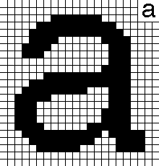

**Representing graphics using bitmaps**

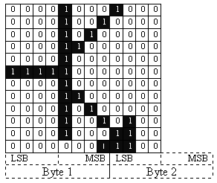Bitmap graphics are made up of pixels, each pixel is a dot on the screen.

Bitmaps are represented using a grid of pixels, each pixel is recorded using a binary number to say what colour it is.

For black and white images we just use a grid of 0s and 1s. The 0s are white pixels and the 1s are black pixels

**Storage requirements of a bitmapped graphic**

Adding more detail to a bitmap graphic does not change the file size, all you are doing is changing the colour of each pixel

As bit depth and resolution increases, the quality of the image will increase but the file size will too, meaning **increased storage requirements** and **slower transmission times**

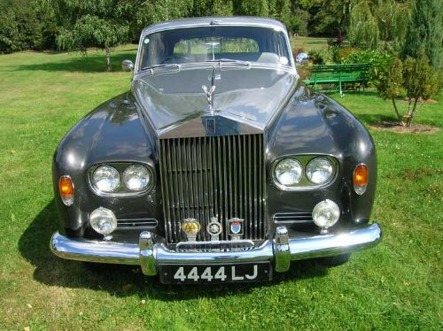

Comparison of bit mapped and vector graphics

**EDITING**: When two shapes overlap in a bit mapped package, the shape on top will “rub out” the shape underneath whereas, with a vector graphic, individual objects can be selected and layered

**EDITING at pixel level**: This is possible with a bit-mapped graphic

To edit an object in a vector graphics file, the object needs to be selected and then the values of its attributes are changed e.g. colour (attribute) red (value) might be changed to colour green

**FILE SIZE**: The file size of a bit mapped graphic stays the same regardless of the amount of detail in the graphic because each pixel is stored regardless of its colour, whereas a vector graphic file size increases as objects are added

The description of each object making up a vector graphic is called its “set of attributes”

**RESOLUTION INDEPENDENCE**: This is when the resolution of the graphic on the screen does not affect the resolution of the printed graphic. This is a characteristic of **vector** **graphics** files because **the processor sends the file of object attributes** that represent the graphic to the printer and the printer prints the graphic off using its own resolution settings

When a **bit map** is printed out, the resolution of the printout is the same as the resolution of the bit map on the screen regardless of the resolution of the printer. This is because **the processor sends the bit map** as it is to the printer and it is printed as it is

Vector and Bitmap Comparison Activity

To demonstrate the advantages of vector graphics we are going to compare basic shapes in two separate graphics packages. Drawing packages (like Serif Drawplus) create vector graphics, paint packages (like Serif Photoplus) create bitmap images.

Start Photoplus and Drawplus by going into your Start Menu, All Programs, Cross Curriculum, Serif Applications

In Photoplus start a new image, set the size to A4 portrait

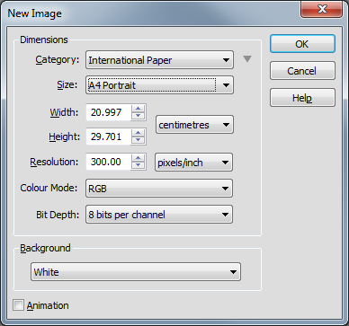

In Drawplus start a new image, set the size to A4 portrait

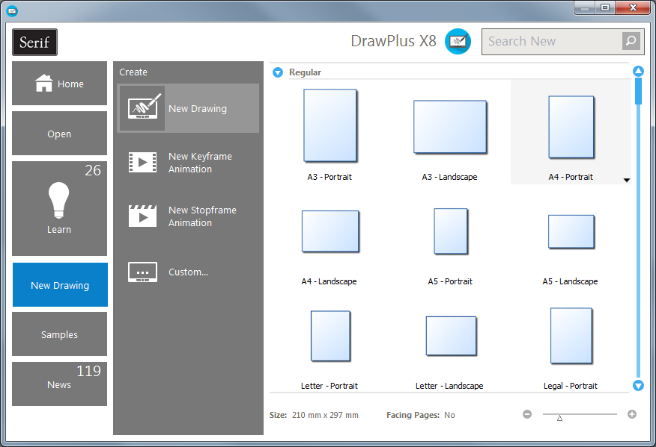

1. In Drawplus and Photoplus draw a large filled circle of any colour, try to fill as much of the space as possible.
2. Zoom in on the edge of the circle in each package.
3. Take a screenshot demonstrating the difference and record it on your record sheet.
4. Export your Photoplus image as a bitmap called Bitmap Example 1
5. Export your Drawplus image as a CAD/CAM file called Vector Example 1
6. Locate the files in your Pictures folder and record the file sizes on your record sheet.
7. In each package add a different coloured rectangle overlapping your circle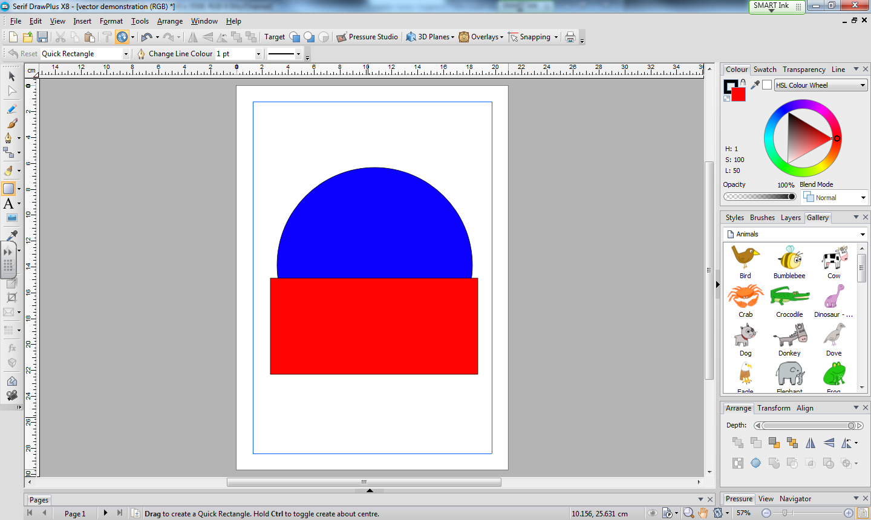
8. Export your Photoplus image as a bitmap called Bitmap Example 2
9. Export your Drawplus image as a CAD/CAM file called Vector Example 2
10. Locate the files in your Pictures folder and record the file sizes on your record sheet.
11. Close Photoplus then reopen it and load your Bitmap Example 2 bitmap.
12. In each package move the rectangle away from the circle and screen shot your results. Record your screenshots in your record sheet.
13. Print a copy of your record sheet for your folder.

Scalable Vector Graphics

One common implementation of vector graphics is Scalable Vector Graphics (SVG). These are embedded within webpages and it is expected that you will be able to write and explain different SVG shapes

The 4 shapes you will need to know are

* rectangle
* ellipse
* line
* polygon

and the attributes you will need to know are

* co-ordinates
* fill colour
* line colour

Co-ordinates

Shape

Fill colour

Line colour

<rect x="60" y="10" width="30" height="30" stroke="black" fill="yellow”/>

Fill colour

Line colour

Co-ordinates

Shape

<ellipse cx="75" cy="75" rx="20" ry="5" stroke="red" fill="transparent" />

Line colour

Co-ordinates

Shape

<line x1="10" x2="50" y1="110" y2="150" stroke="orange"/>

Fill colour

Line colour

Co-ordinates

Shape

<polygon points="60 110 65 120 70 115" stroke="orange" fill="blue" />

We will get more experience with SVG when we complete the Website Development topic.

Crossword

Complete the **Computer Systems 9 - Graphics Crossword**

Quiz 9

Complete the Graphics Quiz



Graphics Questions

Answer the following questions in your jotter. Remember to answer in sentences.

1. State which graphic type has the smaller file size.
2. Describe what would happen if you enlarged a bitmap graphic too much.
3. Write the SVG rule for a blue rectangle with a red outline.
4. Compare Vector and Bitmap graphics



Data Representation

Exam Questions

1. Describe how the contents of the variable total (188.50) would be stored in the computer’s memory.
2. Convert the decimal number 164 into the equivalent 8-bit binary number.
3. A program is tested but stops running after a few lines. An error is highlighted.

(i) Name the type of translator being used.

(ii) State one disadvantage of using this type of translator.

1. When all errors are removed, the completed program is translated. A section of the translated code is shown below.
2. Convert the decimal value 47 into the equivalent 8-bit binary number.
3. A temperature is displayed as 23·6 °C State how this number would be stored by a computer system.
4. While the program is being implemented, the programmer stops occasionally to run the program.

State the type of translator you would recommend the programmer uses in this situation. Explain your answer.

1. The shapes that are drawn by the program can be saved as vector graphics.

Describe how a square would be saved as a vector graphic.

1. Convert the value 25 into an 8-bit binary number. Show your working
2. A completed program is translated into binary using a compiler.

(i) State the name given to binary instructions.

(ii) State two reasons why a compiler is used to translate the completed program.

Security Precautions

Learning Intentions

* To understand and explain the need for security on a computer system
* To understand and explain the different methods we can use to secure computer systems and data.

The Need for Security

In September 2017 it was discovered that the Yahoo! Search engine and email system had been breached. Over 200 million account details had been stolen and put up for sale on the darkweb.

The data stolen includes (but isn't limited to):

* Usernames
* Names
* Email addresses
* Physical addresses
* Birth dates
* Account security questions and your answers to them
* Any other information you gave Yahoo in your profile on any of their sites
* Passwords, which were encrypted when stolen, but have been at least partially decrypted now

Using this information criminals could commit identity fraud by setting up fake bank and credit card accounts in their victims’ names. They could then run up thousands of pounds of debt in someone else’s name and keep the money for themselves.

**This could have been avoided by improving two pieces of basic computer security.**

Security precautions

### Firewalls

A firewall is a network security system designed to prevent unauthorized access to or from a private network. Firewalls can be implemented in both hardware and software, or a combination of both. Network firewalls are frequently used to prevent unauthorized Internet users from accessing private networks connected to the Internet. All messages entering or leaving the network pass through the firewall, which examines each message and blocks those that do not meet the specified security criteria.

### Encryption

Encryption is when data held on a computing system is put into a code. This means that if the data is hacked into, it is meaningless to the hacker unless they have the security key to unlock or decipher the encrypted data - only authorized parties who have the key can access it. Encryption does not prevent hacking or interception of data, but makes the data meaningless to anyone trying to steal it. In an encryption scheme, the intended information or message is encrypted using an encryption algorithm, generating information that can only be read if decrypted.

The most common form of encryption is https over the internet. Most browsers will let you know that you are using https. You should always make sure a websites URL starts with https before you enter any personal information.

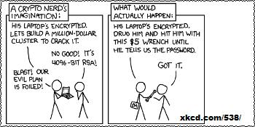

Crossword

Complete the **Computer Systems 10 - Security Crossword**

Quiz 10

Complete the Security Quiz



Security Questions

Answer the following questions in your jotter. Remember to answer in sentences.

1. Explain how encryption helps keep data secure.
2. Name a security threat that can be countered by a firewall.
3. Name the most common form of encryption on the Internet..
4. Explain why it is necessary to encrypt laptops containing sensitive information..

Environmental Impact

Learning Intentions

* To understand and explain the impact computer systems can have on the environment
* To understand and explain the different methods we can use to minimise the impact computer systems have on the environment.

Environmental impact

A computing-related carbon footprint measures the amount of greenhouse gases emitted by computer equipment during its

* **manufacture**
* **use**
* **disposal**

In particular, the use of computer equipment can require large amounts of energy

* *Problem:* Some energy sources: oil, gas and coal are non-renewable. This means that the use of them as energy sources is unsustainable. In the long run, the supplies will run out – and mining/drilling for such energy sources can harm the environment
* *Problem:* Energy production e.g. by a coal-fired power station, releases CO2 and other gases that contribute to global warming

If the user of a computer system is accessing the Internet, then the carbon footprint also involves the electricity usage (and therefore carbon emissions) of the companies that run the websites that the user views

We should try to reduce carbon emissions while we use computers by making equipment more efficient. Modern manufacturers of IT equipment are constantly looking for ways to reduce the energy consumption of devices.

Some solutions

Use low-power computing devices e.g. low–power-consumption processors, low-energy-rated LED monitors

Make the computing device more energy efficient by

1. adjusting the monitor settings (e.g. brightness, sleep)
2. power-down settings (e.g. set the hard drive to stop spinning after a period of time, set the Minimum Processor State which allows you to choose a percentage of power to allot to the processor when it is inactive or performing minimal tasks
3. Computers can also be left on standby when not in use to cut power consumption

Crossword

Complete the **Computer Systems 11 - Environmental Issues Crossword**

Quiz 11

Complete the Environmental Issues Quiz



Environmental Issues Questions

Answer the following questions in your jotter. Remember to answer in sentences.

1. Describe what is meant by a carbon footprint.
2. Describe two ways to reduce a computers energy use without changing its hardware.
3. Describe two hardware changes you can make to reduce a computers energy usage.

Legislation and the Environment

Exam Questions

1. Explain the purpose of a firewall.
2. Explain how encryption can help keep data safe
3. Describe how keylogging can be an online security risk.
4. A supermarket decides to replace its current computers.

Explain two ways the company should dispose of the “old” computer systems.

1. A bank employee has lost a laptop storing customers’ personal details.

Identify one security precaution the bank should have in place to prevent unauthorised access to this information.

1. When buying items online, encryption is used. Explain why customers should be reassured by this feature.
2. At the end of the questions, the user’s carbon footprint is calculated.

Explain what is meant by a carbon footprint.

1. The following e-mail is received by one of the instructors who is a registered customer of YourMoni Bank Plc.

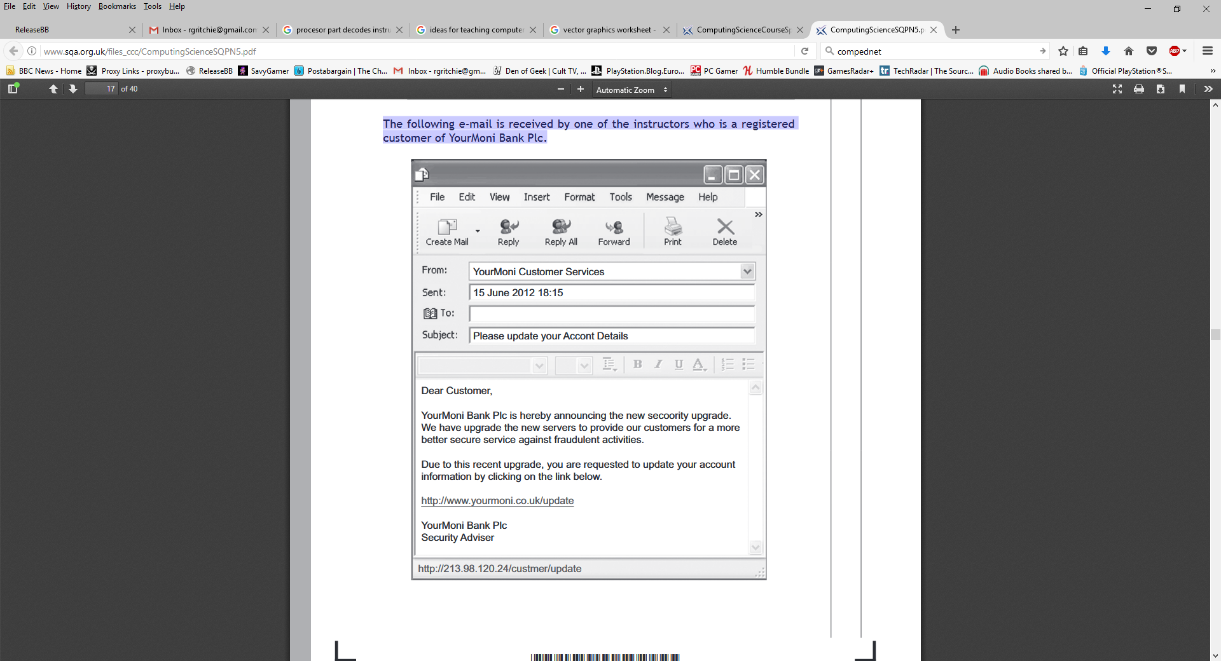

Explain why the instructor might suspect this is not a genuine e-mail from the bank. Your explanation should refer to two features of the email which could cause suspicion.