HIGHER Prelim Revision Questions
No | Question | Marks
1 | State the range of numbers that can be represented using 8 bit 2’s complement. | 1
-2^{n-1} 2^{n-1} -1
n=8
-2⁸⁻¹ 2⁸⁻¹ -1
-128 127
2 | Describe the Memory Data Register (MDR). | 1
 | The memory data register temporarily holds the data the processor is currently decoding/executing in binary form.
3 | State how the location of data in memory is stored in the processor. | 1
As binary.
Also accept: Holds the location of the data in the Memory Address Register (MAR)
4 | Describe the term CARDINALITY. | 1
 | Cardinality is a term used to describe the relationship between two entities.
5 | State 3 different cardinalities a database may have. | 3
 | One to one, one to many, many to many
6 | Show using an Entity Relationship diagram, one of these relationships. | 1
School
Pupils

7 | Write a line of CSS code which will display an image on the left hand side of some writing. | 1
 | .imageLeft { FLOAT: left }
8 | State two ways you could make space around some text or image using CSS. | 2
Padding
Margin
9 | Describe the difference between the scope of a local and global variable. | 2
The scope of a local variable is only within the sub-routine/function it has been declared in.
The scope of a global variable is it is available in all sub-routines/functions, across the entire program.
10 | Explain why it is important that we evaluate a program’s Fit for Purpose. | 1
 | We must evaluate a software’s fit for purpose as we must make sure the program does exactly what was asked for in the software specification.

11 | Line 1 IF exam_mark > 70 AND exam_mark < 100 THEN  Line 2 SEND “Grade = A” TO DISPLAY  Line 3 ELSE  Line 4 SEND “Sorry, You did not receive an A” TO DISPLAY  Line 5 END IF  State the output if the exam mark was 85. | 1
 | Grade = A
12 | Using the program from Q11, State the output if the exam mark was 100. | 1
 | Sorry, you did not receive an A
13 | Describe the debugging technique breakpoint. | 1
 | A breakpoint is used when the programmer/tester wants to pause the program at a set line. This will allow them to compare the expected values and the actual values of all variables.
14 | Create a table showing the advantages and disadvantages of bitmap vs vector graphics. | 4
 | Bitmap | Vector
Advantages | -able to edit graphic at pixel level  -Same file size no matter the complexity  -Produce realistic Images | -able to edit graphic at different layers without effecting other objects/layers  -Produce basic graphics
Disadvantages | -unable to edit graphic at different layers without effecting other objects/layers  -Tends to be large file size | - unable to edit graphic at pixel level  -Increase file size when you increase the complexity  -unable to produce realistic images

15 | Explain why it would be more suitable to use a vector graphic package for a simple company logo and a bitmap package for a photographer. | 2
A simple company logo would be made up of a few simple shapes with block colours so a vector package would be most suitable.
A photographer requires a lot of details for realistic images which would be best suited to a bitmap graphics package.
16 | Susan Jones has started a new job with a salary of £45,650 and has been automatically assigned an employee ID of 127. Write the correct SQL statement to add Ms Jones to the company’s Employee Details database. The fieldnames are EmployeeID, Title, Firstname, Surname and Salary. | 3
INSERT INTO employee_details
VALUES (127, Ms, Susan, Jones, 45650);
17 | Describe the 3 keys used in a database. | 3
Primary Key: Unique identifier to one record. Eg: Employee ID.
Foreign Key: Primary key from a different entity, used to link another table.
Compound Key: Two or more fields combine to create a primary key.

18 | Describe, with examples, the 7 pieces of information used to construct a Data Dictionary. | 7
 | Entity name, Entity Attribute, PK/FK, Unique, Data Type, Data size (in characters), Validation.
19 | True or False – a foreign key will be a unique value in an entity. | 1
 | False, a foreign key’s value may be used many times in the entity.
20 | Create an entity relationship diagram for the following database:  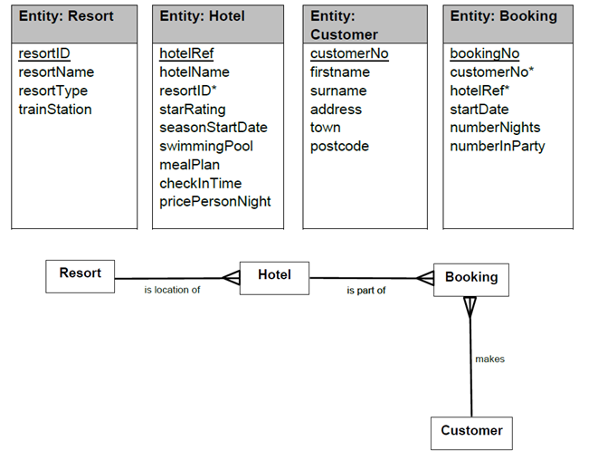 | 3
21 | Describe, using an example, what a calculated field is used for. | 2
 | A temporary field created by using 2 or more fields along with an arithmetic function to create new values. Eg: domestic_sales + Internal_sales = Total_sales.
22 | Using your answer from Q21, write a SQL query for that calculated field including an alias. | 2
 | SELECT (domestic_sales + Internal_sales) AS Total_sales FROM box_office

23 | Write the 5 standard algorithms in their simplest form using pseudo code. | 5
Find Min  SET min TO list[0]  FOR counter=1to endoflist DO  IF list(counter) < min THEN  SET min TO item(counter)  END IF  END FOR EACH  SEND max TO DISPLAY | Find Max  SET max TO list[0]  FOR counter=1to endoflist DO  IF list(counter) > max THEN  SET max TO item(counter)  END IF  END FOR EACH  SEND max TO DISPLAY
Linear Search  Receive target From Keyboard  FOR counter=1 to endoflist DO  IF list(counter) = target THEN  SET position TO counter  SEND position TO DISPLAY  END IF  END FOR EACH | Count Occurance  Receive target From Keyboard  FOR counter=1 to endoflist DO  IF list(counter) = target THEN  SET total to total + 1  END IF  END FOR EACH  SEND total TO DISPLAY
Input Validation
Receive number From Keyboard
Do while number < 0 or >100
SEND “Not in range” TO DISPLAY
Receive number From Keyboard
Loop

24 | Describe an Actual and Formal parameter. | 2
Actual = parameter being passed when the subroutine is being called. Eg: call calculate_total (number_1, number_2)
Formal = parameter being passed at the called subroutine. Eg: Private Subroutine calculate_total (byVal number_1, byVal number_2)
25 | Explain the error in this example of Actual and Formal Parameter passing.  Line 1. RECORD students IS {STRING name, INTEGER pass_mark}  …  Line 5. SET students(counter) TO (pass_mark[counter], name[counter]) | 2
 | The parameters order used in line 2 has been mixed up. It should be name(counter) then pass_mark(counter) as set in line 1. Otherwise it would try to put a name (which would be a string) into an integer data type which would cause a run-time/execution error.
26 | Using the program from Q25, identify one example of an actual and formal parameter. | 2
27 | Using the program from Q25, Describe what is happening in line 1. | 1
 | A record structure is set up with an array of names (data type = string) and an array of pass_marks (data type = integer).
28 | Using the program from Q25, Describe what is happening in line 5. | 1
 | The record structure called Students is set the values. Counter is used as there will be many values set in the record structure.

29 | Describe a trace table and explain how it can be used in helping you debug a program. | 2
 | A trace table allows the programmer to record the value of variables line by line. This is usually done on paper and not while the program has been implemented or run. You can then compare the expected results with actual results to find errors.
30 | 1.SET speed as [79, 45, 91, 56, 80]  2.FOR Counter 0 to 4  3. IF speed(counter) > 70 THEN  4. SET Total_speeding = Total_speeding + 1  5. END IF  6.NEXT  7. SEND Total_speeding message TO DISPLAY  Using the program above create a complete trace table, including every loop and 3 variables (speed, counter and total_speeding) | 4
Line | Speeds | Counter | Total_Speeding
1 | 79,45,91,56,80
2 |  | 0
3 | 79
4 |  |  | 1
2 |  | 1
3 | 45
4 |  |  | 1
2 |  | 2
3 | 91
4 |  |  | 2
2 |  | 3
3 | 56
4 |  |  | 2
2 |  | 4
3 | 80
4 |  |  | 3

31 | Name and describe the 2 design notations used in the design stage of the website development process. | 2
Wireframing: A basic layout design of what the webpage will look like. Where text, images, video or audio would go.
Low-Fidelity Prototyping: A sketch of what the webpage will look like including colour and exact text written. If video is used then a simple sketch will be shown in that area.
32 | Suggest how you could improve the navigation of your website. | 1
 | Navigation Bar, search feature, home icon/button, sitemap, breadcrumbs.
33 | ˂head˃˂style˃body{background-color: light-cyan}h1{ color: purple; margin-left: 40px}˂/style˃˂/head˃  Describe what the CSS statement above will look like. | 2
 | The main body of the webpage will have a background colour of light cyan. The large headings will have purple font and a 40pixel margin to it’s left.

34 | State with reason, if the above CSS statement is inline, internal or external. | 1
 | Internal, as the style statements are within the <head> tags.
35 | With reference to Q33, write a CSS statement that will position an image to the right of the heading. | 1
 | .ImageRight { float:right }
36 | H1{margin-right:10px;margin-left:10px}  P{ margin-right:10px;margin-left:10px}  .image{margin:5px}  Make the above CSS code more efficient. | 3
H1, p{margin-right:10px;margin-left:10px}
.image{margin:5px}
37 | State the programming language that allows you to give interactivity to a webpage? | 1
 | Javascript
38 | onClick is a function of interaction you can use on webpages. Name and describe 2 other functions. | 2
OnMouseOver: when the mouse cursor moves over the element a javascript function will be activated. Eg: mouse goes over image = Image enlarges.
OnMouseOut: when the mouse cursor moves off the element a javascript function will be activated. Eg: mouse moves off image = Image returns to original size.
39 | Name and describe 3 methods of validating HTML Form data. | 3
Presence check (using required), this makes sure data has been entered into the textbox.
Length check (eg: 11 characters long), this makes sure the data is a certain length, like a phone number or password.
Range check (eg: number must be between 1 and 10), this makes sure the data entered is in the correct range, like your age is between 0 and 150.
Restricted choice: this makes sure the data is limited to only what is listed. Eg: pizza toppings.
40 | Describe, with examples, compatibility and persona testing. | 2
Persona testing is when the tester portrays a customer eg: elderly user.
Compatibility testing is when you test your program/website on different computer systems, with different hardware and software setups. Eg: test on ipad or a desktop PC running windows.

