HIGHER Prelim Revision Questions
No | Question | Marks
1 | State the range of numbers that can be represented using 8 bit 2’s complement. | 1
2 | Describe the Memory Data Register (MDR). | 1
3 | State how the location of data in memory is stored in the processor. | 1
4 | Describe the term CARDINALITY. | 1
5 | State 3 different cardinalities a database may have. | 3
6 | Show using an Entity Relationship diagram, one of these relationships. | 1
7 | Write a line of CSS code which will display an image on the left hand side of some writing. | 1
8 | State two ways you could make space around some text or image using CSS. | 2
9 | Describe the difference between the scope of a local and global variable. | 2
10 | Explain why it is important that we evaluate a program’s Fit for Purpose. | 1
11 | Line 1 IF exam_mark > 70 AND exam_mark < 100 THEN  Line 2 SEND “Grade = A” TO DISPLAY  Line 3 ELSE  Line 4 SEND “Sorry, You did not receive an A” TO DISPLAY  Line 5 END IF  State the output if the exam mark was 85. | 1
12 | Using the program from Q11, State the output if the exam mark was 100. | 1
13 | Describe the debugging technique breakpoint. | 1
14 | Create a table showing the advantages and disadvantages of bitmap vs vector graphics. | 4
15 | Explain why it would be more suitable to use a vector graphic package for a simple company logo and a bitmap package for a photographer. | 2
16 | Susan Jones has started a new job with a salary of £45,650 and has been automatically assigned an employee ID of 127. Write the correct SQL statement to add Ms Jones to the company’s Employee Details database. The fieldnames are EmployeeID, Title, Firstname, Surname and Salary. | 3
17 | Describe the 3 keys used in a database. | 3
18 | Describe, with examples, the 7 pieces of information used to construct a Data Dictionary. | 7
19 | True or False – a foreign key will be a unique value in an entity. | 1
20 | Create an entity relationship diagram for the following database:  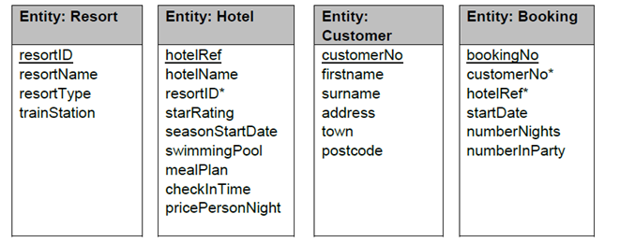 | 3

21 | Describe, using an example, what a calculated field is used for. | 2
22 | Using your answer from Q21, write a SQL query for that calculated field including an alias. | 2
23 | Write the 5 standard algorithms in their simplest form using pseudo code. | 5
24 | Describe an Actual and Formal parameter. | 2
25 | Explain the error in this example of Actual and Formal Parameter passing.  Line 1. RECORD students IS {STRING name, INTEGER pass_mark}  …  Line 5. SET students(counter) TO (pass_mark[counter], name[counter]) | 2
26 | Using the program from Q25, identify one example of an actual and formal parameter. | 2
27 | Using the program from Q25, Describe what is happening in line 1. | 1
28 | Using the program from Q25, Describe what is happening in line 5. | 1
29 | Describe a trace table and explain how it can be used in helping you debug a program. | 2
30 | 1.SET speed as [79, 45, 91, 56, 80]  2.FOR Counter 0 to 4  3. IF speed(counter) > 70 THEN  4. SET Total_speeding = Total_speeding + 1  5. END IF  6.NEXT  7. SEND Total_speeding message TO DISPLAY  Using the program above create a complete trace table, including every loop and 3 variables (speed, counter and total_speeding) | 4
31 | Name and describe the 2 design notations used in the design stage of the website development process. | 2
32 | Suggest how you could improve the navigation of your website. | 1
33 | ˂head˃˂style˃body{background-color: light-cyan}h1{ color: purple; margin-left: 40px}˂/style˃˂/head˃  Describe what the CSS statement above will look like. | 2
34 | State with reason, if the above CSS statement is inline, internal or external. | 1
35 | With reference to Q33, write a CSS statement that will position an image to the right of the heading. | 1
36 | H1{margin-right:10px;margin-left:10px}  P{ margin-right:10px;margin-left:10px}  .image{margin:5px}  Make the above CSS code more efficient. | 3
37 | State the programming language that allows you to give interactivity to a webpage? | 1
38 | onClick is a function of interaction you can use on webpages. Name and describe 2 other functions. | 2
39 | Name and describe 3 methods of validating HTML Form data. | 3
40 | Describe, with examples, compatibility and persona testing. | 2

