Bannerman High School Physics Department
N5 Electricity and Energy
Unit Test Revision
“Accurate statements about Physics”

Name_________________________

Date _________________________

Class_________________________

Conservation of energy
- A power station is used to convert energy to supply to the national grid
State the main energy transformation which takes place in a
Wind Farm

Coal Fired Power Station

A Hydro electric power station

In practice for each megajoule of energy available from the source only a small fraction of the energy is available to the consumer.
Explain why some of the energy is not available to the consumer

Which relationship would allow the efficiency a machine to be calculated

- A survival expert is able to start a fire by rubbing two sticks together. What is the name of the force doing work in this process.

- A mountaineer climbing Ben Nevis does work against the force of gravity to give herself 715kJ of potential energy at the summit. She has to eat 4000kJ of energy in her food to fuel this journey.
In what other way , apart from the gain of potential energy is she using the energy from her food.

- A transformer is used to step up the voltage from a power station for transmission through the national grid. The transformer is found to be only 80% efficient.
How might energy be lost in the transformer

- Two kettles , A and B, with the same power rating are used to boil 1kg of water starting from 14°C. Kettle A takes 2 minutes and B takes 3 minutes. How could you account for this difference in the efficiency of the kettles.

Electric Fields and Charge Carriers
- An atom contains a nucleus and electron shells held together by electric forces in the same way a solar system might be held together by gravity.
Are the charges in the nucleus the same polarity as the electrons or of opposite polarity?

Complete the sentences about the structure of the atom.
An atom consists of a heavy central __________ which contains neutrons (with no charge) and protons (with _________ charge). Around the nucleus are shells of orbiting ________ (which have a ____________ charge)

Complete the diagram to show the electric field lines between two oppositely charged metal plates

+ -
+ -
+ -
+ -

If an electron was fired into the space between the plates in which direction would it move towards the positively or negatively charge plate

The electron will move towards the ___________________________ charged plate.

- Rechargeable batteries are often described in terms of the charge they can store measured in “milliamperes hours” , for example a battery of 1000 milliampere hours could supply a current of 1mA for 1000 hours or 2mA for 500 hours.
State the relationship between charge, current and time

What is meant by a current of 2mA

Potential Difference
- A lithium ion battery and a Nickel Cadmium battery both store 3200mAhours of charge. The lithium ion battery provides a potential difference of 4.2V and the Nickel Cadmium battery provides a potential difference of 1.6V. Which battery stores the greatest amount of energy?

- Which commonly used word means the same as “potential difference”

- What is meant by a potential difference of 6V

Ohm’s Law
- State the relationship between resistance , current and potential difference

- The following circuit was used to collect the results of an experiment into the current flowing through an unknown resistor at different potential differences.

Label the diagram to show appropriate measuring devices

How does the voltage across the variable resistor compare to the reading on the voltmeter when its resistance is equal to that of the unknown resistor?

What happens to the current flowing in the circuit when the resistance of the variable resistor is reduced

- The following graphs were obtained in experiments to determine the resistance of unknown resistors. One of them was a 10 ohm resistor and the other a 15 ohm resistor.
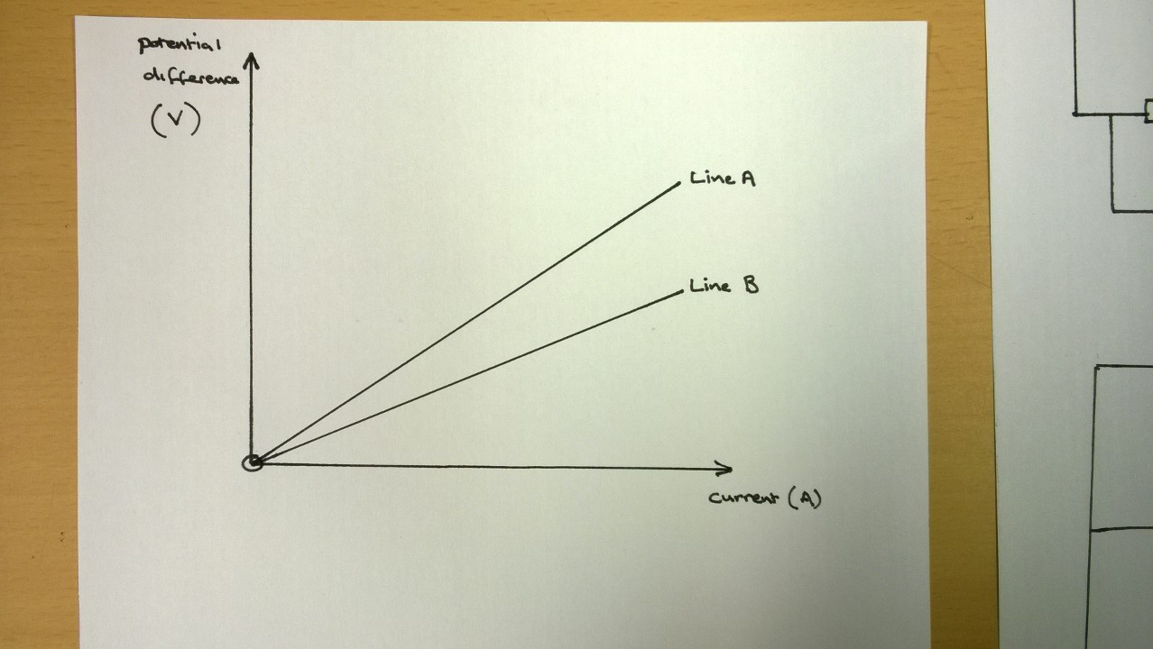

Which line on the graph represents the results for the 10 ohm resistor?

Electrical Power
- A convection heater has two settings 1000W or 2000W.
What is meant by a power rating of 2000W

The convection heater uses the current flowing in a resistance wire to change electrical energy into heat. What is the relationship which links the power rating of an appliance, the current flowing and its resistance.

The convection heater operates at the mains voltage of 230V. At which of its settings does it draw the most current from the supply?

Does the mains supply provide ac or dc current?

A householder uses the convection heater at its lowest setting for 30 minutes which costs him 6p. How long could he operate the heater at its highest setting for the same cost?

- A car has several options for lighting the road ahead and making itself visible to other road users These include a 40W light and a 12W light.

Which if these lights uses the most energy during a 10 minute journey?

Which of the lights would be brightest to an observer approaching in another car

The following diagram shows a simple car lighting circuit

Explain why the lights in a car must be connected in a parallel circuit.

In which of the bulbs is the highest current flowing

Specific Heat Capacity

- Water has a specific heat capacity of 4180 Jkg⁻¹°C⁻¹. What does this mean?

- Explain the difference between heat and temperature

- An experiment is conducted using a “calorimeter” which measure the heat energy supplied to a block of metal and which prevents heat escaping from the block during the experiment.
During one experiment a block of copper is heated and its temperature changes by 25°C. In another experiment a block of unknown metal of the same mass is heated using the same amount of energy and its temperature rises by 20°C.
Is the specific heat capacity of the unknown metal, greater than, equal to or smaller than the specific heat capacity of copper?

- A storage heater contains a 20kg block of ceramic material with a very high specific heat capacity This is heated over a long period to a temperature of 50°C before releasing energy as it gradually cools down. An engineer wants to increase the amount of energy the heater can store. Which 3 changes could she make to the design to achieve this.

  - Increase the mass of the ceramic material
  - Decrease the mass of the ceramic material
  - Use a material with higher specific heat capacity
  - Use a material with lower specific heat capacity
  - Increase the final temperature of the material
  - Insulate the heater

Pressure and Kinetic Theory
- Atmospheric pressure is 101000Pa. What is meant by a pressure of 101000Pa.

- Suggest a unit which is equivalent to 1Pa

- State the relationship which links the pressure volume and temperature of an ideal gas.

- When performing calculations using Gas Laws it is important that the Kelvin Temperature scale is use
What name is often given to 0K

- What is unusual about the motion of particles in an ideal gas at temperature of 0K

- What is the equivalent of 27°C in the Kelvin temperature scale

- A student predicts that the pressure of a sealed container containing 25ml of gas will double if he increases the temperature from 20°C to 40°C. Is this prediction correct or incorrect? Explain your answer .

- During braking the brake discs of a car become very hot and heat the wheel rims and tyres of the car raising their temperature. What would happen to the volume of the gas inside the tyre (assuming that the atmospheric pressure does not change)?

- Explain, using the kinetic theory of gases, why raising the temperature of a fixed volume of gas increases the pressure of the gas.

