Amur leopard
Due to extensive habitat loss and conflict with humans, the situation concerning the Amur leopard is critical. However, the fact that its more eminent cousin – the Amur tiger – recovered from a precarious state of fewer than 40 individuals some 60-70 years ago gives conservationists hope. It is believed that the Amur leopard can be saved from extinction if the present conservation initiatives are implemented, enhanced and sustained.

Key Facts
- common name
Amur leopard, Far East leopard, Manchurian leopard, Korean leopard; Léopard d'Amur (Fr); (Sp)
- scientific name
Panthera pardus orientalis
- status
IUCN: Critically Endangered C2a(ii)
- population
About 7-12 in China and 20-25 in Russia

The cat that stalks alone: An endangered solitary hunter
The leopard is rarely found in cold or high-elevation environments and is best known in its more familiar home in the savannas of Africa, where populations are relatively stable.
However, in the northernmost part of its range, a rare subspecies of this cat lives in the temperate forests and harsh winters of the Russian Far East. This is the Amur leopard (Panthera pardus orientalis). It is also known as the Far East leopard, the Manchurian leopard or the Korean leopard.
IUCN's 2000 Red List of Threatened Species classifies the subspecies as Critically Endangered, and the CITES has listed it on Appendix I.
Physical Description
The Amur leopard has some very distinguishing features. The hairs of its summer pelt are 2.5 cm long but in winter they are replaced by 7 cm long ones.
Apart from its long winter coat, which is a light colour in the winter, and more reddish-yellow in the summer, the Amur leopard is easily told apart from other leopard subspecies by its widely spaced rosettes with thick borders. It also has longer legs, probably an adaptation for walking through snow.
Adult males weight around 32-48 kg, and exceptionally large males weigh up to 75 kg. Females typically weigh 25-43 kg.
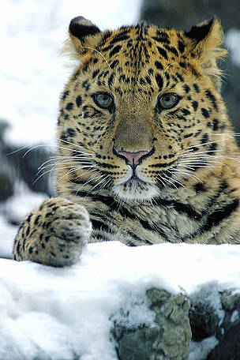
Amur Leopard, located in the Russian Far East. As of mid-2008, only 35 remain in existence.
© WWF / V. Solkin

Priority species
The Amur leopard is a WWF priority species. WWF treats priority species as one of the most ecologically, economically and/or culturally important species on our planet. And so we are working to ensure such species can live and thrive in their natural habitats.

What is the habitat and ecology of the Amur leopard?
The Amur leopard is found in temperate forest habitat, which experience a wide range of variability in temperature and precipitation. It is known to adapt to almost any habitat that provides it with sufficient food and cover.
Social Structure
The Amur leopard is habitually nocturnal and solitary. Nimble-footed and strong, it carries and hides unfinished kills so that they are not taken by other predators. However, it has been reported that some males stay with females after mating, and may even help with rearing the young. Several males sometimes follow and fight over a female.
Life Cycle
The Amur leopard attains sexual maturity at three years, is known to live for 10-15 years, and in captivity up to 20 years.
Breeding
The species breeds in spring and early summer. The litter size ranges from 1 to 4 cubs. The cubs are weaned when they are three months old, and leave their mother when they are one-and-a-half to two years old.
What do they eat?
The main prey species are roe deer and sika deers, small wild boars, along with hares, badgers and raccoon dogs.
- Major habitat type
- Temperate Broadleaf and Mixed Forests
- Biogeographic realm
Palearctic
- Range States
Russia, China, probably North Korea
- Geographical Location
South of the Far East-Primorskii Province (Russian Far East), Jilin, Heilongjiang Provinces (Northern China).
- Ecological Region
Russian Far East Temperate Forests

What is the distribution of the Amur leopard?
Previous population and distribution
The distribution of the Amur leopard has been reduced to a fraction of its original range. It once extended throughout northeastern ("Manchurian") China, including Jilin and Heilongjiang Provinces, and throughout the Korean Peninsula. The species range in Russia was dramatically reduced during the seventies, losing about 80% of its former range.
Current population and distribution
Today, the Amur leopard inhabits about 5,000 km². The last remaining viable wild population, estimated 20-25 individuals, is found in a small area in the Russian Province of Primorsky Krai, between Vladivostok and the Chinese border.
In adjacent China, 7-12 scattered individuals are estimated to remain. In South Korea, the last record of an Amur leopard dates back to 1969, when a leopard was captured on the slopes of Odo Mountain, in South Kyongsang Province.

Priority region
The Amur leopard's habitat is part of the Amur-Heilong region, which is a WWF global priority region.
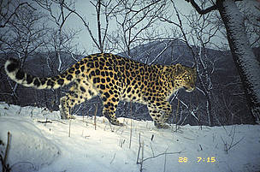
This female amur leopard (Panthera pardus orientalis) was photographed using a camera trap. She had recently had kittens as indicated by the small tracks in the snow in her range.
© WWF-Russia / ISUNR

What are the main threats to the Amur leopard?
Habitat loss and fragmentation
It is estimated that between 1970-1983, the Amur leopard lost an astonishing 80% of its former territory. Indiscriminate logging, forest fires and land conversion for farming are the main causes.
Still all is not lost. Even now large tracts of forest, which are ideal leopard habitat exist. If these areas can be protected from unsustainable logging, rampant forest fires and poaching of wildlife, the chance exists to increase the population of the subspecies in the wild.
Prey scarcity
There are still large tracts of suitable habitat left in China, but the prey base in these forests is insufficient to sustain populations of leopards and tigers. Prey populations will recover if the use of the forests by the local population is regulated and if measures are taken to limit the poaching of ungulates. For the Amur leopard to survive for the long term, it needs to repopulate its former range. But for that to happen, prey populations need to recover first.
Poaching and illegal trade
The Amur leopard is poached largely for its beautiful, spotted fur. In 1999, an undercover investigation team recovered a female and a male Amur leopard skin, which were being sold for US$ 500 and US$ 1,000 respectively, in the village of Barabash, not far from the Kedrovaya Pad reserve. This suggests that there is a market for such products within the locality itself.
Agriculture and villages surround the forests where the leopards live. As a result the forests are relatively accessible, making poaching a bigger problem than elsewhere. Not only for the leopards themselves, but also for important prey species, such as roe deer, sika deer and hare, which are hunted by the villagers both for food and hard cash.
Conflict with humans
Amur leopards are particularly vulnerable because of their preference for deer, a natural predatory preference but dangerous in the Russian Far East due to direct human involvement: farmers in the Russian Far East raise deer for human consumption, and to produce antlers for the Asian medicine market.
In absence of wild prey, the leopards often venture into the deer farms in search for food. Owners of these farms are quick to protect their investment by eliminating leopards attacking their stock. Presently, the leopard's most immediate threat comes from such retaliatory or preventive killing.
Vulnerable population size and inbreeding
Additionally, the Amur leopard is threatened by the extremely small wild population size, which makes them vulnerable to "catastrophes" such as fire or disease, to chance variation in birth and death rates and sex ratios (e.g., all cubs born for two years might be male), and to inbreeding depression.
Father-daughter and sibling matings have been observed and it is possible that this may lead to genetic problems including reduced fertility. Such matings do of course occur naturally to a certain extent in large cat populations, but in a very small population there is no possibility of subsequent outbreeding. Studies have shown that the number of cubs per adult female fell to 1 in 1991 from 1.9 in 1973.
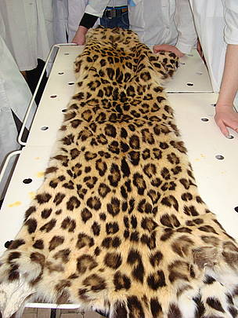
Police investiged the killing of an Amur Leopard after officers discovered the skin of an adult leopard in a private car. Read article
© WWF-Russia / S. Aramilev

Amur leopards on video

What is WWF doing?
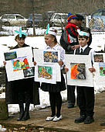
An educational activity at WWF's Leopard Visitor Centre in the Khasansky District of south-east Russia.
© ALTA
In 1998, the Russian government adopted a strategy for the conservation of the Amur leopard. WWF is supporting anti-poaching activities in the Barsovy wildlife refuge, as well within the whole leopard habitat in the Russian Far East.
WWF implements programmes to stop the traffic in Amur leopard parts and to increase the population of prey ungulate (hoofed) species in the leopard's habitat. WWF staff continue to monitor the Amur leopard population and its habitat.
In 2007, WWF and other conservationists successfully lobbied the Russian government to reroute a planned oil pipeline that would have endangered the leopard's habitat.
WWF projects that support this work include:
- Forest Conservation Programme in the Russian Far East Ecoregion Complex

http://www.altaconservation.org/assets/alta/pdf/documents_for_website/WCS_Report_%20Monitoring_Amur_Leopards_and%20_Tigers_in_the_Russian_%20Far_%20East_March_2012.pdf

Population Monitoring
Home > Home > Conservation Activities > Population Monitoring

Camera-trapping and snow track counts

How do you know how many Amur leopards there are in the wild?
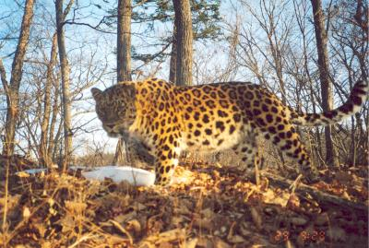A critical component of Amur leopard conservation is monitoring of the population, which allows us to better understand population numbers and trends. Only through intensive monitoring can we determine whether our conservation actions are having a positive impact.
ALTA partner WCS has been engaged in monitoring the Amur leopard population since 1997, using two approaches – a traditional Russian methodology based on tracks in the snow, and more recently, more precise estimates using camera traps.

Tracking leopards
Historically Amur leopards and other wildlife in Russia have been surveyed in winter by counting tracks in the snow along an extensive series of designated routes. The track data are used to estimate relative abundance (tracks/km) and, with standardised approaches, population size. The first “snow-track leopard counts” were conducted in the 1970s by Dimitri Pikunov and Vladimir Abramov, and Pikunov and others have continued these counts to the present. These counts provide important information on the distribution and status of the entire Amur leopard population in Russia. Currently we attempt to repeat snow track counts every 3 years. The results of the most recent count in February-March 2007, financed by WWF-Russia and WCS, resulted in an estimated population of 27 to 32 leopards in SW Russia.

Snapping leopards
These traditional snow counts, while extremely useful, do not give precise information on densities of leopards, and cannot provide us other pieces of information vital to assessing viability of this subspecies, such as survival and recruitment rates. To obtain these data, we conduct camera-trap surveys. Camera trapping allows us to identify individual leopards by their unique spot patterns, and therefore we are able to monitor individual animals over many years. For instance, one leopard, captured in 1996 as part of a telemetry study, showed up in our camera traps in 2002 and 2003, but then disappeared. Because we know that this leopard was an adult when first captured in 1996, we were able to determine that he lived a minimum of 10 years. Before WCS began camera-trapping in 2002, camera traps had never before been used for population monitoring in Russia. The method turned out to be very effective, and more than 300 photos of leopards have been taken since our first efforts in 2002.
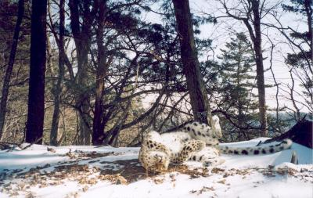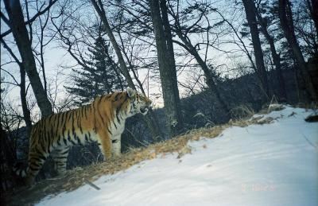
Find out more about our Amur tiger camera trapping in Lazo

Putting the information together
Camera-trap data provide statistically rigorous estimates of population density and trends over time. Long-term data will also provide insight into turnover and mortality rates. Camera-trap monitoring results are maintained in a GIS (Geographic Information System) database that facilitates other analyses, such as determining correlations between leopard and ungulate densities, habitat types, land use, forest fires, proximity of settlements and roads, etc.
Camera-trap results between 2002 and 2011 as well as recent snow-track counts (2000, 2003, 2007) indicated a small but stable population of around 30 individuals in SW Primorye in Russia. A few individuals (probably no more than 5 leopards) live across the border in China. Cameras are placed along trails likely to be used by leopards (two cameras on eitehr side of trail at each sampling point) and as the pattern of rosettes is unique to each leopard, individual animals can be identified and counted.
The number of leopard photographs and the minimum number of leopards in the study area since 2002 can be seen in the table below:
YEAR | # Leopard Photos | Minimum # of Leopards
2002-2003 | 65 | 9
2004 | 69 | 13
2005 | 113 | 14
2006 | 63 | 9
2007 | 65 | 14
2008 | 56 | 8
2009 | 106 | 9
2010 | 63 | 12
2011 | 156 | 17
The overall trend in leopard numbers is positive with 17 being seen in 2011 but the fluctuations over the years show there is sadly no steady upward trend in the study area. WCS used new camera in 2011 which are able to take picture in quick succession and they photographed two leopard cubs in camera traps for the first time ever. This means 15 adults were counted and it is likely that a lot of the leopards are transients and are unlikely to be present in 2012. It seems only a few leopards are permanent residents of the area who appear regularly in the monitoring.
Overall though the monitoring does indicate that there is robust reproduction and animals are dispersing in search of suitable habitat. Concerted efforts are therefore needed to ensure habitat improvement to increase prey base is a priority in both the Russia and China.

Snapping Amur tigers
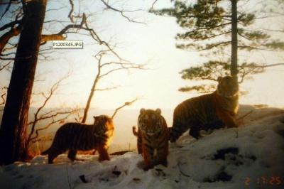
Amur tiger numbers are also monitored and their numbers appear to be more stable with 3-4 adult tigers in the study area in all years except 2010 when two new females arrived. In 2011 the camera traps twice captured a litter of three cubs bringing the total number to 7 tigers. As with the leopards, the presence of cubs and transients indicates reproduction is good and this particular population appears to be sustaining itself.
http://en.ria.ru/russia/20130315/180047044/Amur-Leopard-Population-in-Russia-Up-50--WWF.html

MOSCOW, March 15 (RIA Novosti) – The population of the Amur leopard has grown by half since 2007 and the cats have expanded their habitat as far as North Korea, the World Wide Fund for Nature (WWF) said on Friday.
But at an estimated 48 to 50 animals in Russia, including four to five cubs, it remains critically endangered and the least populous of all leopard subspecies, the fund said in a press release.
Environmentalists were unable to take a census of the big cats for several years, because the population is counted by their paw prints in the snow – and no lasting snow was seen since 2011 in their habitat, an area 5,000 square kilometers (some 3,100 square miles) wide in Russia’s far eastern Primorye Region.
The previous census in 2007 put the number of Amur leopards at between 27 and 34 – which, many experts said at the time, is not enough to ensure continued reproduction of the subspecies.
But a conservation drive spearheaded by the WWF and supported by the Kremlin improved the situation. Now the Amur leopard is expanding its range to territories both north and south of its current habitat, reaching the Russian-North Korean border in Primorye’s south, where no big cats were seen since last century, the fund said.
Even the leopards’ appearance is diversifying: A photo distributed by the WWF showed an Amur leopard with white paws – a rarity among the yellow-and-black cats. “The White-Gloved Leopard,” as the creature was identified by the fund, encroached on the territory of the 18-year-old cat nicknamed Fat Guy, whose current whereabouts are unknown.
The total number of Amur leopards may be even higher than 50, because between five and 11 cats also supposedly live in northern China, where no census was held.
Environmentalists hope to increase the population to 70 to 100 cats, which would ensure its stability, the head of WWF’s Amur branch, Yury Darman, was quoted in the press release as saying. At its current size, the population of the Amur leopard can be wiped out by an epidemic.
But whether the WWF can reach its goals remains open to question, given that the cats’ food supply is depleting due to mismanagement of deer parks in the area, the report said.
Moreover, the number of Amur tigers sharing the territory with the leopard has doubled to 23 animals since 2008, the WWF said. Tigers compete with the leopard for food and are not above killing a smaller cat in a standoff over a deer or boar corpse.

http://en.ria.ru/analysis/20120918/176033761.html
Amur Leopard: The Cat That Should Have Died
It all began when then-Russian Deputy Prime Minister Sergei Ivanov saw a movie about leopards.
“We’d be nowhere without him,” said Yury Darman of World Wildlife Fund Russia, who spent a decade trying to save the Amur leopard, the rarest of leopard subspecies.
“It’s really about Ivanov, not the leopard,” Darman said. “The leopard was here forever, but then Ivanov came along.”
The educational film, Save Each of the Survivors!, which Ivanov saw in 2010, prompted the man once tipped to be President Vladimir Putin’s successor to lobby for the creation of the world’s only nature reserve for the near-extinct big cat.
Now the leopards, which reside in a less than ideal location for an endangered species to live in, have a shot at surviving, ecologists say.
But they still face plenty of dangers, including wildfires, hungry tigers, a shrinking gene pool and marines with hunting rifles.
Also threatening their survival are things that big cats usually do not have to deal with, like rural poverty, the state of Russian exports and even the shortcomings of the country’s youth policy.

© RIA Novosti. Alexey Eremenko
Yury Darman, the head of WWF Russia’s far eastern branch
At least there were 13 leopard cubs born last year, up from zero in 2001, Darman said.
The Last of the Leopards
“In theory, the Amur leopard should have died out a decade ago,” said Sergei Khokhryakov, deputy director of the Land of the Leopard national park which is home to the last 40 to 50 Amur leopards. “There is some factor we underestimate or don’t understand about it.”
The far eastern leopard, one of nine subspecies of Panthera pardus across the globe, once ranged as far as Beijing in the west and the coast of the Sea of Japan in the east, as well as throughout the Korean peninsula.
Now all it has left is an area some 5,000 square kilometers wide, mostly in Russia’s Primorye region – a tiny blotch on the world map.
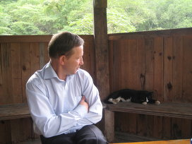
© RIA Novosti. Alexey Eremenko
Sergei Khokhryakov facing Harlequin, the pet of the Land of the Leopard’s office. Bigger cats are harder to spot.
The Amur leopard was placed on a protected species list as early as 1956, but the ban was hard to enforce. Border guard officers wanting to transfer from the Far East to some less remote place were rumored to be charged two leopard skins by their superiors, environmentalists say.
By the early 2000’s, only some 30 leopards remained in the wild, including only five fertile females. Some 200 Amur leopards live in captivity, but most are descendants of only two males, which increases the risks of inbreeding and its inherent health problems.
“When I first came here, I didn’t want to work on the leopard at all,” Darman said. “I thought it was a lost cause.”
Khokhryakov said he felt the same, but then national pride kicked in. “How come we can send stuff to Mars but not save a species at home?” he asked.
Bad Neighborhood
The Khasan district, the last refuge of the Amur leopard, is not really a good place for a far-ranging reclusive cat thriving on roe deer and the occasional dog.
A closed military zone in Soviet times, the district saw its economy virtually ruined when the army pulled out after the USSR’s perestroika reforms, leaving kilometers of empty barracks.
Left unemployed, many locals turned to poaching just to feed their families. Professional poachers also emerged, butchering salmon for caviar, boiling frogs for fat, a precious commodity in China, and inflicting other damage on local food chains that are topped by leopards and tigers.
Some poachers specifically targeted leopards, though they are now “over and done with,” Darman said with a scowl.
The locals also use fire as a primary means of clearing stubble in fields, not bothering too much if it spreads to the forest afterwards, threatening the cats’ habitat.
Even the Ivanov-backed nature reserve burned unhindered for days this spring, said WWF employee Andrei Fereferov.
He saved the day back then by raising a media fuss, which prompted the regional authorities to dispatch enough people and equipment to swiftly put out the fire. That was despite earlier claims that they had no resources for the job.
In some places, the local economy actually thrived: a railway and a federal highway pass through the area, serving both a stream of tourists heading for the beaches in the district's south and an inflow of goods to local ports.
At its peak, the traffic is 11 cars per minute, which makes it almost impossible for animals to safely cross the road. Even a tigress died under the wheels three years ago, and though no leopards have been hit, a lot of their prey is becoming roadkill, diminishing the food base.
Construction of a gas pipeline to China across the district is also underway. And that's not to mention the three firing ranges and the legal hunting grounds that the military, including the marines of the Pacific Fleet, has kept here and puts to active use.
“The fleet petitioned to not include the hunting grounds in the reserve because it's needed for the 5,000 sailors and their wives and children,” said Svetlana Titova, who oversees protected areas at WWF Russia’s far eastern branch.
“They claimed that otherwise the combat efficiency of the Pacific Fleet will be compromised,” she said.
Another threat is the Amur tiger, also an endangered species, which is not above killing or maiming a leopard in a territorial dispute.
“The job would have been a thousand times easier had the leopard been anywhere else in the region,” said Khokhryakov, who himself previously worked to save the Amur tiger in the Lazovsky nature reserve elsewhere in Primorye.
Cat Man to the Rescue
The original nature reserve in the area, Kedrovaya Pad, spanned a mere 18,000 hectares and had a budget of just 7 million rubles ($230,000).
Environmentalists have spent years campaigning to have it expanded. “I've made enemies of everyone in these parts,” said Darman, himself a graduate of a college in Irkutsk in eastern Siberia.
Indeed, the local press is full of stories vehemently attacking the leopard backers, who are accused of seeking to obtain land for personal gain, and squeezing out longtime residents – a claim they indignantly dismiss.
Only the interference of Ivanov, now the chief of Kremlin staff, made it possible to overrule the resistance of local authorities and communities and set up a national park spanning 262,000 hectares.
“Putin's protecting tigers, so Ivanov showed subordination and picked a smaller animal!” an environmental activist quipped, referring to President Vladimir Putin's much-publicized involvement in saving the Amur tigers, some 500 of whom now live in the wild.
There is an alternative explanation. “He's just a cat person!” said Titova of WWF.
The total protected area spans 280,000 hectares. Combined with 230,000 hectares of nature reserves on the Chinese side of the border, this will provide enough land for some 100 to 120 leopards – enough to ensure the immediate survival of the subspecies, experts say.
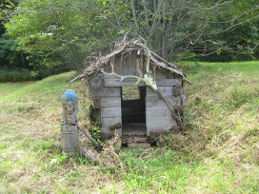
© RIA Novosti. Alexey Eremenko
The leopard national park sports an improvised “eco-track” complete with faded laminated photographs and wooden animals carved by inmates of a local prison
But a separate reserve population is needed to ensure the leopards are not wiped out by some epidemics, nature park deputy director Khokhryakov said. Work is underway, with a program awaiting sanction from Moscow.
Gun Under the Pillow
The Land of the Leopard houses more than 80 landowners, including several rural settlements and the Pacific Fleet marines and their firing range. Most of the inhabitants are armed, and unhappy at finding themselves residents of a national park.
“I've slept with a handgun under my pillow for three years,” said Khokhryakov, who used to head the nature reserve until a Moscow-ordered reshuffle this month.
More than 430 administrative offences have been recorded in connection with violations of the park in its first year alone, he said.
The WWF has launched an extensive education campaign for locals, printing out leaflets for each of the 30,000-plus district residents and making schools choose a leopard to “adopt.”
In the mid-2000’s, most locals polled by the WWF said they would shoot a leopard upon meeting it, but now the only deaths are accidental, with cats shot when mistaken for other game, Titova said.
The district has formidable potential for eco-tourism, but all it has to offer for now is an improvised “eco-track” created by WWF and now property of the national park, complete with faded laminated photographs of plants and taiga wildlife, and wooden animals carved by inmates of a local prison.
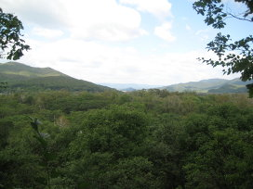
© RIA Novosti. Alexey Eremenko
Typical leopard haunts in the Khasan district
Khokhryakov, who now oversees tourism at the reserve, is dismissive of regional officials’ attention to tourism development, which does not make his job any easier. “All they care about is how to stock the bar,” he says.
Money Doesn't Save Leopards
Anatoly Belov, declared the world’s best ranger by none other than Britain’s Prince Philip in 2010, works in the Land of the Leopard.
Working on a nature reserve is not lucrative. Khokhryakov recalled how he used to feed his family in Soviet times on tiger meat confiscated from poachers (“tastes like veal,” he said).
Rangers at the Land of the Leopard earn an average 17,000-18,000 rubles ($550-580) a month, a reasonable income for the Russian countryside.
They also get various monetary bonuses and are granted overseas trips, said Sergei Bereznyuk of the Phoenix fund, a local charity that supports the reserve with money and the occasional quad bike.
Still, most of the personnel are enthusiastic professionals who are not in for the money, both Darman and Khokhryakov said.
But enthusiasm for the mission is in short supply outside the Land of the Leopard.
The WWF used to run seven “leopard's friends groups” across the Russian Far East stocked with local teens and college students, but now, there are only enough people for three, said Titova.
“The kids just don't care anymore,” she said.
The adults are not much better. The annual budget of the nature reserve stands at 90 million rubles – under $3 million, a fraction of the $22 billion price tag for the recent Asia-Pacific Economic Cooperation summit in Primorye. Admittedly, another 3 billion rubles were earmarked for a tunnel that would spare the leopards crossing the dangerous local highway.
But most prominent nongovernmental donors are not Russian citizens or companies, but Britons and Germans, Darman said.
“Only the government can save a species,” he said. “Public groups can only do odd jobs.”
Titova pointed that the WWF has been doing the government's job for years until Ivanov's recent involvement.
Creating a second leopard population will cost an estimated $10 million, experts estimate. Nobody can say where the money will come from.
There are five more nature reserves and two national parks in the region, many of them bigger than the Land of the Leopard, but also underfunded and understaffed. Unfortunately for the animals there, they have no films to show to big beasts in government.
(An earlier version of the story incorrectly specified the size of Russian and Chinese leopard parks as 370,000 and 280,000 hectares, respectively.)

