GIANT PANDA

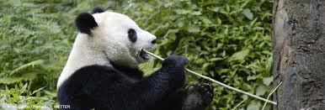

How many are left in the wild?

PANDA POPULATION IN THE WILD
By 2004, there were estimated to be 1,600 pandas alive in the wild.
How does this compare to past figures? In the first ever mass survey that took place between 1974-1977, the researchers estimated that there were around 1,000 -1,100 giant pandas in the wild. In the 2nd ever survey, done between 1985-1988, again, around 1,000 animals were thought to exist.

What do pandas eat?
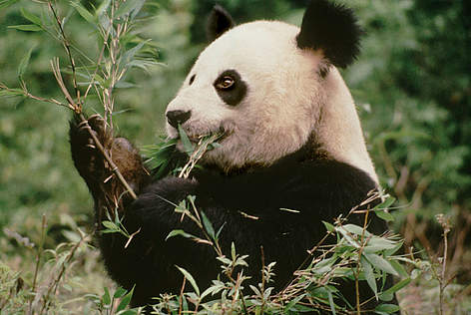
The simple answers is: bamboo.
A Panda's daily menu consists almost entirely of the leaves, stems, and shoots of various bamboo species.
Bamboo contains very little nutritional value, so pandas must eat 12-38kg every day to meet their energy needs.
Only about 1% of their diet is made up of other plants and meat. Occasionally the panda will hunt for pikas and other small rodents. As members of the bear family, giant pandas possess the same digestive system of a carnivore. But they differ in the sense that they have adapted to a vegetarian diet.
This behaviour defines their lives in many ways, since they will often rely on living close to areas where bamboo is abundant. This leaves them vulnerable to any loss of bamboo habitat – a key threat to their survival.

Life cycle
- A new born panda cub weighs only 90-130gr. and is about the size of a stick of butter.
- The panda cub is 1/900th the size of its mother, one of the smallest new born mammals relative to its mother's size.
- Pandas are dependent on their mothers for the first few months of their lives and are fully weaned at 8 to 9 months.
- Most pandas leave their mothers when she conceives again, usually at about 18 months.
- A panda's average life span in the wild is 14-20 years (but a panda can live up to 30 years in captivity).

Problems

Ongoing threats to the panda's survival
Despite the conservation success in the panda's habitat in recent years problems still persist.
The major factors contributing to habitat loss and fragmentation — the most pressing threats to the giant panda — are:
- conversion of forests to agricultural areas,
- medicinal herb collection,
- bamboo harvesting,
- poaching, and
- Large scale development activities such as road construction, hydropower development, and mining.
The illegal wildlife trade and the natural phenomenon of bamboo die-back are also threats.
Because of China's dense and growing human population, many panda populations are isolated in narrow belts of bamboo no more than 1.2km wide — and panda habitat is continuing to disappear as settlers push higher up the mountain slopes.

Why should we save the giant panda?

The giant panda is one of these species threatened to be wiped off planet. Ironically, it is also one better known and loved species in the world and one of the strongest symbols of nature conservation.
That is one of the main reasons why they are so important: by mobilizing people to save the panda, we are actually helping preserve the rich biodiversity - plants, landscapes, other animals - that need to be there in order for the pandas to survive.
They also play a crucial role in the bamboo forests where they roam by spreading seeds and facilitating greater growth of the vegetation.

Giant Panda
Giant pandas live only in China.
They eat bamboo. Sometimes the bamboo dies and the pandas starve.
They are endangered because the forests where they live are cut down.
Giant pandas climb trees.
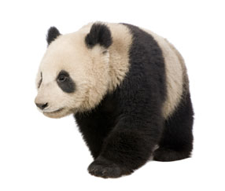
The Giant Panda is one of the rarest animals in the world. It is a species, or kind, of bear and is found only in China. They are solitary animals, living alone in the bamboo forests.
Appearance
They are black and white animals with round heads, small black ears and white faces. They have a black patch around each eye. They have short tails. They walk on all fours and can climb trees, often doing so to find a place to sleep.
An adult Giant Panda is about 150 centimetres long and weighs about 90 kilograms, although the biggest one ever weighed was 180 kilograms.
Habitat
Giant Pandas live in bamboo forests in the mountains of western China. The forests are very thick and the pandas are generally hidden from view, so it has been hard for scientists to learn about them. This lack of knowledge adds to the difficulty of saving the pandas.
Once they were found throughout China, but the bamboo forests in eastern China have been cut down for farming. This has made the forest areas into 'islands', making it impossible for the bears to roam widely and meet each other to mate.
Feeding
About 99% of the Giant Panda's food is bamboo, though it also eats grass, roots, plants and even meat. Bamboo is actually a type of grass that grows as tall as trees. Although there are hundreds of kinds of bamboo, the Giant Panda eats only 4 or 5 kinds. It is estimated that a Giant Panda can chew more than 3,500 stalks of bamboo a day. Bamboo is not very nutritious, so the Giant Panda spends about 12 hours a day feeding.
It is estimated that a giant panda can chew more than 3,500 stalks of bamboo a day.
The front paws of the Giant Panda are specially adapted to help it hold bamboo. There is a bone on each palm that looks a bit like a thumb. The panda's five fingers wrap around the bamboo stalk, and the 'thumb' moves forward to jam against the bamboo so that it is firmly held. The very large teeth, strong jaws and huge cheek muscles help crush the hard bamboo.
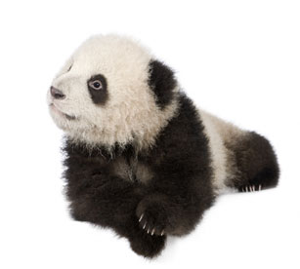
Life Cycle
Baby pandas are very small when they are born, weighing about 120 grams. The mother holds the new baby in a similar way to a human, cradling it in her arms. The baby panda's eyes open after about 40 days. At one month old the black markings can be seen on their pink skin. At three months old the young pandas are furry, black and white miniatures of their parents. They crawl when they are about 3-4 months old. At 7 months, a young panda weighs about 9 kilograms, runs and climbs trees, and has started eating bamboo. At about 18 months, it weighs about 55 kilograms, and will soon leave its mother.
Conservation Status
Giant Pandas are classified as Endangered because the bamboo forests are being cleared for farming. Different types of bamboo die off every 40 to 100 years and because of the clearing, there are fewer types of bamboo left. Pandas often starve when the bamboo dies off. In the past they were hunted for their fur or were trained as performing circus animals. Giant Pandas are now protected by law.
In China, research and breeding centres have been set up and are trying to breed them to increase their numbers. This is a very slow and difficult process, and so far the success is limited.

Giant Panda

THREATS

The Greatest Challenge
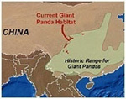
While giant pandas once roamed much of Southern China, they are now confined to isolated patches on six mountain ranges. Enlarge Map
Panda conservation activities are at their highest ever, but at the same time the giant panda is facing its greatest challenge: lightning speed economic development. In the past decade, environmental awareness among the Chinese public has increased enormously, and the national government has positioned environmental protection as one of its top priorities. A series of large-scale national environmental programs have been launched, including a national natural forest logging ban and ecological restoration in western China. However, the country’s promotion of its booming economy is often perceived to be at the cost of natural resources, sometimes even outside China’s borders. Sustainable resource use and management is an issue that requires urgent attention. The misuse of natural resources creates the most pressing threats to the giant panda, habitat loss and fragmentation.

Habitat Loss
Bamboo, the panda's primary source of food, only grows at an elevation above sea level of between 550 and 3,400 yards. A pair of breeding pandas needs a minimum of around 7,400 acres to support them.
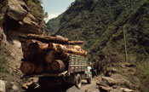
Logging is one of the threats facing China's nature reserves. Wolong Nature Reserve, Sichuan Province, China
© Soh Koon CHNG / WWF-Canon

Much of the lower elevation land has been claimed for agriculture so remaining habitats are now confined to above 1,500 yards, but this area too is now under pressure from human activities.
Much of the panda's mountainous bamboo habitat has been degraded by timber logging. In the Sichuan Province alone it shrank by 50% between 1974 and 1989. The Chinese government banned logging in the panda's habitat in 1998.

Fragmentation
Across the panda's range, the habitat is broken into 20 isolated patches in the Shaanxi, Gansu and Sichuan provinces. Within these patches, a network of nature reserves provides protection for more than half of the panda population. Since pandas cannot migrate between these far-flung habitat blocks, they have less flexibility to find new feeding areas during periodic bamboo die-off episodes.
Bamboo die-off is a natural occurrence in the bamboo life-cycle – happening every 15-120 years - forcing pandas to look elsewhere for their main food source. Without habitat corridors - often through lowland areas between mountain ranges - the pandas may die of starvation.
Small, isolated populations also face a greater risk of inbreeding, which can lead to reduced resistance to disease, less adaptability to environmental changes and reproductive problems. Pandas stand a much greater chance of extinction if their populations remain isolated from each other.

Climate change
Access to bamboo, their main source of food, may become a problem for giant pandas as climate change affects its delicate habitat in China’s Yangtze River basin. Projected impacts to the area could cause more forest pests and diseases, resulting in less bamboo and therefore less food available for the giant panda.

The giant panda
Fact file
Name: Giant panda
Status: Endangered
Habitat: Forests in Central China.
Description: The giant panda is a type of bear, although for a long time scientists weren't certain what its closest relatives were. You probably know what a panda looks like - it is very large and has a distinctive black and white coat. Giant pandas mainly eat bamboo but will also eat some small animals.
Why is it endangered?
The giant panda is one of the world's rarest animals and it is very shy. The giant panda eats a lot of bamboo. As people cut down more and more bamboo to clear land for building, industry and farming, the panda loses its food source and its home. The giant panda is very slow to reproduce, it has only a few babies during its life, and this also contributes to its vulnerability.
Now that people have realised that pandas are so endangered they have started to protect them. There are also a few giant pandas in zoos - a zoo in China has even managed to get their pandas to have a baby!

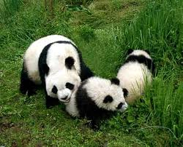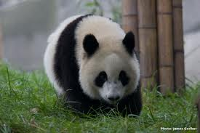

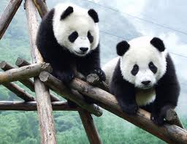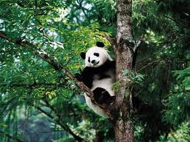

TO BE PRINTED OFF:
http://www.worldwildlife.org/species/finder/giantpanda/panda.html
http://news.bbc.co.uk/earth/hi/earth_news/newsid_9225000/9225918.stm
http://www.guardian.co.uk/environment/2009/sep/23/panda-extinction-chris-packham
http://www.deadlinenews.co.uk/2008/11/05/bamboo-breakthrough-could-save-giant-pandas/
http://www.bbc.co.uk/news/uk-scotland-edinburgh-east-fife-16023328
http://www.bbc.co.uk/news/science-environment-12161671
http://www.bbc.co.uk/nature/14153997
http://news.nationalgeographic.com/news/2003/04/0428_030428_panda1.html

