TIGER
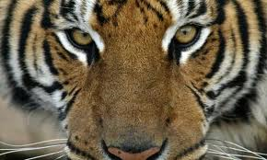

Fast Tiger Facts
Height: 3/3 ½ feet (.9 - 1.1m) at shoulders.
Length: Head and body length 4.6 - 9.2 (1.4 - 2.8m) feet (tail length 2-3 feet (.6 - .9m).
Weight: The Siberian tiger is the largest subspecies and males weigh from around 400-675 lbs (181-306 kg), while the Sumatran tiger, the smallest living subspecies, weighs in from around 220-310 lbs (100-136 kg).
Females of all tiger subspecies are smaller than males.
Lifespan 10-15 years

Diet
Tigers mainly eat deer, wild pigs, water buffalo and antelope. Tigers are also known to hunt sloth bears, dogs, leopards, crocodiles and pythons as well as monkeys and hares. Old and injured tigers have been known to attack humans and domestic cattle.

Population
In the early 1900s, there were around 100,000 tigers throughout their range. Today, an estimated total of around 3,000-4,500 exist in the wild. Below is a breakdown of tiger numbers by species:

Bengal tiger: Less than 2,000
Indochinese tiger: 750-1,300
Siberian tiger: Around 450
Sumatran tiger: 400-500
Malayan tiger: 600-800
South Chinese tiger: Extinct in the wild
Caspian tiger: Extinct
Javan tiger: Extinct
Bali tiger: Extinct

Behaviour
Tigers occupy a variety of habitats from tropical forests, evergreen forests, woodlands and swamps. They are mostly nocturnal (more active at night) and are ambush predators that rely on the camouflage their stripes provide. Tigers use their body weight to knock prey to the ground and kills with a bite to the neck. They are also very good swimmers and have been known to kill prey while swimming.
Mating Season: In tropical climates, mostly from around November to April; during the winter months in temperate regions.
Gestation: 103 days.
Litter size: 3-4 cubs.
Cubs follow their mother out of the den at around 8 weeks and become independent at around 18 months of age. They leave their mothers at about 2 ½ years. Mothers guard their young from wandering males that may kill the cubs to make the female receptive to mating.

Climate Change and Other Threats
As climate change continues to warm the planet, tigers are feeling the heat. As we see ocean levels rise, tigers are losing habitat due to coastal erosion (land falling into the ocean) in areas like India's islands. As rising sea levels claim more habitat and sea water moves up river, naturally fresh water is becoming more highly concentrated with salt. These factors are forcing the tigers to move northward towards areas more heavily populated by humans and increasing the likelihood of animal/human conflicts.

Tigers are also facing many other threats. They are illegally killed or poached because their pelts are valuable in the black market trade, their body parts are used in traditional Asian medicines and they are seen as threats to human communities. There is also large scale habitat loss due to human population growth and expansion. Human encroachment into tiger habitat also decreases prey animals.

Facts About Tigers
Description of Tigers
The Tiger is described as a large carnivorous feline mammal. Tigers have a tawny coat with transverse black stripes.
Facts about where Tigers live and what they eat!
- Tigers are native to Asia
- The most common habitat are tropical rainforests and grassy or swamp areas
- The diet of Tigers consist of small and large game including wild deer, cattle and pigs

Basic Facts about Tigers
- The name of a male is referred to simply as a tiger
- The name of a female is referred to as a she-tiger
- The name or offspring, or a baby Tiger, is a cub
- The average size of a litter is two
- The sound made by a Tiger is referred to as a growl
Facts about the Size of Siberian Tigers (biggest)
Fully grown they reach the length of 13 feet
An adult male weighs up to 700
Endangered Species
Wild life experts consider that Tigers are an endangered species. The Bali, Javan, and Caspian tigers have been lost forever and are now extinct. An endangered species is one that is in danger of extinction throughout all or a significant portion of its range. The Causes of a species of animal becoming endangered are due to Habitat Destruction such as the rainforest, introduction of exotic species, disease, water pollution, global warming and over exploitation of natural resources. As people are made aware of the facts about endangered species, initiatives such as Recycling are increasing in popularity. Endangered Species Organizations are dedicated to saving and preserving the world's most endangered wildlife. Interesting facts about Endangered Species..

TIGERS IN CRISIS... Since 1900, the endangered tiger's habitat and numbers have been reduced by up to 95 per cent. Poachers continue to poison waterholes or set steel wire snares to kill tigers and tiger prey, selling their skins and body parts for use in traditional Chinese medicine.
Despite 20 years of international conservation efforts, we are losing ground to save the tiger as, on the endangered species list, all sub-species of tigers are considered critically endangered species.
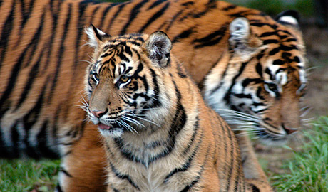
Of the eight original subspecies of tigers, three have become extinct in the last 60 years, an average of one every 20 years.
The Bali tiger became extinct in the 1930's. The Caspian tiger was forced into extinction in the 1970's. And the Javan tiger followed in the 1980's.
The number of tigers in the 1900's was over 100,000 but that dropped to 4,000 in the 1970's. Today, they are a critically endangered species with the total of all the wild populations of the five remaining subspecies (Bengal tigers, Indochinese tigers, Siberian tigers, South China tigers, and Sumatran tigers) is an estimated 4,600 and 7,700 tigers.
It is known that all remaining tigers live in small, isolated populations and are widely scattered.


During the 2010 Year of the Tiger, Russia’s prime minister convened a tiger summit where world leaders endorsed a bold plan to save tigers. All 13 countries where tigers still roam in the wild committed to doubling the number of tigers. WWF is working to ensure those strategies are successfully implemented so that tigers get a strong start on their road to recovery.

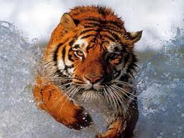

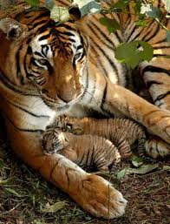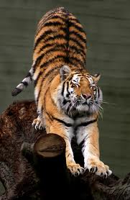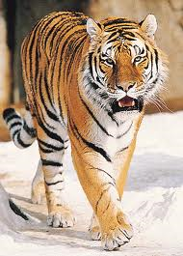

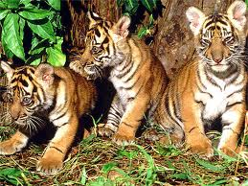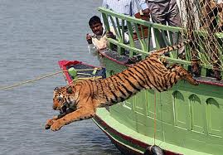



TO BE PRINTED OFF:

http://www.defra.gov.uk/news/2011/12/30/protect-endangered-species/

http://news.bbc.co.uk/1/hi/8568035.stm

http://www.guardian.co.uk/environment/2010/jan/03/tigers-top-10-endangered-species

http://www.bbc.co.uk/news/world-asia-pacific-13330315

http://www.zsl.org/tiger-sos/index,203,ZI.html

