http://www.savetherhino.org
Population figures
http://www.savetherhino.org/rhino_info/rhino_population_figures
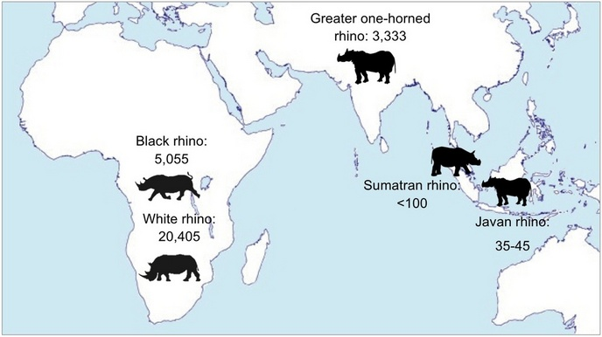
At the beginning of the 20th century there were 500,000 rhinos across Africa and Asia. This fell to 70,000 by 1970 and further to just 29,000 in the wild today. Despite this bleak picture, and the continuing threat of poaching for their valuable horns, global rhino population figures have been increasing in recent years.
Large-scale poaching of the now critically endangered black rhino resulted in a dramatic 96% decline from 65,000 individuals in 1970 to just 2,300 in 1993. Thanks to the persistent efforts of conservation programmes across Africa black rhino numbers have risen since the early 1990s to a current population of 5,055.
The overwhelming rhino conservation success story is that of the southern white rhino. With numbers as low as 50 left in the wild in the early 1900s, this subspecies of rhino has now increased to over 20,000 and has become the most populous of all the rhino species. The population is continuing to increase every year, however there are concerns that the unprecedented rise in rhino poaching since 2008 may bring this species back into decline if the poaching is not reduced.
Save the Rhino supports many programmes conserving black and white rhinos
In Asia the populations of Sumatran and Javan rhinos are extremely low and both species are listed as critically endangered. There are fewer than 100 Sumatran rhinos left in the wild, and efforts are now being invested in captive breeding in an attempt to boost the population.
The Javan story is sadly even more shocking with an estimated 35 to 45 individuals left in a single population in Ujung Kulon National Park. Local conservationists, supported by Save the Rhino, are working hard to increase the habitat for this species since it is believed that the current habitat cannot support any more rhinos, and Rhino Protection Units have been set up to monitor and protect both the remaining Javan and Sumatran rhinos.

African population numbers by subspecies
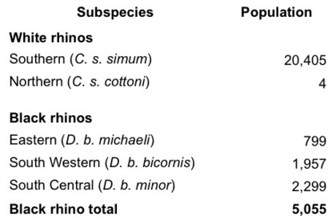

Poaching: The Statistics
Rhinos were once abundant throughout Africa and Asia with an approximated worldwide population of 500 000 in the early twentieth century. However, despite intensive conservation efforts, poaching of this iconic species is dramatically increasing, pushing the remaining rhinos closer and closer towards extinction. The Western black rhino was declared extinct by the IUCN (International Union for Conservation of Nature) in 2011, with the primary cause identified as poaching. In fact, all five remaining rhinos species are listed on the IUCN Redlist of threatened species, with three out of five species classified as critically endangered.
South Africa is home to 83% of Africa’s rhinos and 73% of all wild rhinos worldwide and is an incredibly important country for rhino conservation. However rhino poaching has reached a crisis point, and if the killing continues at this rate, we could see rhino deaths overtaking births in 2016-2018, meaning rhinos could go extinct in the very near future. Figures compiled by the South African Department of Environmental affairs show the dramatic escalation in poaching over recent years - see graph below.
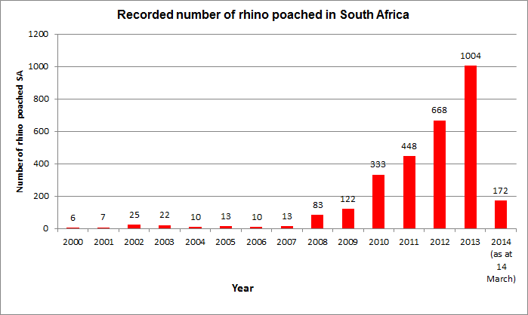
Graph 1, data published by South African Department of Environmental Affairs (2014)
During 2012, in South Africa alone a staggering 668 Rhinos were killed by poachers, that’s almost 2 a day. Worryingly the current figures for 2013 suggest that more than 1000 rhinos could be killed by the end of the year.
This poaching is by no means isolated to South Africa, rhino poaching is surging across the entire African continent, and is a constant threat to the smaller rhino populations in Asia. Other rhino states do not regularly publish poaching statistics, however updates are available in news reports and press releases. For example, in early August 2013, Kenya reported that it had lost 34 rhinos to poaching since the start of the year.
This poaching is predominantly fuelled by the illegal trade in rhino horn; globalisation and economic growth has made it easier to establish illegal trading routes. The current poaching crisis is attributed to the growing demand for rhino horn in Asian countries, mainly China and Vietnam, where horn is believed to have medicinal properties. The high price fetched for the horn has attracted the involvement of ruthless criminal syndicates who use high-tech equipment to track down and kill the rhinos.
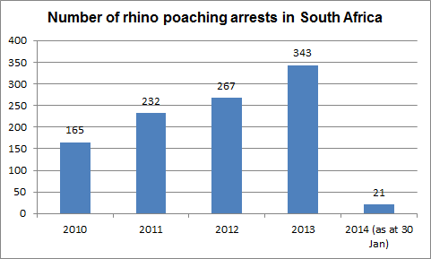
Graph 2, data published by South African Department of Environmental affairs (2013)
However, it is not all doom and gloom; penalties for rhino poaching are becoming increasingly severe and frequent. Figures released by the South African Department of Environmental Affairs, show an increasing number of rhino related arrests over the past few years (shown in graph 2). Law enforcement plays a crucial role in deterring poachers, however there is no single answer to combat the current poaching crisis. A multi-faceted approach is required including ongoing anti-poaching and monitoring patrols, community conservation and environmental education schemes, captive breeding, translocations and demand reduction projects in Asia. If you want to contribute to these efforts and be a part of saving the worlds remaining rhino please to find out more about supporting Save the Rhino International.

Threats to rhino
There are multiple threats to rhinos survival, nearly all of which are caused by humans. Over the past few decades, drastic decline in population numbers has been fuelled by the illegal rhino horn trade, habitat loss and political conflict. Poaching of rhino horn for the production of traditional Chinese medicine is the greatest threat facing rhino today

Poaching for Traditional Chinese Medicine
Rhino horn has been used in Traditional Chinese Medicine for thousands of years. The steep rise in rhino poaching in recent years has been fuelled by the demand for TCM in Asia
Habitat loss
Illegal poaching is the most pressing cause of the decline in rhino populations, but habitat loss has also been a key factor

Political Conflict
In some locations, where normal law and order has broken down – particularly in war zones or where there is political instability – it has become much easier for the poachers to kill rhinos and other endangered species

Poaching for Jambiya Handles
Back in the 1970s and 80s, horn from rhinos killed in East Africa tended to end up in the Yemen, where it could be made into ornamental handles for daggers (jambiyas)

Ten good reasons to save rhinos
- Rhinos are critically endangered
At the turn of the 19th century, there were approximately one million rhinos. In 1970, there were around 70,000. Today, there are only around 28,000 rhinos surviving in the wild.
Three of the five species of rhino are “Critically Endangered” as defined by the IUCN (World Conservation Union). A taxon is classified as critically endangered when the best available evidence indicates that it meets any of a range of pre-determined criteria. It is therefore considered to be facing an extremely high risk of extinction in the wild. The Southern subspecies of the white rhino is classified by the IUCN in the lesser category of being “Near Threatened”; and the Greater one-horned rhino is classified as "Vulnerable"; even this is considered to be facing a high risk of extinction in the wild.
In 2014, some of us are lucky enough to be able to travel to Africa and Asia to see them in the wild. In 2024, when our children have grown up, will they still be able to see wild rhinos?
- Rhinos have been around for 40 million years
Rhinos have been an important part of a wide range of ecosystems for millions of years; we must not let them join the dodo in extinction.
- Humans have caused the drastic decline in numbers
Poachers kill rhinos for the price they can get for the horns (used for traditional Chinese medicine, for high-status gifts in Vietnam and for quack cures invented by criminal syndicates to drive up demand); land encroachment, illegal logging and pollution are destroying their habitat; and political conflicts adversely affect conservation programmes.
- Rhinos are an umbrella species
When protecting and managing a rhino population, rangers and scientists take in account all the other species interacting with rhinos and those sharing the same habitat. When rhinos are protected, many other species are too; not only mammals but also birds, reptiles, fish and insects as well as plants.
- Rhinos are charismatic mega-herbivores!
By focusing on a well-known animal such as a rhino (or, to use the jargon, a charismatic mega-herbivore), we can raise more money and consequently support more conservation programmes benefiting animal and plant species sharing their habitat.
- Rhinos attract visitors and tourists
Rhinos are the second-biggest living land mammals after the elephants. Together with lion, giraffe, chimpanzee and polar bear, the rhino is one of the most popular species with zoo visitors. In the wild, rhinos attract tourists who bring money to national parks and local communities. They are one of the “Big Five”, along with lion, leopard, elephant and buffalo.
- In situ conservation programmes need our help
Protecting and managing a rhino population is a real challenge that costs energy and money. Rhino-range countries need our financial support, and benefit from shared expertise and exchange of ideas.
- Money funds effective conservation programmes that save rhinos
We know that conservation efforts save species. The Southern white rhino would not exist today if it were not for the work of a few determined people, who brought together the 200 or so individuals surviving, for a managed breeding and re-introduction programme. Today, there are some 20,405 (as at 31 Dec. 2012) Southern white rhinos.
With more money, we can support more programmes, and not just save rhino populations, but increase numbers and develop populations. The Northern white rhino subspecies may just have become extinct, but it is not too late to save the rest.
- Many people don’t know that rhinos are critically endangered
Not just that, but how many people know that rhinos also live in Asia? Or that two species have just one horn? Or that the horn is not used as an aphrodisiac? We have even heard some people say that they are carnivores!
If people do not know about these amazing animals and the problems they are facing, how can we expect them to want to do something to help save rhinos?
- We all have an opportunity to get involved!
You can help us raise awareness of the plight of the rhino! The more we do all together, the more people will learn about rhinos and the more field projects we will be able to support. There are lots of fundraising ideas scattered in the 'Support us' section, as well as ways to donate directly to Save the Rhino. And there are rhino-themed games and puzzles in the 'Rhino info' section!

Conservation activities
In this section, you can read about the types of activities that conservation managers carry out, and how those activities help achieve our overall aims, which are:
- To increase the number of rhinos in genetically viable populations in the wild
- To enhance the integrity of ecosystems
- To ensure that local communities benefit from conservation activities
Save the Rhino International focuses on genetically viable populations of critically endangered rhinoceros species in the wild. “Genetically viable” populations are generally taken to mean those with a minimum of 20 individuals. In some areas, smaller populations have been known to breed successfully, although it is not known what the impact is on the long-term genetic diversity of such a population. For rhino populations to qualify as being “wild”, three conditions must be satisfied:
- They must be free-ranging within an area large enough to sustain a breeding group
- The area in question must consist of natural rhino habitat
- They must survive by feeding off natural vegetation in the area (ie, without human intervention)
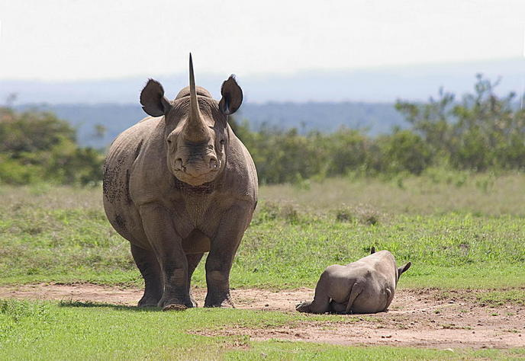
Photo credit Andrew Gell

Anti-poaching
Effective field protection has been critical to success over the last decade. Experience indicates that to achieve success, it is necessary to concentrate law enforcement at or above minimum threshold levels. Apart from having a sufficient manpower density on the ground, field rangers need to be well trained, equipped and effectively deployed. In some reserves, additional specialist anti-poaching units operate in addition to standard field ranger patrols.
While pro-active and reactive anti-poaching patrols can reduce the level of poaching and chances of catching rhino poachers, experience has shown that the setting up and running of informer networks can prove particularly useful and cost-effective. Effort and training is also required to ensure the effective investigation, successful prosecution and sentencing of those guilty of rhino crimes. Ultimately, rhino crimes are perpetrated because of the illegal demand for rhino horn, and so efforts are being made to reduce the illegal demand where possible. Another important aspect of law enforcement is the management, monitoring and protection of legal rhino horn stockpiles.
Richard Emslie
Scientific Officer
IUCN SSC AfRSG

Monitoring
The foremost reason for monitoring is to “audit” rhino populations and to check that none of their members, being valuable biological assets, are missing because of illegal offtakes or other demographic impacts. The knowledge that a rhino population is being kept under close demographic surveillance, so that any poaching will be detected, serves to deter would-be poachers including corrupt elements within that area’s protection/management force. The need to be able to undertake “auditing” fully justifies the costs and (relatively small) risks of immobilizing rhinos in order to cut ear notches as identification features.
A second major reason for rhino monitoring is because the adaptive management that is required to maximize metapopulation growth rates for rhinos is not possible without reasonably accurate annual population estimates, measures of demographic performance, and information on mortality patterns, behaviour and translocations.The sharing and synthesis of this information at a national and regional level (for example, the routine annual black rhino status reporting and periodic analysis of data within the SADC RMG) serves to provide:
- measures of progress towards meeting metapopulation goals (in the form of underlying metapopulation growth rates, and the consequent estimates of how long it will take to reach target metapopulation sizes);
- estimates of population sizes and densities which can be used to derive recommended offtake levels (either using set-percentage harvesting or by keeping numbers at or below 75% of estimated ECC);
- data on the comparative performance of the different populations in a metapopulation, which encourages each park manager to put that park’s rhino population performance into context, and to consider how that population can help contribute to attain metapopulation goals;
- additional insights into factors affecting rhino population performance;
- an effective way to share lessons learned from both experience in the field and the results of research;
a consolidated record of movements of rhinos within and in and out of a metapopulation.
Raoul du Toit
from the "Guidelines for implementing SADC rhino conservation strategies," published by the SADC Regional Program for Rhino Conservation

Environmental Education
Environmental education is seen by most State and private conservation areas as a vital factor in their long term protection. However, it is generally true that with the wide range of core conservation duties that need daily attention, relatively few resources can usually be spared on a sustained basis for education functions. To be effective, consistent commitments of trained personnel, transport, equipment and educational materials are needed, along with clear, measurable goals of what the education should achieve.
Around rhino conservation areas, environmental programmes have taken many forms. Pilanesberg National Park during the 1980s and early 1990s probably went further than most, by employing a full-time team of school teachers, and setting up a large educational facility that could house and feed scores of rural school children on routine basis. A full 2-3 day programme of environmental teaching and field activities awaited visiting children, and the aim was to expose every single school child in the entire region to this programme at least once in their school careers. Realising that a few days of exposure would not usually be sufficient, a travelling road show was devised, and all schools were assisted in setting up Wildlife Clubs. The success of this programme could be gauged by the fact that parents and village elders began to complain to Park staff that the children now knew more than them, and they too needed to be educated. State budget and staff cuts however eventually crippled this education programme, reducing it to a shadow of its former glory. Lapalala Wilderness was the first private conservation area to purchase black rhino, and they set up a similar rustic environmental school camp system. They used the added component of showing the children Bwana, a lovable hand-raised black rhino, who is a great success at stimulating everyone’s interest.
Most environmental education programmes today take the form of general conservation and ecological teaching aimed at school children. Many areas have rustic overnight facilities for children, but many others can only afford one or two usually under-resourced staff members to undertake general community liaison and education, with school classes coming for only a few hours to a conservation area. Efforts to teach school teachers are underway, but usually the deep rural schools have absolutely no resources or capacity to routinely impart
Keryn Adcock
Ecologist, Rhino Consultant
Wild Solutions

Translocations
Having suffered catastrophic declines in their range and numbers, rhinos tend to live in relatively small, isolated populations that need to be actively monitored and managed to ensure their persistence. In nature, animals may at times migrate between centres of population or expand their range. This helps to avoid inbreeding, allows a population to grow, or allows individuals to find sufficient food and water resources if these are scarce. However, as habitats are limited in extent and there are now great distances between rhino populations and barriers to their movements such as human habitation, the process needs to be helped artificially.
The “translocation” or assisted movement of rhinos between different areas has become a necessary and ongoing component of conservation which helps address the problems associated with these discrete populations. This process is known as meta-population management and it takes into consideration the overall status of all the combined, isolated groups of rhinos.
Genetic management Small populations may suffer from inbreeding, which can have negative consequences for individual animals and the population. The solution is to swap rhinos between centres of population and thus ensure gene flow amongst the meta-population. This also helps to increase genetic diversity in a population, which means that it is more likely to be able to adapt and cope with natural catastrophes such as disease.
Safe havens Sometimes, despite the best efforts of conservationists and land managers, the illegal poaching of rhinos occurs and this continues to be the greatest threat to these species. In extreme cases, where anti-poaching measures have either not been effective or are difficult to implement, the only option is to translocate remaining rhinos to safer havens elsewhere in the country. This safeguards the individuals and means that they can continue to contribute to broader conservation goals.
De-stocking and reintroduction If rhinos are well protected and their numbers increase, it is possible that the population reaches carrying capacity in a given area. If this happens, there may be insufficient food and water resources to sustain the population and bulls may compete to breed, which can result in fighting, injuries and even death. Ideally, before these problems occur, it is best to de-stock the area to reduce the rhino population to below the ecological and social carrying capacity.
Rhino populations also tend to grow quicker if they are maintained below carrying capacity. This means that individuals are available to re-establish populations in areas where they have become locally extinct, or be moved to augment numbers in an existing small population. This all helps to achieve the goal of increasing numbers of rhinos and returning them to their former ranges.
The translocation process Translocations are carefully planned operations that involve capturing and moving rhinos with minimal stress. This requires an expert team of vets and other support staff. Depending on the size of the area, vegetation and terrain, the team may be able to get close enough to the rhino on foot or with four-wheel-drive vehicles to capture it. Alternatively, where conditions are more challenging, a fixed-wing aircraft may be used to spot the rhino and a helicopter used to get the vet close enough to dart the rhino. The drugs used to sedate rhinos and the veterinary care given during capture operations have been specially developed and researched over many years to ensure the animals are in safe hands.
As rhinos are such large and strong animals, but also need to be treated with great care, they are transported in specially designed crates on very robust trucks. A lifting crane is often needed to help the process of loading and unloading the rhino in its crate.
At the recipient site, translocated rhino are often kept in an acclimatisation enclosure known as a boma before release. This allows the vet to make sure that the rhino has suffered no ill effects from the journey and is strong and healthy enough to fend for itself before being set free into its new home.
Tim Woodfine EAZA Rhino Campaign 2005/6

Captive Breeding
Zoos are a major and growing source of financial support for in situ conservation of rhinos. Captive rhinos serve as ambassadors to facilitate this role of zoos.
However, protecting rhinos in the wild can be very challenging and uncertain. Hence, viable populations in captivity are also important as ultimate reservoirs of genetic and demographic material for reinforcement or re-establishment of wild populations as need and opportunity occur. Black rhinos from zoos have already been successfully introduced to the wild at Marakele National Park in South Africa and more such introductions are in the pipeline.
Achieving viable captive populations of rhinos for their various conservation roles requires sophisticated scientific management as well as strategic coordination of the space and resource. Such management and coordination are provided by the Regional Captive Propagation Programs (RCPs) like the European Endangered Species Programme and Species Survival Plan, which use a logo with a rhino to designate all endangered species breeding programmes.
Tom Foose
Program Director
International Rhino Foundation
Nick Lindsay
International Zoo Programmes
Zoological Society of London

Tanzania: Mkomazi Rhino Sanctuary
Location
TANZANIA
Activities: Anti-poaching, monitoring,
Support: We focus on the new Environmental Education programme, Rafiki wa Faru, that links local schoolchildren with Tony Fitzjohn’s conservation efforts and on general Rhino Sanctuary maintenance
Funding partners: Chester Zoo, Mohamed Bin Zayed Species Conservation Fund, USFWS

Overview

Due to inadequate funding and levels of protection in the 1970s and 80s, Mkomazi’s wildlife and habitat deteriorated significantly through invasion by livestock and heavy poaching. This included the loss of all resident black rhino and virtually all the elephant. In 1989, the Government of Tanzania invited the George Adamson Wildlife Preservation Trust (GAWPT) to work with them to undertake a rehabilitation programme for Mkomazi, including restoration of habitat and re-introduction and breeding programmes for the highly endangered wild dog and black rhinoceros. The recovery of the Mkomazi Game Reserve was enabled by the Tanzanian Wildlife Division and the GAWPT through extensive rehabilitation of the infrastructure of the Reserve, with work activities bolstered by local community involvement and projects linked to wildlife protection and maintaining the integrity of the MNP. The Government gazetted Mkomazi, formerly a Game Reserve, to National Park status in 2008.

Species / population size
Mkomazi Rhino Sanctuary holds Eastern black rhino (D. b. michaeli). Please note that individual population sizes are confidential.

Habitat
The habitat of MNP and the Tsavo ecosystem in general has a very high carrying capacity (in terms of density) for black rhinos, far exceeding those of southern Africa. With a rich diversity of favoured food plants and vegetation cover based on rich volcanic soils with a bimodal rainfall pattern, the rhino densities recorded by Goddard in Tsavo (including MNP) in the 1960s indicate densities typically one order of magnitude higher that those that could be carried by most rhino conservation areas in southern Africa. Consequently, the cost-effectiveness of rhino conservation in terms of production of rhinos per unit area would also be equivalently high, an important consideration given the expense of construction and maintenance of fencing.

Primary activity
Breeding programme for the black rhino population, together with ongoing monitoring and anti-poaching patrols.

http://www.wwf.org.uk/what_we_do/safeguarding_the_natural_world/wildlife/african_rhino/

African rhino
Scientific name:
Ceratotherium simum (white rhino)
Diceros bicornis (black rhino)
Number remaining: Around 20,000 white rhinos and 4,800 black
Extinction risk:
White rhino: near threatened
Black rhino: critically endangered
Habitat: mainly grassland and open savannah across several African countries

About the African rhino
There are two species of African rhino – the white and the black. Despite their names, both are the same dark grey-brown colour. It’s thought that the name ‘white rhino’ is a misinterpretation of the Afrikaans word ‘wyd’, referring to its square upper lip. Black rhinos have hooked lips.
Most African rhinos are found in just four countries – South Africa, Namibia, Zimbabwe and Kenya – where they mainly roam grassland and open savannah. These armoured giants are vegetarian and need to eat large amounts of food every day.

White rhino
One subspecies - the southern white rhino - is a significant conservation success story. The population has recovered from fewer than 100 in 1895 to over 20,000 today. But sadly there are no northern white rhinos left in the wild, and only a handful in captivity.

Black rhino
The smaller black rhino has three remaining subspecies. A fourth – the western black rhino – was declared extinct in 2011. About 96% of black rhinos were lost to large-scale poaching between 1970 and 1992, and there are now just 4,800 individuals in the wild today.
Poaching for their horns is still the greatest threat to African rhinos today. In South Africa, rhino poaching has risen to worrying new levels since 2007, after falling to much lower numbers during the previous 20 years.
Why rhinos matter

Rhinos have been around for millions of years and play a crucial role in their ecosystem. They’re important grazers, consuming large amounts of vegetation, which helps shape the African landscape. This benefits other animals and keeps a healthy balance within the ecosystem.
Local people also depend on the natural resources within rhino habitat for food, fuel and income. As one of Africa’s ‘big five’, rhinos are a popular sight for tourists. Ecotourism can be an important source of income for local people.
By helping protect the rhino, we’re helping to conserve its habitat for the benefit of both people and wildlife, helping support local communities through ecotourism and making sure natural resources are available for generations to come.

Threats to African rhinos

Poaching

African rhinos are extremely vulnerable to poaching for the illegal trade in body parts. Powdered horn is used in traditional Asian medicine as a supposed cure for a range of illnesses – from hangovers to fevers and even cancer.
The number of rhinos poached in South Africa alone has increased by 7,700% in the past seven years – from 13 in 2007 to 1,004 in 2013. This recent surge has been primarily driven by the demand for horn by upper-middle class citizens in Vietnam. As well as its use in medicine, rhino horn is bought and consumed purely as a symbol of wealth.
Poaching gangs use increasingly sophisticated methods to evade authorities – including helicopters and night vision equipment to track rhinos, and veterinary drugs to knock them out. This means conservationists need to match this level of technology to be able to tackle the problem.

How WWF is helping protect African rhinos
Our goal is to increase rhino numbers in at least five key populations by 5% each year, and establish two new rhino populations by 2020.
Expand protected areas
We’ll help achieve this through our African rhino programme which gives technical and financial support to 12 rhino conservation projects across Africa. We’re helping to expand protected areas, create new ones, and increase security in these areas to protect rhinos from poachers. We also promote wildlife-based tourism that helps fund conservation efforts and gives local communities an income from living alongside wildlife.

Prevent poaching
We’re working with TRAFFIC (the wildlife trade monitoring network) to investigate, expose and crack down on poaching and the illegal trade in rhino horn – and to reduce the demand so that this trade is no longer a significant threat to African rhinos.

