[](http://www.google.co.uk/url?sa=i&rct=j&q=bannerman+high+school+logo&source=images&cd=&cad=rja&uact=8&ved=0CAcQjRw&url=http://www.bannermanhigh.glasgow.sch.uk/&ei=ig1KVZC7Neep7AbB_oDgBQ&bvm=bv.92291466,d.ZGU&psig=AFQjCNExX-r03tV51ZxQPhbzdhhYSAdqmA&ust=1431002887893482)

**Bannerman High School**

**Dance Academy**

**Application**

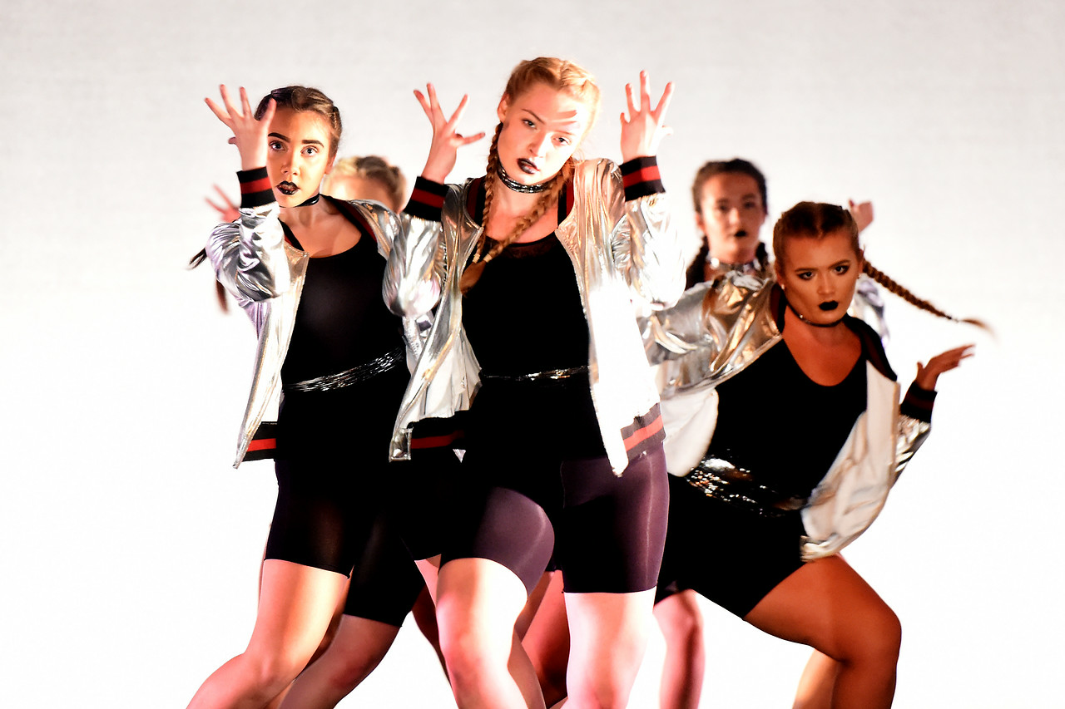

**Academic Year 2021/22**

**How to Apply**

Entry to the Bannerman Dance Academy is by audition. Due to COVID restrictions auditions for this year will be via an online video submission. All applicants who submit their video application on or before **Thursday** **27th May** will be considered for a place within the Dance Academy. There will be an open evening for pupils and parents online on **Tuesday 4th May at 5pm**. This will be an opportunity to hear from staff at the Dance Academy to find out more information about the course and to ask any questions ahead of your submission. To attend the online session please use the QR code below on or before **Friday 30th April**. A link will then be sent to your email address which will allow you to access the video call.

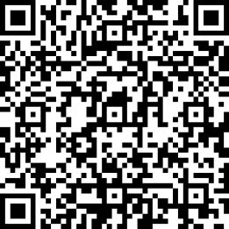

Applicants will need to provide the following within their video submission;

1. A performance in your chosen dance style lasting a minimum of 1min 30secs and a maximum of 2mins. *The video must be filmed in landscape and should not be edited.*
2. Pictures of you in right and left leg splits (this should be taken side on to the camera)
3. A demonstration of the plié exercise which can be accessed via the video link on the web page.

The video should be submitted alongside the completed application below and emailed to;

[Gw10callaghansymone@glow.sch.uk](mailto:Gw10callaghansymone@glow.sch.uk)

Bannerman Dance Academy

Bannerman High School

Glasgow Road

Baillieston

Glasgow

G697NS



**Bannerman Dance Academy Application 2021-22**

Please complete all sections of the application form in block capitals.

|  |  |  |
| --- | --- | --- |
| **Name:** | | **Surname:** |
| **Home Address:** | | |
| **Primary School:** | | |
| **Date of Birth:** | | |
| **Sex:** | | **Ethnic Origin:** |
| **Name of Parent/Guardian:** | | **Contact Number:** |
| **Email Address (Block Capitals):**  *This is how you will be contacted following the auditions* | | |
| **Previous Dance Experience** | | |
| **Dance School** | **Styles Studied** | **Year of Study** (ie 2020-21) |
|  |  |  |
|  |  |  |
|  |  |  |
|  |  |  |
|  |  |  |
| **Students are encouraged to disclose any impairment or condition (eg. physical, sensory or mental health) at the earliest opportunity so that we can endeavour to meet your needs during the audition process and on the course. We can, for example, make adjustments to sight reading for dyslexic students at audition.**  Hearing disability Dyslexia/Dyspraxia Visual disability Learning disability Physical disability  **Other please describe** | | |
| **I consent to photos/videos of my son/daughter being taken and used for the school social media pages.**  **YES/NO** | | |
| **Parent/Guardian Signature:** | | |