Raw data from
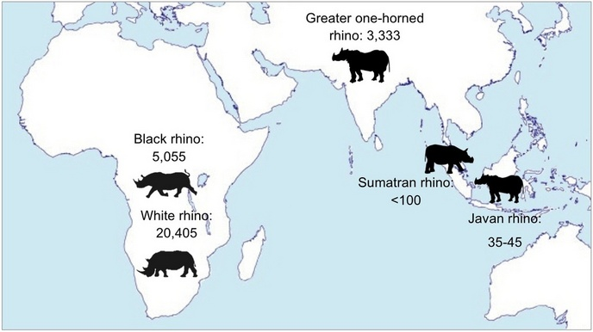
http://www.savetherhino.org/rhino_info/rhino_population_figures
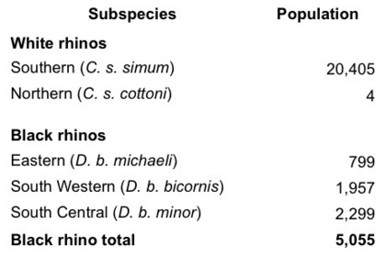
African population numbers by subspecies

Raw Data from: -
http://www.savetherhino.org/rhino_info/poaching_statistics
Graph 1, data published by South African Department of Environmental Affairs (2014)
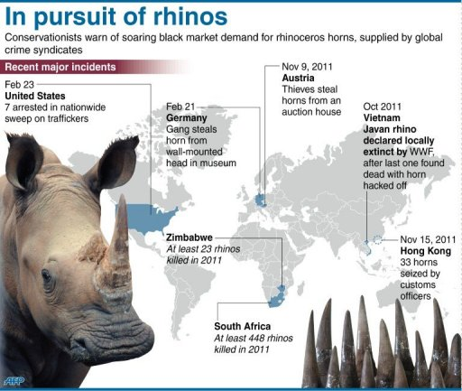
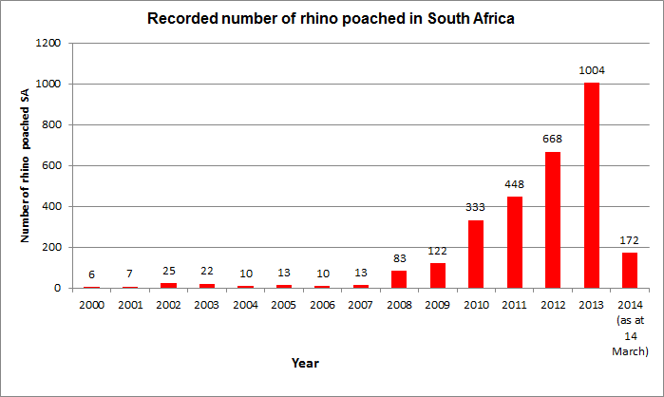
Raw data – Graphic 1:-
http://phys.org/news/2012-02-crackdown-rhino.html

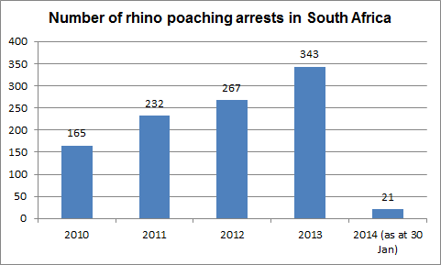

Graph 2, data published by South African Department of Environmental affairs (2013)

