**Bannerman High School Physics Department**

**N5 Waves and Radiation**

**Unit Test Revision**

**“Accurate statements about Physics”**

Name_________________________

Date _________________________

Class_________________________

**Characteristics Of Waves**

1. What does a wave allow energy to do?

Waves move energy from one place to another

1. Describe the difference between longitudinal and transverse waves (you might find a diagram helpful)

In a transverse wave the energy moves at right angles to the movement of the medium. In a longitudinal wave the energy moves parallel to the motion of the medium

1. Give an example of a longitudinal and a transverse wave

Transverse Water surface waves

Longitudinal Sound waves

1. Look at the picture of the wave train below.

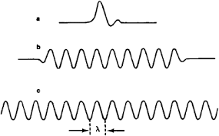

amplitude

wavelength

trough

crest

Label the picture to correctly show **wavelength**, **amplitude**, **crest** and **trough**.

1. Label the pictures of the sound waves to correctly identify their characteristics

**High Frequency Low Frequency Loud Quiet**



Quiet and Low Pitch

Loud & High Pitch

1. What is meant by the period of a wave?

The length of time needed to produce one full wave cycle

1. BBC radio broadcasts on a frequency of 198kHz. What is meant by a frequency of 198kHz?

This means that the source produces 198000 waves every second

1. State the relationship between the period and the frequency of a wave

f = 1/T

1. Two waves of equal amplitude but different frequencies are passing through a medium. Which of the waves transfers the greatest energy in a given time?

The higher frequency wave would transfer more energy

1. The speed of a wave could be calculated using by measuring the distance a wave crest travels in one second. State another relationship which could be used to calculate the speed of a wave.

Speed = frequency x wavelength

**Sound**

1. What is meant by ultrasound?

A sound of a frequency beyond the range of human hearing ( greater than 20 kHz)

1. Give an example of an animal that can hear ultrasound

Bat/ dog/dolphin etc

1. Why is ultrasound preferred to x rays when used for scanning unborn babies?

No damage to foetus due to ionising radiation

1. A guitar string is playing a “flat” note (a note which is too low). What can the guitarist do to the tightness of the string to make the guitar play a higher note?

Making the string tighter increases the frequency and raises the pitch

1. A trombonist stretches his arm out to make the length of his trombone longer. What happens to the pitch or note his instrument makes when he does this?

Pitch frequency decreases. Note gets lowers

1. What unit is used to measure the loudness of a sound or the sound level.

Decibel (dB)

1. A welder is working in a very noisy factory. What precaution should she take to ensure her hearing isn’t damaged?

Wear ear protectors

**Light**

1. Look at the diagram of light reflecting from a plane mirror.

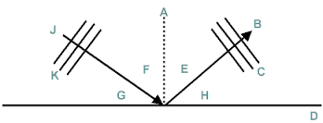

F

Which of the angles is the angle of incidence

E

Which of the angles is the angle of reflection

What is the relationship between these angles

They are the same

1. Complete the diagram to show how light reflects from a parabolic dish reflector

Give one application of a dish reflector

Satellite communication, radar dishes, radio astronomy etc

1. State what is meant by refraction

Refraction takes place when light ( or any wave) changes speed as it passes from one medium to another

1. When a pencil is half inserted into a bowl of water the pencil can look as if it might be broken at the water’s surface. Use your knowledge of physics to explain this observation.

This is because the light bends as it travels from the water into the air because of refraction

1. Look at the diagram of laser light passing through a rectangular block of glass .

i

r

Clearly label the angle on incidence (i) and the angle of refraction (r) on the diagram

The light emerges from the block of glass at an angles of 30° to the normal at that surface. How does this angle compare to the angle of incidence here it first enters the glass

These angles are equal – light emerges parallel

1. Complete this sentence to make it an accurate statement about physics.

*If light passes from water to glass the light bends towards the normal, this is because light travels more slowly in glass than in water.*

1. What is meant by the term total internal reflection?

Total internal reflection takes place when light tries to pass from a slower medium to a faster one where the angle of incidence is greater than a critical angle ( where the angle of refraction would be 90°)

1. Light is directed from water into another substance and total internal reflection takes place. Is the second substance



A. Glass

B. Air

1. Complete the diagram to show the path that laser light would follow in a fibre optic cable
2. State one application of a fibre optic cable in modern society

Endoscopes in medicine

Broadband Internet

1. Complete the diagram below to show what happens when water waves in ripple tank diffract past gaps or obstacles

. 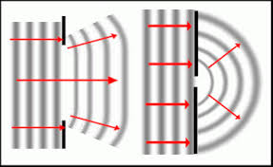

1. When driving through the highlands a driver has to retune her radio from the FM , high frequency band to the AM low frequency band.

Use your knowledge of physics to explain why this is necessary.

Longer wavelengths diffract and can therefore reach areas in the “shadow” of the transmitter whereas the shorter wavelengths do not.

1. Although it is difficult to receive radio signals of frequency 100MHz in some highland villages residents in those villages are still able to receive SKY TV broadcasts of even higher frequency through their satellite dishes.

Why is it possible to receive satellite TV in these regions? You might find a diagram useful

Light travels in straight lines. Satellite broadcast from high above the mountains so there are no obstacles in the way of the transmitted signals

**Electromagnetic Spectrum**

1. Give a piece of evidence that shows that electromagnetic waves can travel in a vacuum

Stars are visible in space

1. State the speed at which electromagnetic waves travel through space

300,000,000 m/s ( 3x108 m/s)

1. Look at the diagram showing the waves in the electromagnetic spectrum

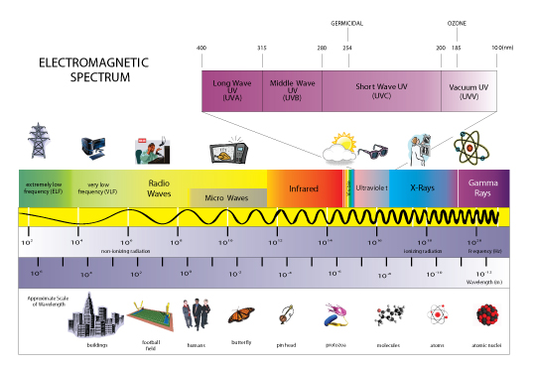

gamma

Which of the wave types has the smallest wavelength?

Which of the wave types has the highest frequency?

gamma



1. Complete the table giving an application and a hazard associated each type of electromagnetic radiation.

|  |  |  |
| --- | --- | --- |
| **Radiation** | **Application** | **Hazard** |
| Radio | communications | Very low risk |
| Microwave | Radar / cooking | Heating of biological tissue |
| Infra red | Bluetooth/ heat lamps | Low risk/ heating |
| Visible light | Laser/photography etc | Damage to eyes |
| Ultra violet | Security markings | Sunburn |
| X Rays | Security scanning / medical | Ionising |
| Gamma Rays | Sterilisation/Weld inspection | Ionising |

**Nuclear Radiation**

1. A radio-isotope used to trace the flow of blood emits gamma radiation and has an activity of 540KBq.

What is meant by an activity of 540kBq

An activity of 540 kBq means that 540000 nuclei decays occur in the source every second

1. The diagram shows how alpha, beta and gamma radiation interact with matter. Label the diagram to show which type of ionising radiation is which

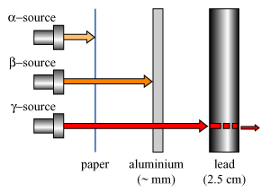

beta

gamma

alpha

1. What is meant by “background radiation”?

Background radiation is the radiation naturally occurring in the environment

1. State two possible sources of background radiation.

Cosmic rays , radon Gas, Rocks containing heavy elements like thorium or uranium, smoke detectors, trace elements in living organisms like potassium or selenium

1. What is meant by ionisation?

Ionisation takes place when radiation knocks an electron off an atom to leave a charged particle or ion

Which type of radiation, alpha, beta or gamma produces the greatest ionisation density in materials. Explain your answer.

1. Imagine you are the radiation protection officer in a large general hospital.

In which departments are workers most likely to be effected by ionising radiation?

X rays - radiography

What advice should you give to limit the possible danger of your workers’ exposure to radiation?

Limit time exposure, Wear protective clothing , Wear a dosimeter badge, Do not point sources at people, do not ingest sources

1. What is meant by the “half life” of a radioactive source?

Half life is the length of time for the activity to decrease to half its original value

1. Why does the activity of a radioactive source decrease over time?

The activity decreases over time because the population of unstable nuclei gets less and so each event becomes more unlikely

1. Describe the difference between a fission and a fusion reaction?

Fission - large nucleus splits into smaller nuclei

Fusion – smaller nuclei join to make a larger nucleus

1. What is the purpose of the control rods in a fission reactor?

Control rods absorb excess neutrons to prevent a chain reaction

1. What causes a fission chain reaction?

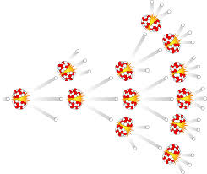A chain reaction is caused by the production of excess neutrons in the fission reaction. Each of these can produce a new fission reaction.

1. A worker in the nuclear industry receives a dose of radiation of 6mGy. What is meant by a dose of 6mGy.

This means that 0.006J of radiated energy is absorbed into each kg mass of absorber

1. Different types of radiation are given different radiation weighting factors. What does the radiation weighting factor tell us about each type of radiation?

The radiation weighting factor tells us the likelihood of damage to living tissue for each type of radiation

1. State the relationship connecting the absorbed dose and the absorbed dose equivalent for a source of ionising radiation

H=DWR

1. What is the unit used to measure the absorbed dose equivalent?

Sievert (Sv)