Vitalism: the spark of life
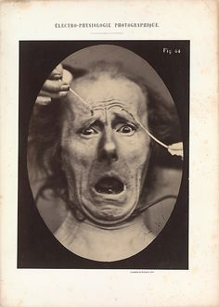
The scientist Duchenne conducted experients on living subjects showing how the nerves responded to electric currents
In medieval times people thought that living things were completely different from non living things. They imagined that living things were made of substances which they called “organic” and that non living things were “inorganic”. They thought that organic chemicals could not be made except by living things. This was a form of the idea called “vitalism” which suggested that there was something uniquely special or even miraculous about life.
After the Renaissance in Europe scientific study became much more common and evidence against this type of thinking began to be found. In 1828 The chemist Friedrich Wohler became the first person to make an organic compound ( urea) from entirely non living ingredients. He wrote describing his discovery to a friend “ I have seen the tragedy of science, a beautiful hypothesis slain by an ugly fact.”
Although Wohler’s experiment showed that there was no fundamental difference between organic and inorganic substances the idea of vitalism lived on in trying to explain how things became alive. For many years the idea of an electrical “vital spark” was popular – Galvani’s twitching frog’s legs and the gruesome experiments conducted by his nephew Aldani were the main reason.
Aldani stood by the guillotine at executions and collected the chopped heads of the victims. He would hold up the ehads and “entertain” the crowds by pushing electrodes into the ears: the electric current would make the head twitch and grimace or the eyes open and roll. Its easy to see how such a sight might have inspired Mary Shelley to write “Frankenstein”.
Nowadays a better understanding of chemistry and genetics has gone a long way to towards explaining the processes of life. Scientists such as Craig Venter are even researching the possibility of making entirely artificial life. But vitalism is still not quite dead: no-one has been able to explain in detail how life began on Earth, nor has anyone explained where human consciousness, which gives our sense of self and being, comes from - philosophers call this “the hard problem”.
There are still many mysteries to solve.

Questions
- What type of chemicals were thought to make up living things?

- Who was the first scientist to make up ( or synthesise) an organic chemical?

- Describe two gruesome aspects of Aldani’s experiments

- The passage mentions “beautiful hypotheses”.

What do you think scientists or mathematicians mean when they describe a theory as beautiful ?

How does this compare to use of this word by artists and musicians?

- Do you think other living things have consciousness? Explain why.

- Do you think it will ever be possible for science or philosophy to explain consciousness?

- The passage mentions “the hard problem” in philosophy . Try and find out about other major unsolved problems in science.
What makes them so hard to solve?
Do you think it is important to solve them?
Choose the art work which you think is the most beautiful. Write a short paragraph to explain what makes you say it is beautiful. Why do you prefer it over the others? 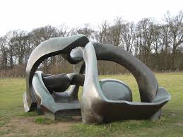 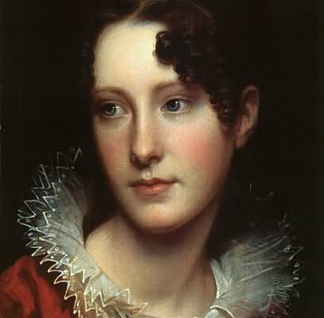 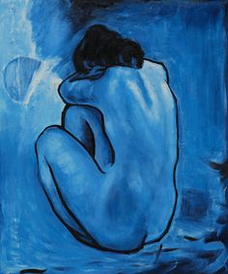
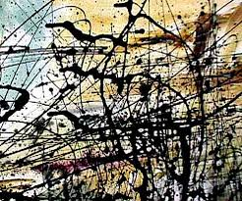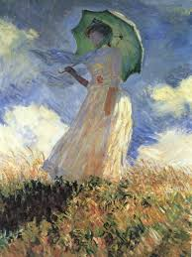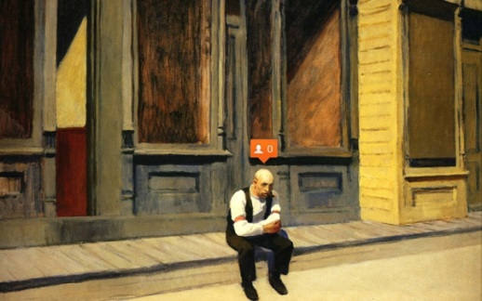
( Artworks by Henry Moore , Rembrandt, Pablo Picasso
Jackson Pollock, Claude Monet, Edward Hopper)
What words other than beautiful would you use to describe the other pictures?

