S1 BODY SYSTEMS SUMMARY NOTES.

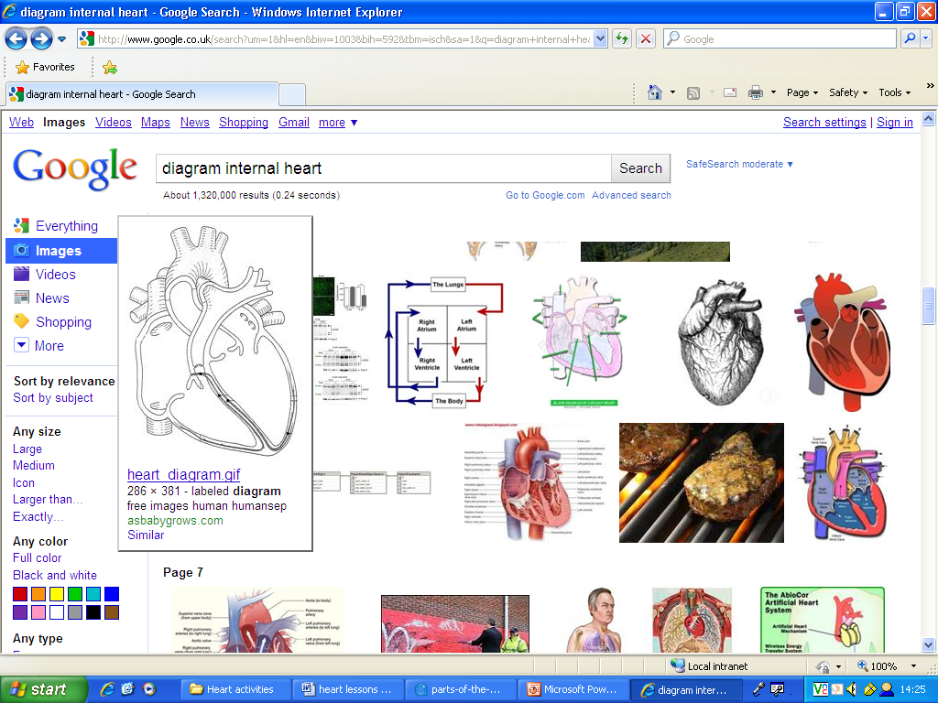
THE CIRCULATORY SYSTEM
LEFT ATRIUM

The heart is a muscle which pumps blood around
the body. It has four chambers. The left side of
the heart has thicker walls, as it has to pump
blood full of oxygen around the body at high
RIGHT ATRIUM
pressure.

Blood travelling from the left hand side to
the body is full of oxygen and food.

Once the blood passes through the body, the
RIGHT VENTRICLE
LEFT VENTRICLE
Oxygen and food have moved into the cells, and
Carbon Dioxide and waste have moved into the blood.

BLOOD VESSELS

There are three main blood vessels, arteries, capillaries and veins.

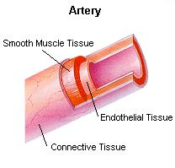
- Arteries carry blood away from the heart rich in food and oxygen and have thick muscular walls to withstand the high pressure the blood travels at.

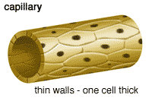
- Capillaries are a dense network of tiny blood vessels, only one cell thick which allow easy passage of materials. This is where the substances pass to and from the cell.

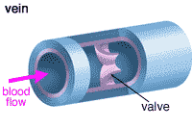
- Veins carry blood rich in Carbon Dioxide and waste back to the blood at low pressure where it is then pumped back to the lungs so it can pick up more oxygen. Veins contain valves which stop the backflow of blood and keep it moving in one direction.
PULSE RATE AND RECOVERY TIME

Your pulse rate is measured by how many times your heart beats per minute. Your pulse rate is the movement of blood through your arteries.
Pulse rate increases during exercise.

One exercise has stopped your pulse rate will eventually slow down. The time it takes your heart to return to your normal resting rate after exercise is called your recovery time.

THE RESPIRATORY SYSTEM

LUNG STRUCTURE AND FUNCTION

Your lungs are the structures found in your chest which are involved in breathing. You have two lungs. The left one is slightly smaller than the right to make space for your heart!

The lungs allow the oxygen we need to live to enter the body. They also allow the Carbon Dioxide (waste gas) to be removed from the body.
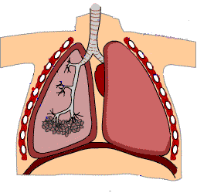
WINDPIPE
RIBS
DIAPHRAGM
BRONCHUS
BRONCHIOLES
AIR SACS
INTERCOSTAL MUSCLES (Between ribs)
Windpipe – made of cartilage
Bronchus – Windpipe splits into two of these one leading to each lung
Bronchioles – Bronchus splits into lots of these smaller branches
Air Sacs Site of gas exchange)
Diaphragm – Large circular muscle involved in breathing.
BREATHING

Breathing in (Inhalation) takes air into the lungs. Your lungs expand in
volume (get bigger) so the space inside your chest needs to get bigger also. This happens by the ribs (and muscles in between the ribs) moving up and out and your diaphragm moving down.

Breathing in (Exhalation) removes Carbon Dioxide and water from the body. The space inside your chest gets smaller as the lungs deflate (get smaller). This happens by the ribs (and muscles in between the ribs) moving down and in and your diaphragm moving down.

BREATHING
IN
Chest cavity gets bigger

BREATHING
OUT
Chest cavity gets smaller

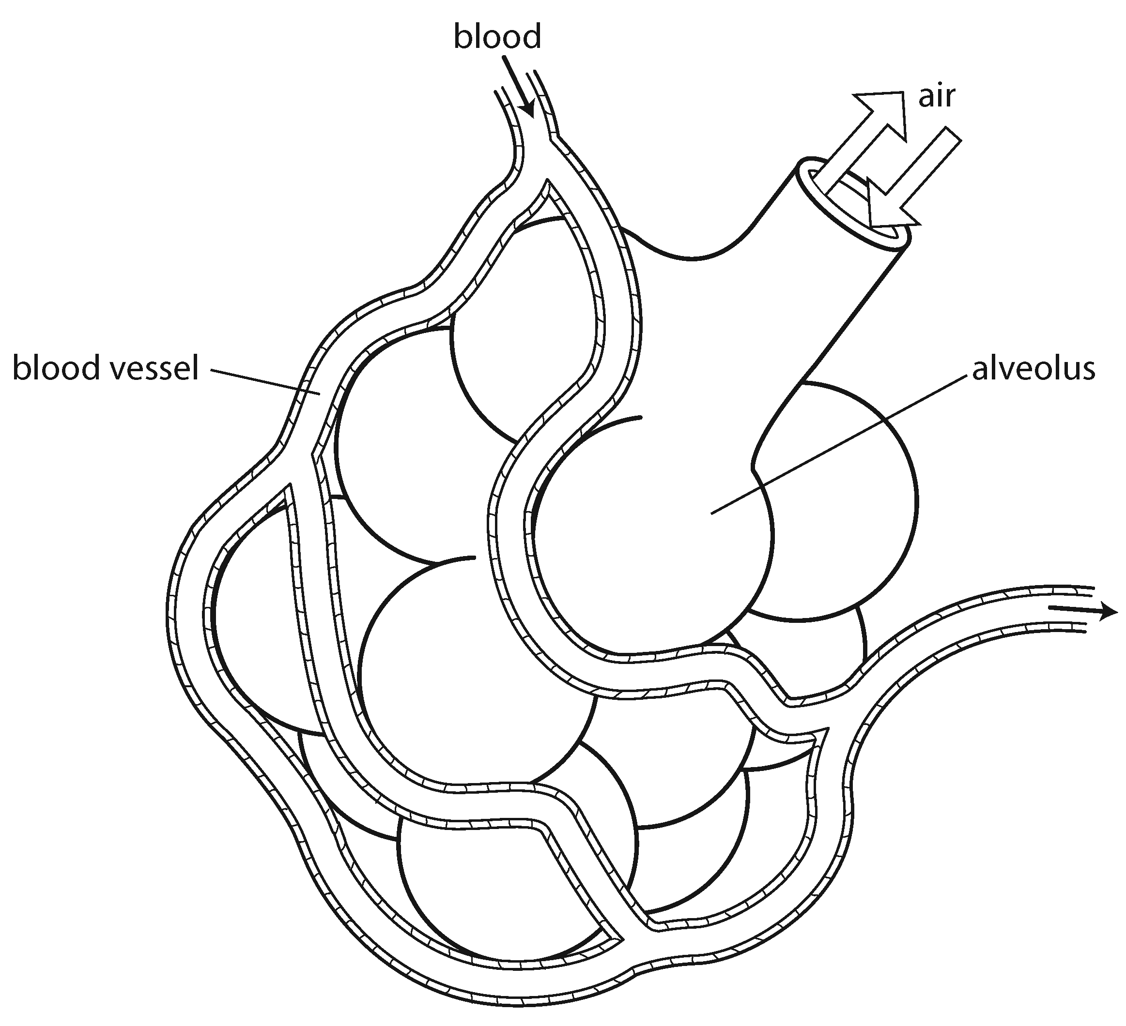
GAS EXCHANGE
The oxygen from the air we breathe in moves into our blood capillaries from the air sacs. The carbon dioxide in your blood moves into the air sacs from the blood capillaries. Air Sacs are covered by a dense network of blood capillaries which are tiny blood vessels only 1 cell thick. This allows the oxygen and carbon dioxide to diffuse easily.

REMEMBER
OXYGEN (moves from)CARBON DIOXIDE (moves from)
LUNGS → BLOOD VESSELSBLOOD VESSELS → LUNGS

SMOKING AND YOUR LUNGS

Your lifestyle choices can damage your lungs, for example if you smoke. Cigarette smoke contains lots of toxic chemicals including tar in which can cause cancer. Carbon monoxide which is in cigarette smoke can affect the bloods ability to carry oxygen. This makes you heart work harder and can also result in heart disease.
Salivary Glands

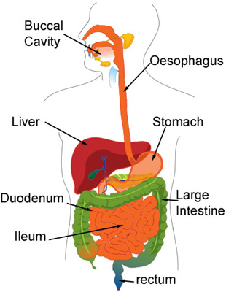
THE DIGESTIVE SYSTEM
Mouth (with teeth)

Digestion is breakdown of large insoluble molecules of food to small soluble molecules of food so our body can use this. This happens in the digestive system. It begins in the mouth where you teeth chew up the food.

Small intestine
Anus

STRUCTURE | FUNCTION
Teeth | Teeth chew up the food to help with digestion
Saliva | Saliva is produced in the salivary glands and contains enzymes which help break down the food for digestion.
Oesophagus (Gullet) | Muscular tube which the bolus (Ball) of food moves down via PERISTALSIS
Stomach | J shaped muscular sack that mixes the food with digestive juices
Liver | Filters out harmful substances and waste
Small Intestine | Fully digested food is absorbed into the blood here
Large intestine | Water is reabsorbed back into the body from the undigested waste
Rectum | The solid waste (faeces) is stored here
Anus | The exit point in the digestive tract where faeces (poo) leaves the body

THE ROLE OF TEETH IN DIGESTION

Teeth are the organs of chewing, which is also known as mastication.
Teeth cut, tear and grind food in the mouth, enabling it to be mixed with saliva (from the salivary glands) effectively and therefore swallowed more easily.

Teeth start mechanical digestion. (i.e. the chewing of food).

THE ROLE OF SALIVARY GLANDS IN DIGESTION

Salivary Glands produce saliva. Saliva is a substance which contains enzymes. This saliva containing the enzymes mixes with the food being chewed and the enzymes start to break down the food to help with digestion.

This is also known as chemical digestion.

