Parent signature:
Name:
Date due:
Body Systems Homework 2
KU /15
PS /3
1.What is the function of the heart?
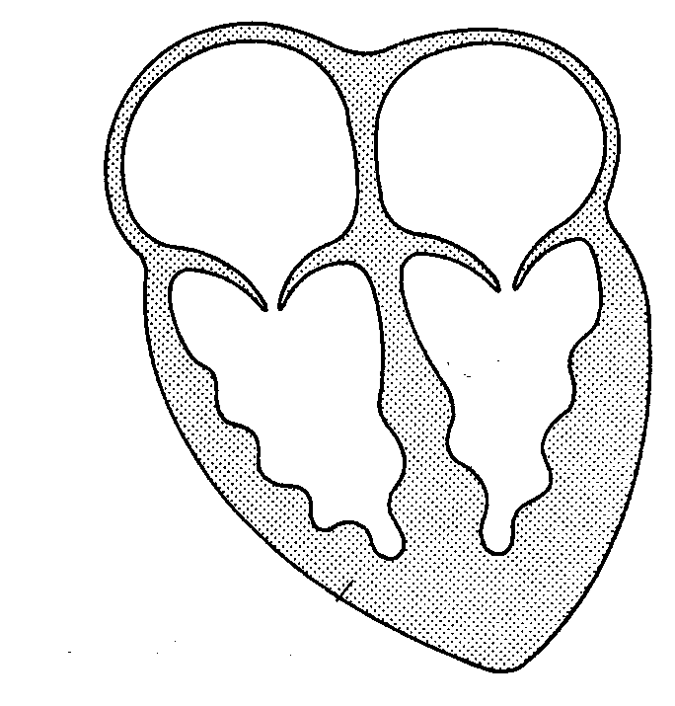
2.Complete the diagram and label the chambers of the heart (don’t forget to mention the left/ right sides):
4
3.Why does the heart need valves?

1

4. Draw lines to match the blood vessels and their descriptions properly:

Artery Carries blood to the heart
Capillary Carries blood away from heart
3
Vein Supplies blood to the tissues

5. Why do arteries need to have thicker walls than veins?

2
6.Which kind of blood vessel has a pulse and what is it caused by?

2

7. Why does the bottom left chamber of the heart have a thicker muscle than the bottom right chamber?

1

8.Heart disease is a major concern in Scotland. Suggest at least 2 life style changes which could reduce a person's risk of suffering from heart disease.

2

9.If the volume of one heart chamber is 70 mls and the heart beats 60 times a minute how many litres of blood will the heart pump in one hour?

1 PS

10. An investigation was carried out to compare the fitness of two female students. The results are shown in the table below. Using what you already know about the heart who do you think may be the fittest justify your answer? (suggest a reason why you chose her)
Name | Pulse rate (beats per minute) |  | Time for pulse rate to return to resting value (minutes)
 | Resting | After exercise
Kelly | 60 | 100 | 3
Claire | 70 | 120 | 6

2 PS

