Respiratory system Homework 5
Name:
Date Due:
Parent signature:
PS /9

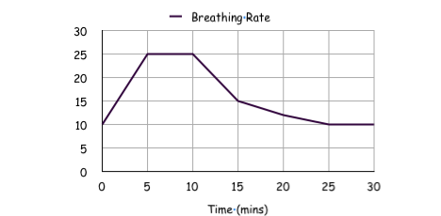
B

C
While training for a race Freddie decided to ride his bicycle with breathing rate monitor attached to his chest. His results produced this graph
1. He measured his Breathing rate in Breaths per Minute. This label is missing from the graph. Should the label be at point A, B or C?

1

2. Give a time (in minutes) when he would have been pedaling hard.
A

1

3. What was his resting breathing rate?

2

4. After what time does the graph suggest he might have stopped pedaling?

1

5. Using your answer from the last question work out how long it took for him to get back to his resting breathing rate.

1

6. What conclusion do you think Freddie would draw from his results?

1

7. How could Freddie have improved this experiment?

1

8. “Breathe easy in space”, what problems do scientists have to overcome to allow astronauts to not just exercise in space but just breath in general?

