Name:
Date Due:

Parent signature:

Body systems homework 6
KU /10

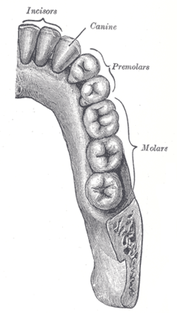
The diagram shows a picture of human teeth.
- Describe the role teeth play in the digestive system?

2

- What role does saliva have in the digestive system?

2

- Draw lines to connect the parts of the digestive system on the left to the correct function on the right.
Carries food to the stomach
Gullet
Large intestine
Absorbs nutrients like fats and proteins
3
Absorbs water from food
Small intestine
- Describe the function of the digestive system. Your description should include the following information:-
What goes into the digestive system
Why we need to change this to a different form
How this is achieved

3

