Bannerman High School

Homework Policy
Homework Policy:

Our Homework Policy aims to outline the provision and supports in place for our young people to complete their homework.

This document outlines the expectations for our young people and provides guidance on how all young people can access their homework from home.

Homework is part of every child’s school day and our expectation as a school is that all tasks provided by teachers are completed.
Everyone, staff, pupils and families, has a part to play in homework, to maximise success and achievement. At Bannerman High School we have a team of highly committed staff who will go the extra mile to ensure the best for your child. At this point, we ask you to join us in supporting your child at home by ensuring they complete all homework set. It is crucial we work together, so please contact us should you or your child need any additional support. We don’t want any child to be left behind on this journey.
All work completed will be part of the on-going continuous assessment of every young person S1-S6. This evidence, along with classwork and teachers professional judgement, will contribute to your child’s achievement and level of attainment. Homework will be set and supported by their teachers to ensure they are not disadvantaged and they progress at an appropriate pace for their age, stage and qualification levels. Homework submissions as well as in class learning will both be taken into consideration when assessing progress and assigning grades and levels throughout the year.
For Pupils Self-Isolating:
At Bannerman we have two Principal Teachers who will coordinate all home learning for pupils asked to self- isolate. They will link in with class teachers to provide information for families of pupils who have been asked to self isolate to ensure they stay on track with class work and progress.
Principal Teacher of Home Learning BGE (S1-S3)
Mr Glen: gw13glenjohn@glow.ea.glasgow.sch.uk
Principal Teacher of Home Learning Senior Phase (S4-S6)
Miss MacLeod : gw16macleodgemma@glow.ea.glasgow.sch.uk

This Homework Policy will outline expectations and guidance for:
- Young People
- Parents/Carers
- Teachers
By sharing this information, the hope is that we all understand the role each of us can play in every child’s journey to success. By working together, we will be able to create a supportive team around every child at Bannerman High School. This shared understanding and collaborative working will enable us to create structure, consistency and maximise engagement in learning both at school and at home.
This policy also provides details on the platforms that we will be using in order to provide our Home Learning Programme.
How Will Homework Be Shared?
In order to deliver online homework we will be using three platforms:
- Glow Launch Pad
- Satchel:One
- Microsoft Teams
For all 3 of these platforms the young person’s username and password is the same. It is the Glow usernname and password they have been issued with at school. This can be reset if required.
Glow Launch Pad:
Any pupil can access their Glow Launch Pad by typing into their internet searchbar “sign in to glow”. Once the have signed in using their glow username and password they will have access to their own individual launchpad. This will show them an Satchel One tile, Microsoft Team tile and Outlook Email tile. This is important as they can access all of their online learning through this method.
Satchel:One/ SMHW:
This is essentially an online homework diary. All pupils should already be logged on to Satchel:One. When a homework or home learning task has been set, young people will be able to view their homework tasks, see instructions for homework, completion set by their teachers and will be sent regular reminders and notifications for deadlines. If a young person requires clarification of a task they can communicate with their teacher in the comments section. Important announcements for pupils will also be shared on Satchel:One. This will be used next sesion as Assemblies and Tutor time will not be possible.
Satchel:One can be accessed through Glow Launchpad or the Satchel:One app.
Parents and carers can log in to Satchel:One with a unique parent code. This will allow access to an overview of your child’s asignments and help you to support and encourage them. If you need your pin reset or re-issued please contact Ms Hart in the office.
Microsoft Teams:
Each pupil will be placed in a Microsoft Team for each of their classes. This is a virtual classroom which gives them access to tasks, worksheets and resources shared by their teacher. In their Team they will have an online notebook to record their work. This is private between the young person and their teacher and keeps all their work together in one online space. In addition, it allows their teacher to mark work and provide effective feedback and guidance for improvement on their notebook. An added feature is that each teacher can communicate with the class as a whole or with individual young people regarding their work. This can be accessed through Glow Launchpad or Microsoft Teams app.
Your child will be taught how to use all of these platforms in school.

What We Expect From Our Pupils at Home:
Part of your school day will rely on you completing learning tasks at home set by your teachers. For each subject you study in school the expectation for homework per week will be as follows:
S1/2 up to 30 mins per curricular area. English and Maths 1 hour
S3 up to 1 hours per SQA National Subject
S4 up to 1 hours per SQA National Subject
S5/6 up to 2 hours Per SQA National/ Higher Subject
Homework is not optional.
Teachers will expect all homework tasks to be completed and will contact home if they are not. We will help you if you have barriers to completing work at home and you should always tell your subject teacher or Pastoral Care teacher if you are having problems.
It is a good idea to establish a routine:

- Set up a designated study space without distractions.
- Ask someone at home to support you to make sure you can focus and get through work within a reasonable time scale.
- Use Satchel:One (SMHW) and create a personal planner to get organised.
- Choose a regular time each day.
- Several spaced-out sessions are best don’t leave everything to the last minute.
- Seek help if there is anything you don’t understand, don’t know how to do or your technology isn’t working.

Families- What You Can Do to Support:
Families will play an important role in helping young people complete homework. Please remember, you are not being asked to home school or teach your child but it is really important that you monitor you child’s work to make sure they are keeping up to date with homework tasks. Every task being set is important for their learning.
You can help in the following ways:
- Download Sachel:One (SMHW) and have regular conversations about their homework and learning.
- Check your child is keeping up to date with their homework deadlines.
- Look at their work, ask questions and encourage them to always produce their best.
- Help by asking your child how they might do a task or find a solution to a problem, will be of greater benefit than simply telling them what to do (or giving them the answer).
- Help them find a good place to work at home. If your child is easily distracted, finding a space that is quiet will be important. If they are distracted by phones or other gadgets, then working out a plan to remove these while working would be a good idea.
- Help your child devise a schedule for working. We know the challenges this will present for many families, especially if there is no adult around during the day to supervise. The expectations on the amount of homework should act as guide. Working out a homework l timetable and supporting your child to stick to it will be one of the best things you can do to support.
- Any concerns, please contact your child’s Pastoral Care Teacher or Year Head so support can be provided. Never feel that your questions or concerns are not important. If they are preventing your child from learning, then they are very important.

What if?
You don't know how to help your child with a piece of homework which is due in the next day?
- encourage your child to contact friends
- send a note or email to the class teacher with your child explaining the difficulty
- don’t stay up till midnight worrying about it – we can sort it out together. Just let us know.
What if?
The homework is presenting problems but is due to be returned right away?
- encourage your child to discuss it with friends
- encourage him or her to ask the teacher about it
- contact the subject teacher or Pastoral Care staff to seek help.
Information for Teachers:

Homework Content Guide per week (work to be completed at home):
S1/2 up to 30 mins per curricular area. English and Maths 1 hour
S3 up to 1 hours per SQA National Subject
S4 up to 1 hours per SQA National Subject
S5/6 up to 2 hours Per SQA National/ Higher Subject

Feedback (Marking schemes for self -marking tasks, marks, written, voice feedback)

Principal Teachers will lead departments on how this will be delivered to ensure consistency across all classes within their subject.
If homework has not been handed in please alert your Principal Teacher so contact can be made with home.

Methodology
The main platforms we will be using are outlined below:
- Glow Launchpad
- Satchel: One
- Microsoft Teams

Glow Launchpad
Teachers can access Satchel: One, Microsoft Teams and school emails via the Glow Launchpad. Teachers should regularly check their emails for submissions and homework enquiries from young people, parents and carers.
Satchel: One
All homework assignments will be posted on Satchel: One with clear instructions of how to complete the assignment. If a child fails to complete homework please notify your Principal Teacher so that contact can be made with home.
Microsoft Teams
Each class will have a Microsoft Team. Teachers should share all proformas, workbooks, worksheets, videos, research, online texts and presentations on Microsoft Teams. Where classes have multiple teachers all teachers should be co -owners of the team.
Where possible, pupils should be encouraged to use their class notebook in Microsoft Teams to complete their homework.
When all pupils have iPads this will be the primary space we will be working from as their jotter in school and at home.
Principal Teachers will lead discussions on how this can be utilised best for each subject area.

ICT Issues
Sachel:One (SMHW)
Ms Hart gw17hartlinda@glow.ea.glasgow.sch.uk
Mrs Dickson gw10dicksonlynn@@glow.ea.glasgow.sch.uk
Ms Pearson gw10pearsonjenny@glow.ea.glasgow.sch.uk

Microsoft Teams:
Miss MacKenzie gw17mackenziecatriona@glow.ea.glasgow.sch.uk
Miss MacLeod gw16macleodgemma@glow.ea.glasgow.sch.uk
H McNish gw18mcnishhayley@glow.ea.glasgow.sch.uk
Mr Kelly gw15kellyross@glow.ea.glasgow.sch.uk
Mr McMenemy gw17mcmenemyelliot@glow.ea.glasgow.sch.uk
Mr Bristow gw18bristowbobby@glow.ea.glasgow.sch.uk

Glow:
S2: gw13ohldagruth@glow.ea.glasgow.sch.uk
S3: gw10pearsonjenny@glow.ea.glasgow.sch.uk
S4: gw14mcconachieruth@glow.ea.glasgow.sch.uk
S5: gw07colquhounstephen@glow.ea.glasgow.sch.uk
S1& S6: gw08kerrfiona8@glow.ea.glasgow.sch.uk

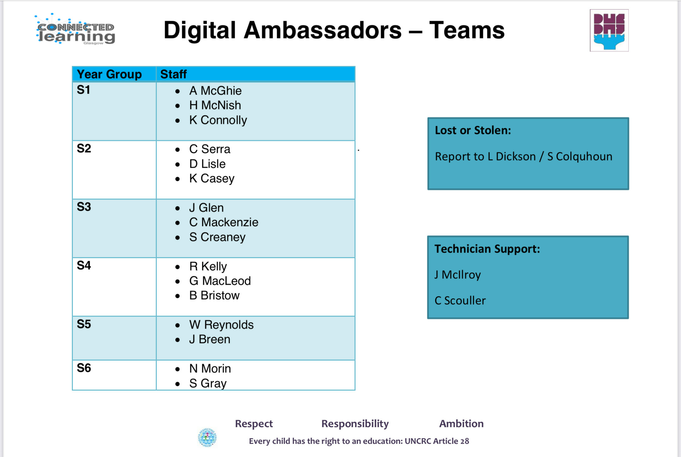
Information for Parents and Carers
- Homework will be issued to all young people via Satchel:One (SMHW)
- Download Satchel:One (SMHW) and login using your unique parent code to see tasks that have been assigned to your child. If you need this reissued please phone Ms Hart at the Bannerman school office.
Family Assistance
• If you require additional help or assistance please see additional contacts sheet.
Additional Information
- Bannerman Twitter feed
- Satchel:One/ SMHW
- Bannerman High School website
- Check GLOW

How to access Glow Launch Pad?

- Type in Glow login to your internet browser bar

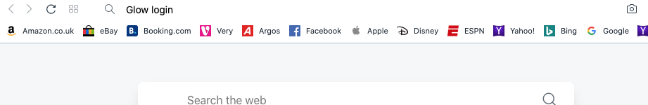

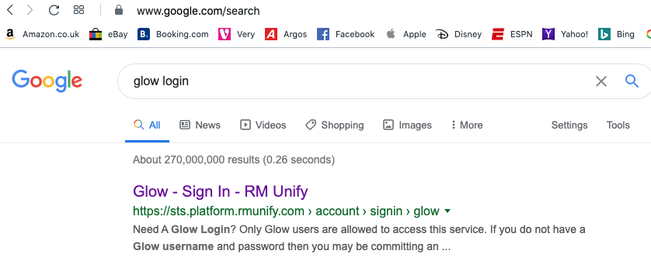
2. Click on the first option “Glow- Sign In- RM Unify “

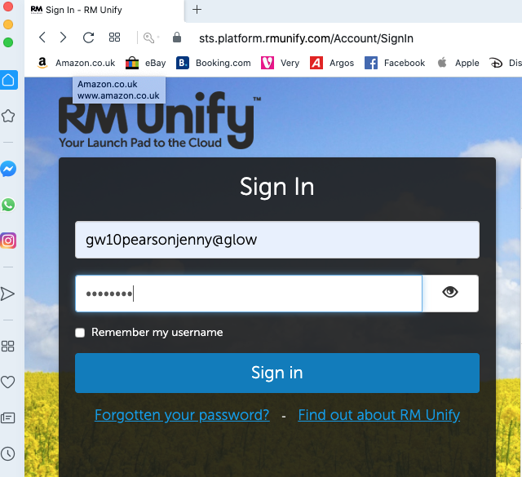
3.Type in glow username and password and press the sign in button

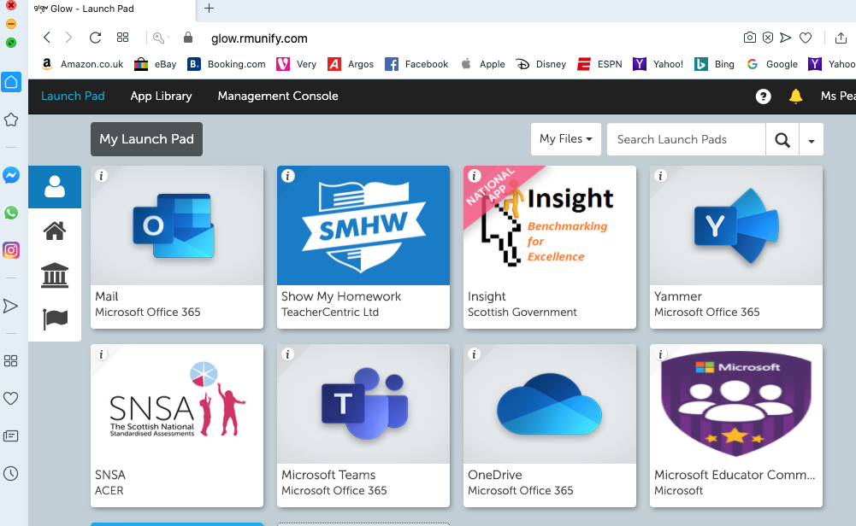

4.You are now in your Glow Launchpad. From here you can access your emails, SMHW/ Satchel:One and Teams. Click on the tile and it will take you straight to what you want access to.

5.If you have not added the tiles already click on the tile with “add” on it and search for the tiles you want to add.

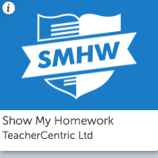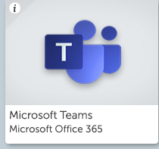

How to access Satchel:One via app on smart device

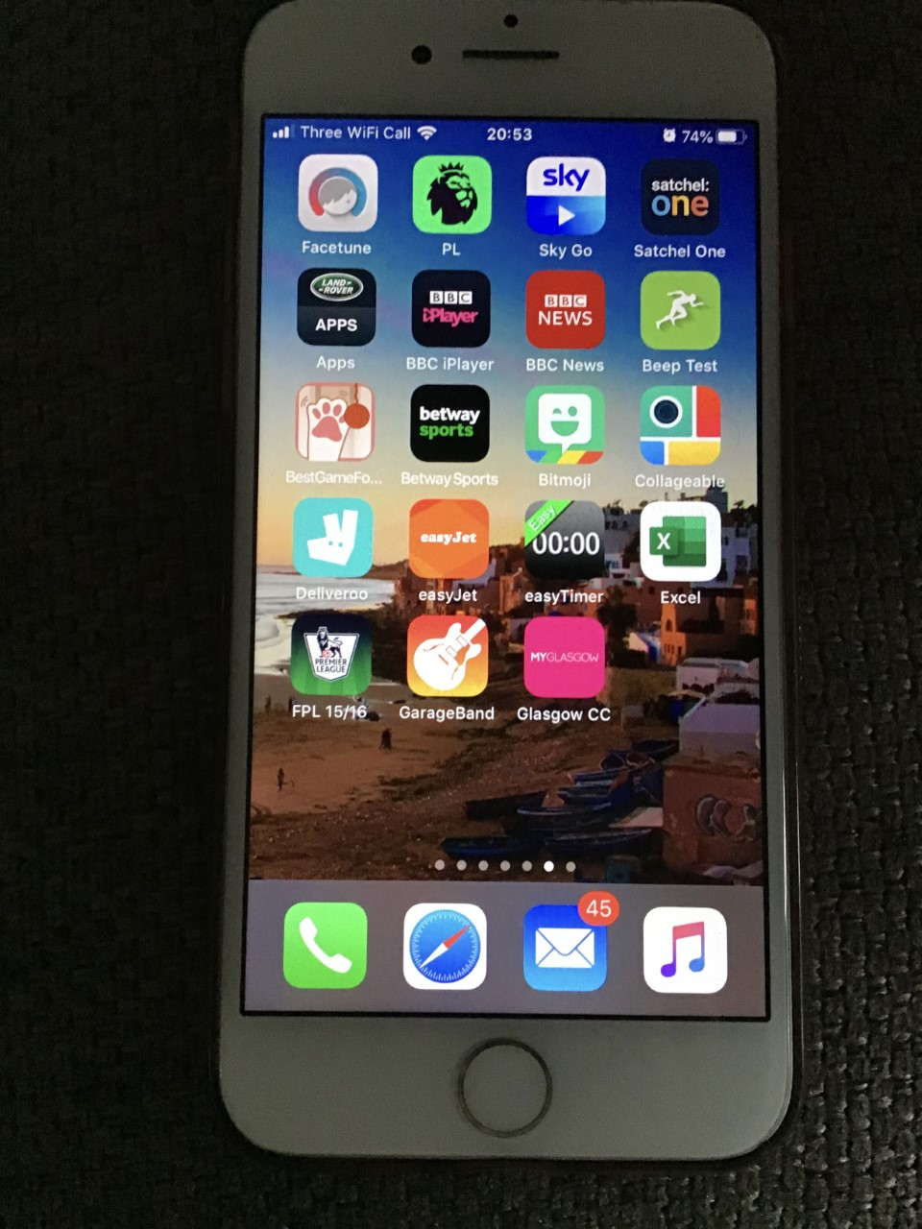
- Download Satchel:One app (top right)

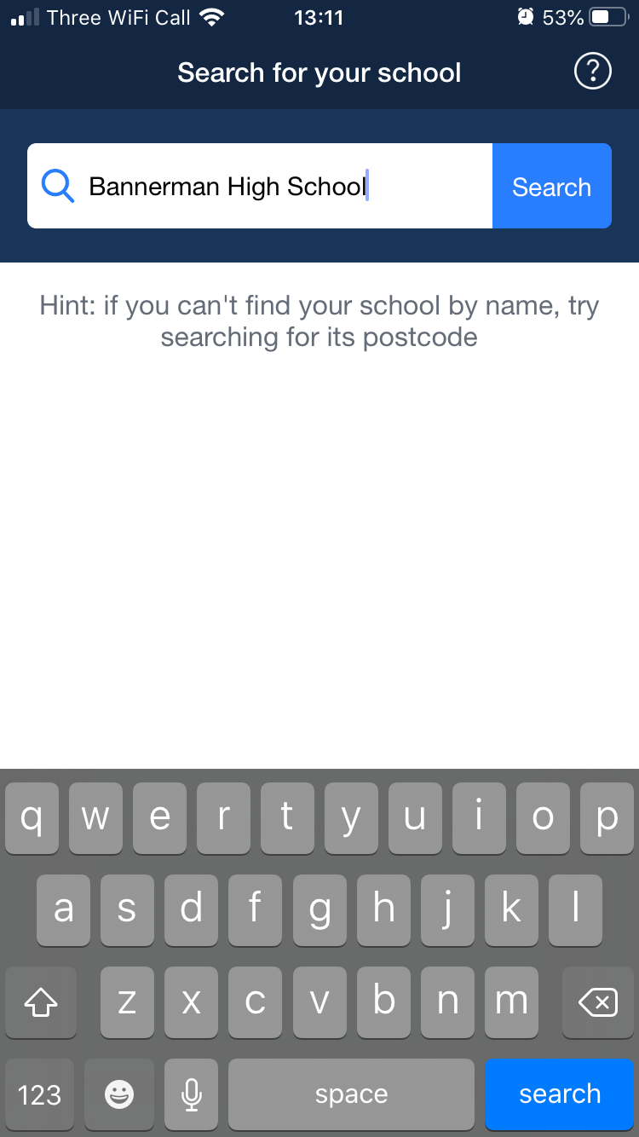
- Select Bannerman High School

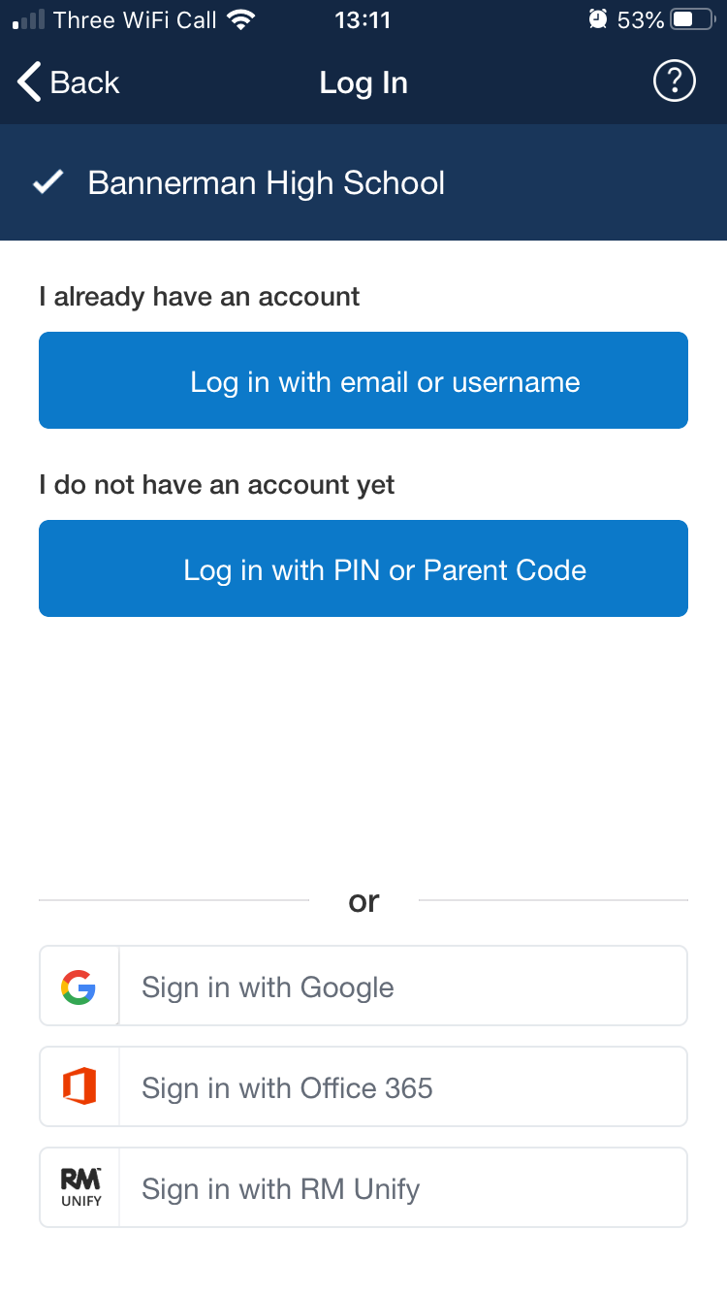

3. Go to the very bottom of the screen on your phone and press the ‘Sign in with RM Unify’ button.

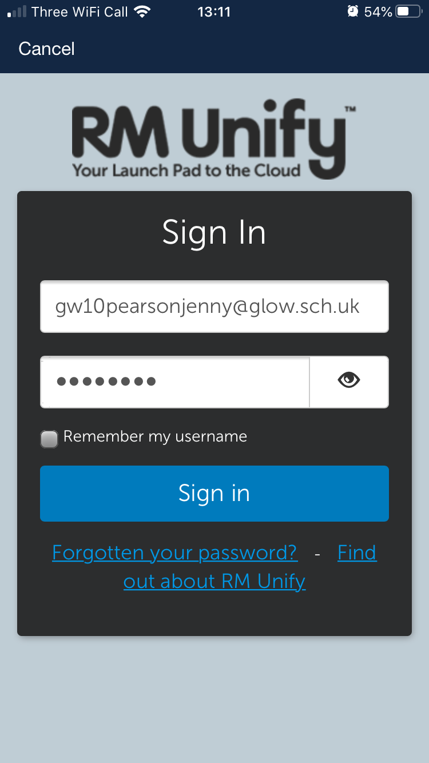
5.Once you press the sign in button that should be you logged on to Satchel:One (SMHW)

4. Once you see the below screen enter your glow username and password.

How to access Microsoft Teams via app on smart device

- Download Microsoft Teams App

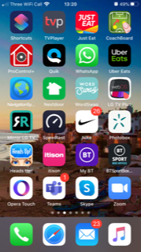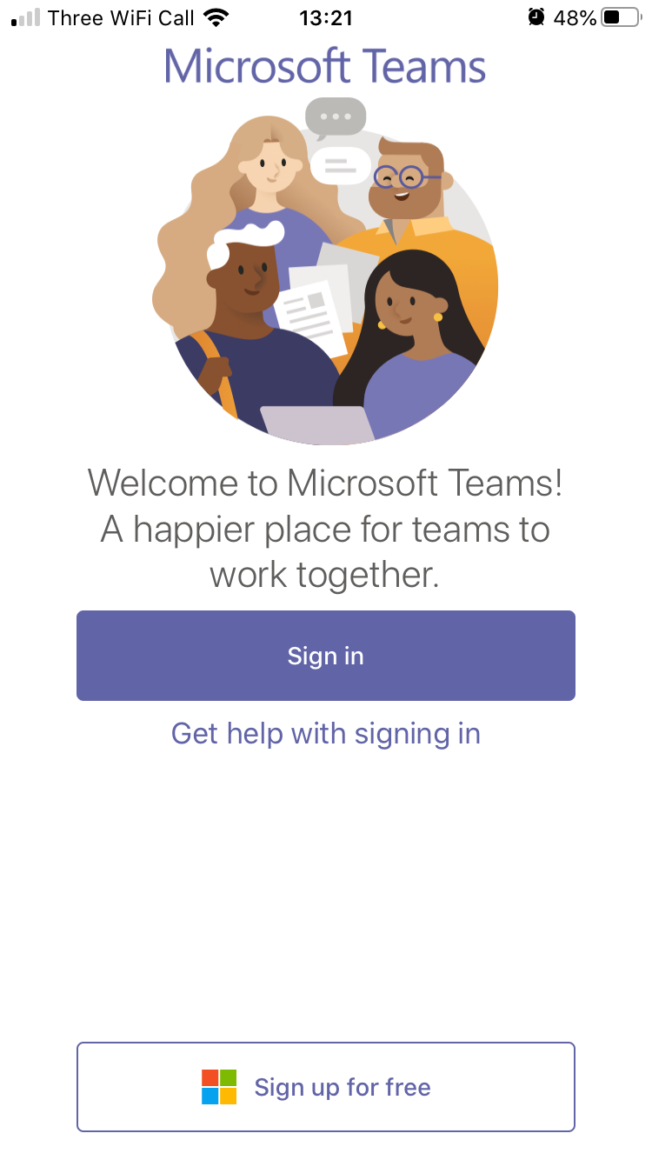
- Press the sign in button

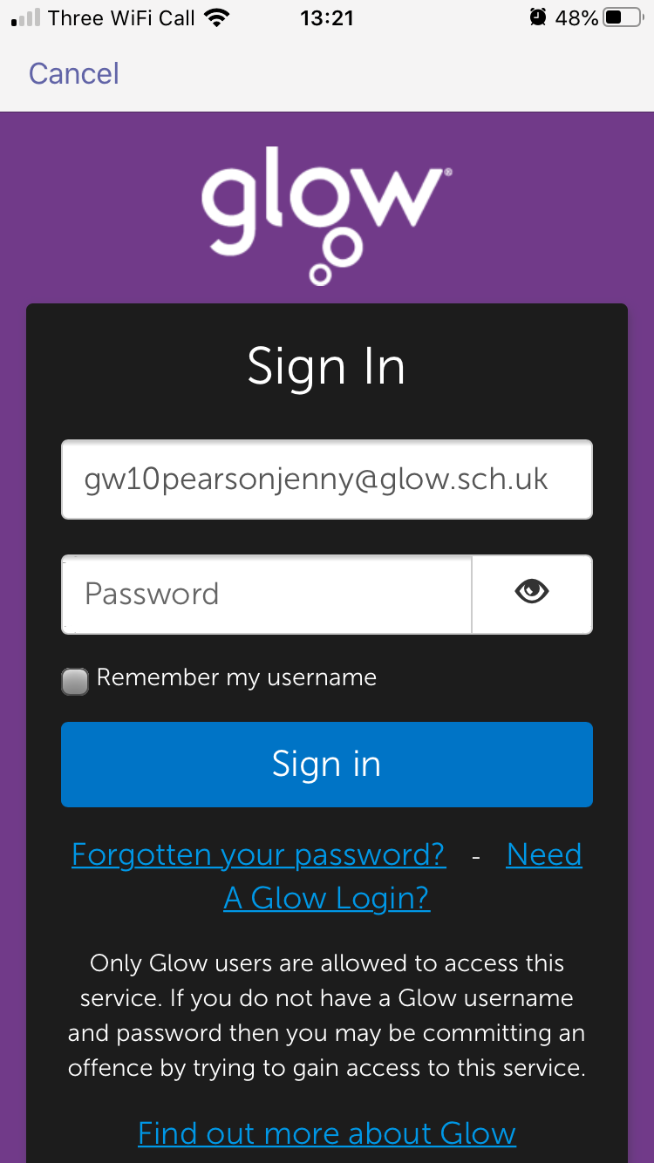
3.Login using your glow username and password

4. You should now be signed in to Microsoft Teams

SUBJECT SPECIFIC RESOURCES - List of subjects and links to support

BGE – LEVEL 3 AND 4

https://www.bbc.co.uk/bitesize/levels/zvk2fg8
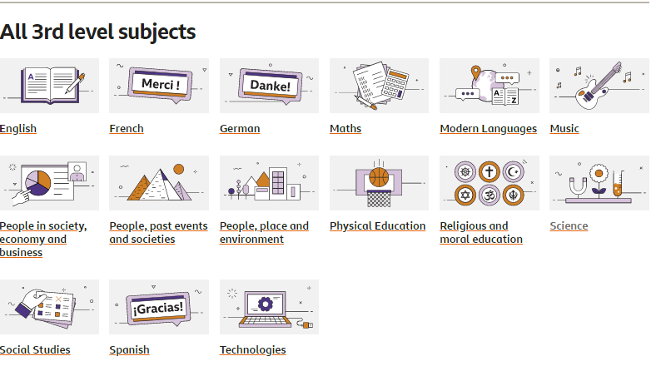
https://www.bbc.co.uk/bitesize/levels/zy4qn39
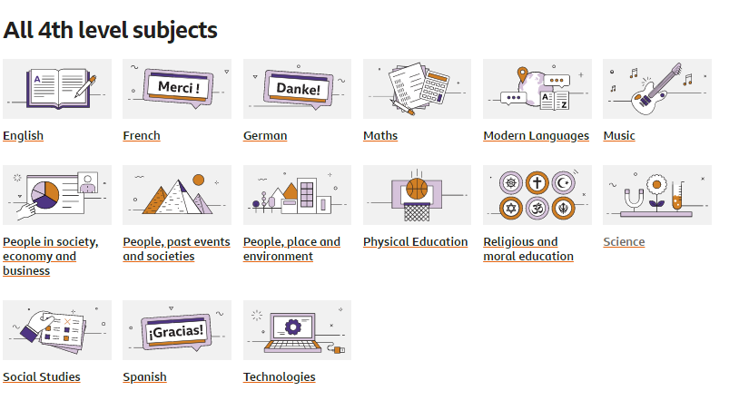

NATIONAL 4 SUBJECT SPECIFIC RESOURCES

BBC BITESIZE https://www.bbc.co.uk/bitesize/levels/zp3d7ty
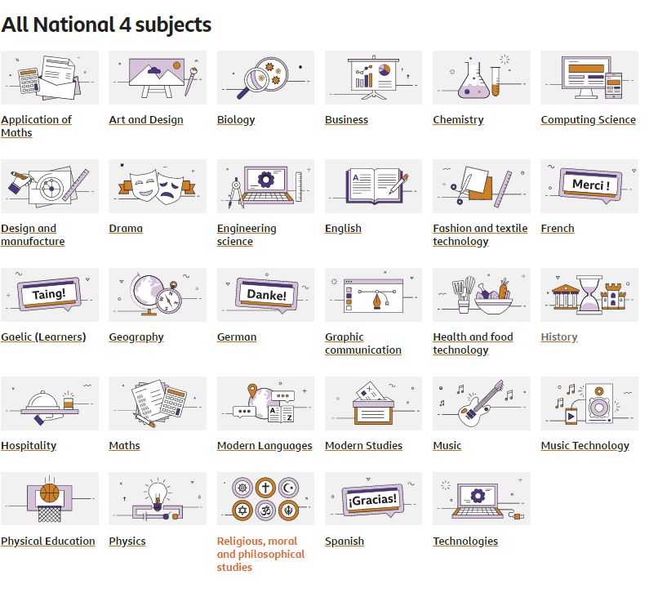

NATIONAL 5 SUBJECT SPECIFIC RESOURCES
BBC BITESIZE https://www.bbc.co.uk/bitesize/levels/z6gw2hv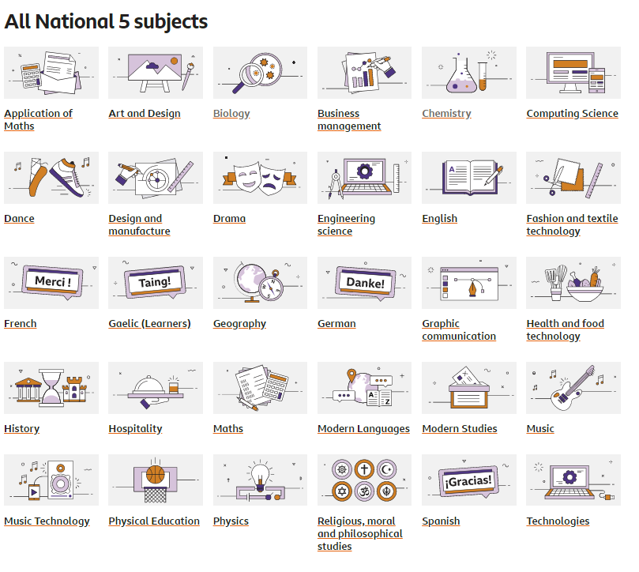

BRIGHT RED DIGITAL ZONE – Revision book website free to access Digital Zone (note you need to register but once registered can access revision materials for all subjects.
National 5 resources https://www.brightredbooks.net/n5
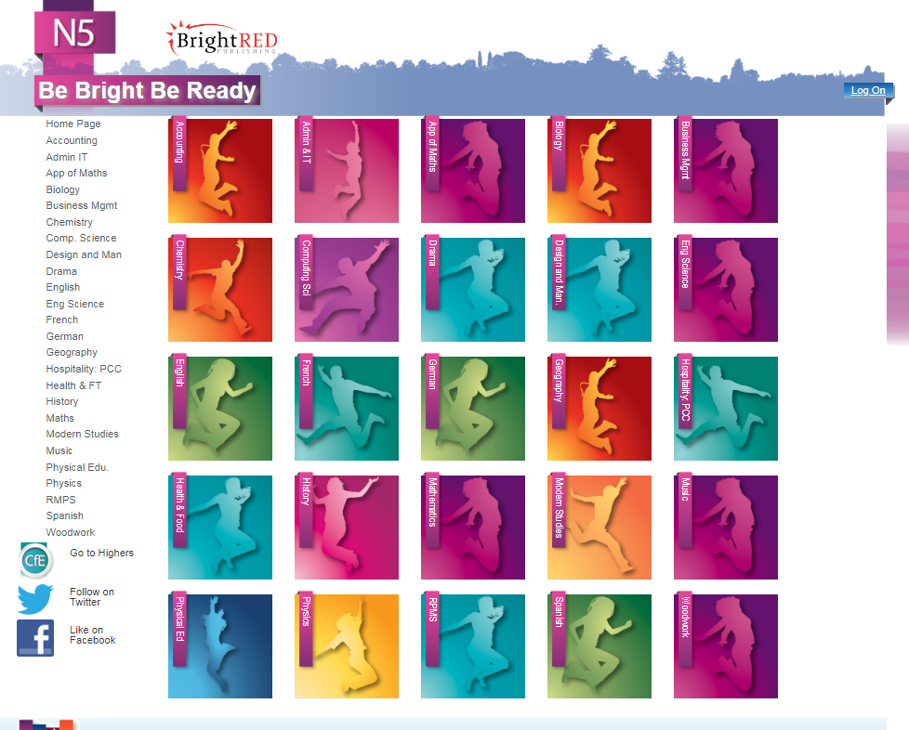

Higher Resources

s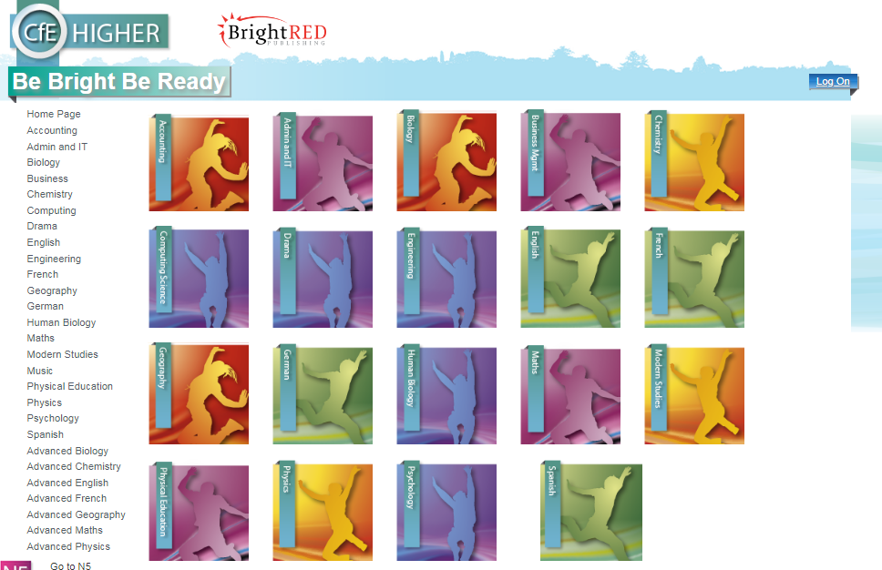

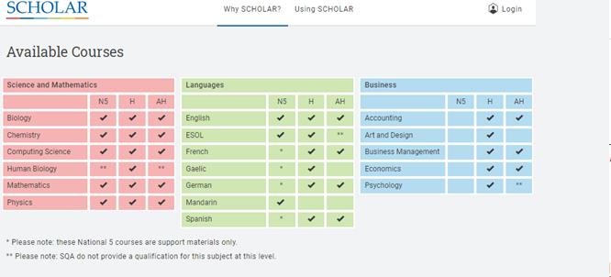
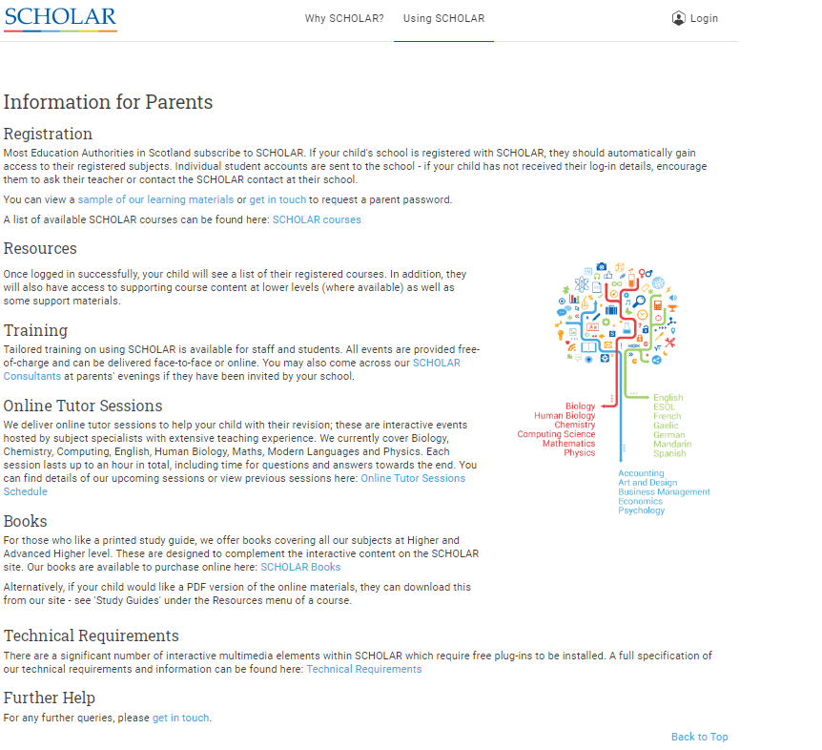

Further Online Revision Resources

MATHS
NATIONAL 4 - https://www.national5maths.co.uk/free-national-4-maths/
NATIONAL 5 - https://www.national5maths.co.uk/#tourstop

ENGLISH
Preferred revision website for English is Scholar

BIOLOGY
NATIONAL 4 - Nat 4 1 Cell division
https://youtu.be/5zoYDTsqViU
Nat 4 2 – DNA GENES AND CHROMOSOMES
https://youtu.be/obRVcBOr0zc
Nat 4 3 – THERAPEUTIC USE OF CELLS
https://youtu.be/IKxJpIlb0j4
Nat 4 4 - Properties of enzymes and their use in industry –
https://youtu.be/tM6jNttMaCw
Nat 4 5 Properties of micro-organisms and their uses in industry
https://youtu.be/9HOk8A-j4Es
NATIONAL 5 & HIGHER
Youtube channel - https://www.youtube.com/channel/UCsDviUaUZHs0zgUXbb3regQ
ORONSAY BIOLOGY(NATIONAL 5 AND HIGHER)
http://www.oronsay.org/Biology.htm

CHEMISTRY
Youtube channel – Nat 4/5 and Higher videos https://www.youtube.com/channel/UCU32Og7N9VTUWL1qfJOPZxA/featured

TECHNICAL STUDIES
http://www.technologystudent.com/
https://www.bbc.com/education/subjects/zyfb87h
http://www.bannermanhigh.glasgow.sch.uk/

Pupil Support

Staff Member | Overall Responsibility | Email
Ms Black | Head Teacher | gw10blackseonaidh@glow.ea.glasgow.sch.uk
Ms Kerr | DHT  Head of Year for S1 & S6 | gw08kerrfiona8@glow.ea.glasgow.sch.uk
Ms Ohldag | DHT  Head of Year for S2 | gw13ohldagruth@glow.ea.glasgow.sch.uk
Ms Pearson | DHT  Head of Year for S3 | gw10pearsonjenny@glow.ea.glasgow.sch.uk
Ms McConachie | DHT  Head of Year for S4 | gw14mcconachieruth@glow.ea.glasgow.sch.uk
Mr Colquhoun | DHT  Head of Year for S5 | gw07colquhounstephen@glow.ea.glasgow.sch.uk
Ms Peoples | PTPC  Burns | gw10peopleslynn@glow.ea.glasgow.sch.uk
Mr Pattison | PTPC  Livingstone | gw10pattisonnorman@glow.ea.glasgow.sch.uk
Mrs Morton  Miss Reid | PTPC  Mackintosh | gw10mortonlynsey@glow.ea.glasgow.sch.uk  gw10reidgillian2@glow.ea.glasgow.sch.uk
Mr Gardiner | PTPC  Napier | gw10gardinercolin@glow.ea.glasgow.sch.uk
Ms Heeney | PTPC  Telford | gw10heeneysheila@glow.ea.glasgow.sch.uk
Mrs Guile | PTPC  Wallace | gw08guileruth@glow.ea.glasgow.sch.uk
Mr Statham | PT in Charge of LCR | gw10stathamrobert@glow.ea.glasgow.sch.uk
Ms Kerr | DHT in charge of Additional Support Needs | gw08kerrfiona8@glow.ea.glasgow.sch.uk
Ms Lisa Wilson | Action for Children Bannerman Family Support Practitioner | Lisa.Wilson@actionforchildren.org.uk

Help Guides / Additional Information

The following are links to particular sites relating to home learning:

Glow- https://glowconnect.org.uk/about-glow/
Teams - https://glowconnect.org.uk/teams-in-glow/
Show My Homework/ Satchel:One - Parent and pupil guides can be found on the school website with link direct to the site if you click on this SMHW badge:
If you have not got your glow username and password please speak with relevant Year Head, PTPC , Ms Hart, ICT Teacher, or Mrs Dickson and they will re-set it for you.
Twitter - @BannermanHigh
Microsoft Teams https://www.microsoft.com/en-us/education/remote-learning
Glow groups https://glowconnect.org.uk/contingency-planning/
Guide to Online Safety – Keep your child safe online:
www.thinkuknow.co.uk/professionals/our-views/parents-helpsheets/

