WHAT IS BULLYING?

Bullying involves some form of taking advantage of someone which is hurtful or rejecting. It can be
(i) verbal (eg. name calling)
(ii) social (eg. no one talking to you)
(iii) material (eg. your things being damaged)
(iv) mental (eg. being threatened or forced to
do things)
(v) physical (eg. being hit)

WHO GETS PICKED ON

Anyone can be bullied and many young people are bullied for no particular reason. The victims of bullying need help and support. No one brings bullying on themselves.

WHY DO YOUNG PEOPLE BULLY

Young people bully others for a lot of different reasons. It may be because they are
(i) lacking in confidence
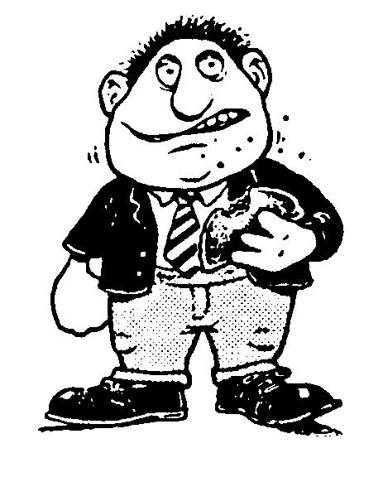
(ii) unhappy
(iii) jealous
(iv) being bullied themselves
They bully in order to
(i) look tough - (gain status)
(ii) show off
(iii) gain attention
(iv) make up for lack of success
(v) hide their own fears and things which
worry them.
(vi) “keep in” with their friends

WHAT IS THE SCHOOL DOING?

Bullying goes on in all schools and it is the action which a school takes to combat the problem which is important. We at Bannerman High School have acknowledged that every child has the right to be educated in a safe environment free from fear and intimidation and every staff member, pupil and parent has a responsibility to play a part in the school’s anti-bullying strategy. In Bannerman we aim to promote positive relationships and our school rules/code of conduct emphasises the values of mutual respect, caring, support and co-operation.

WHAT WE DO OR HAVE DONE TO PREVENT BULLYING

(i) All staff have undergone awareness raising in-service training.
(ii) The school has an anti-bullying statement of policy and practice which has been issued to all staff.
(iii) This leaflet is issued to all pupils and parents to raise awareness of the problems and offer advice.
(iv) The school’s Personal and Social Education Programme teaches anti-bullying strategies and dealing with bullying in S1 to S4.
(v) We have a Bannerman Buddy Scheme where senior pupils are paired with junior pupils to offer them support.

IN ADDITION TO THE ABOVE WE WILL ALWAYS FOLLOW THROUGH ALLEGATIONS OF BULLYING. THIS IS SOMETHING WE TAKE VERY SERIOUSLY IN BANNERMAN

WHAT PUPILS SHOULD DO

IF YOU ARE BEING BULLIED

a) Tell someone you trust that it is happening. This could be your Tutor Teacher, your Pastoral Care Teacher or any teacher in the school. It could equally be a family member or a friend. Remember bullying thrives on
secrecy.
b) Be persistent, don’t give in. If you have a problem make sure that the person you tell takes you seriously. Go back more than
once, or tell someone else.
c) Ask a friend to go with you if you don’t feel
that you can approach an adult yourself.
d) Always tell the truth. Do not add to the story or exaggerate things - bullying is bad enough on its own without added lies. Also, lying can get you into difficulties.

IF YOU KNOW SOMEONE WHO IS BEING BULLIED

a) Tell someone.
b) Offer support to the person - be a friend. Do not resort to violence to help them; this will
only make things worse.
c) Don’t accept bullying behaviour; it is a nasty and twisted way of showing off. Remember the cartoon on the front page. If you see or
hear of bulling, never ignore it.
d) Contribute your ideas on anti-bullying in Personal and Social Education classes.

WHAT PARENTS SHOULD DO

(i) Listen to any anxieties or concerns which your children might have

(ii) Talk to your children about school and be sensitive to changes in their attitude towards school. Often the first reaction to being bullied is to become moody or depressed. Parents are best placed to pick up on these character changes.

(iii) Report any unusual changes in behaviour to the school. A sudden unwillingness to go to school is often another sign of bullying. Be assured your concerns will be acted upon.

(iv) Keep in regular contact with the school about the measures being undertaken to stop the bullying. This will allow you to keep the school up-to-date and let the school give you feedback on progress.

CONTACT PEOPLE IN SCHOOL

The following can be contacted on:
0141 582 0020

House Pastoral Care Teachers

Livingstone Mrs S Shah
Mackintosh Miss J Frew
Napier Mrs Lindsay
Telford Mr J McGilivray
Wallace Mrs Kirwan
X Ms L Peoples

SOME WAYS TO DEAL WITH BULLYING

DOs
(i) Tell someone about it. Bullying exists because people keep quiet about it. Let someone you trust know about it (any teacher, a parent, a friend, a senior pupil). People will help you.
(ii) Establish a group of friends or just people to “go about with” in school. Bullies rarely take on more than one person at a time and your friends will support you and tell someone of the bullying even if you find that idea frightening.
(iii) Stay calm and confident if confronted by a bully. Bullies want to scare and hurt people. If the bully gets no reaction or thinks he/she will be reported, the bullying will stop. Remember if you overreact (eg. hit the person) you might end up accused of bullying.

DON’Ts
(i) Blame yourself - most people have been bullied at some time, it is something which everyone agrees should not happen. No one
deserves to be bullied.
(ii) Think like a victim - it is important that you do not feel bad about yourself if you are being bullied. You have a lot to offer, you are not the one with the problem.
(iii) Put yourself at risk - be “streetwise” or better “schoolwise”. Avoid places or situations where you feel there may be a danger of you being bullied.

BANNERMAN HIGH SCHOOL

ACTION AGAINST BULLYING

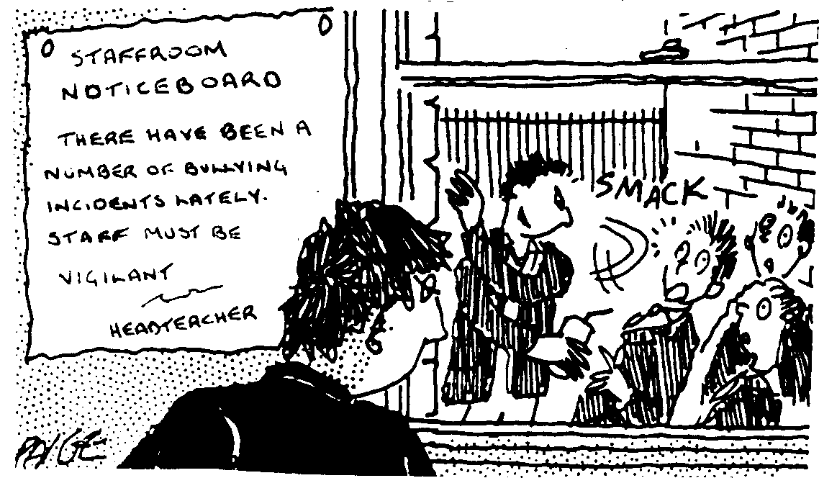

REMEMBER

We can all help to stop bullying. In the picture above the situation gets worse if:
(i) the teacher doesn’t take action
(ii) the watching pupils ignore it
(iii) the pupil is too scared to report it
(iv) the pupil’s parents don’t want to
bother the school

WE MUST ALL ACT TOGETHER TO STAMP OUT THE EVIL OF BULLYING

