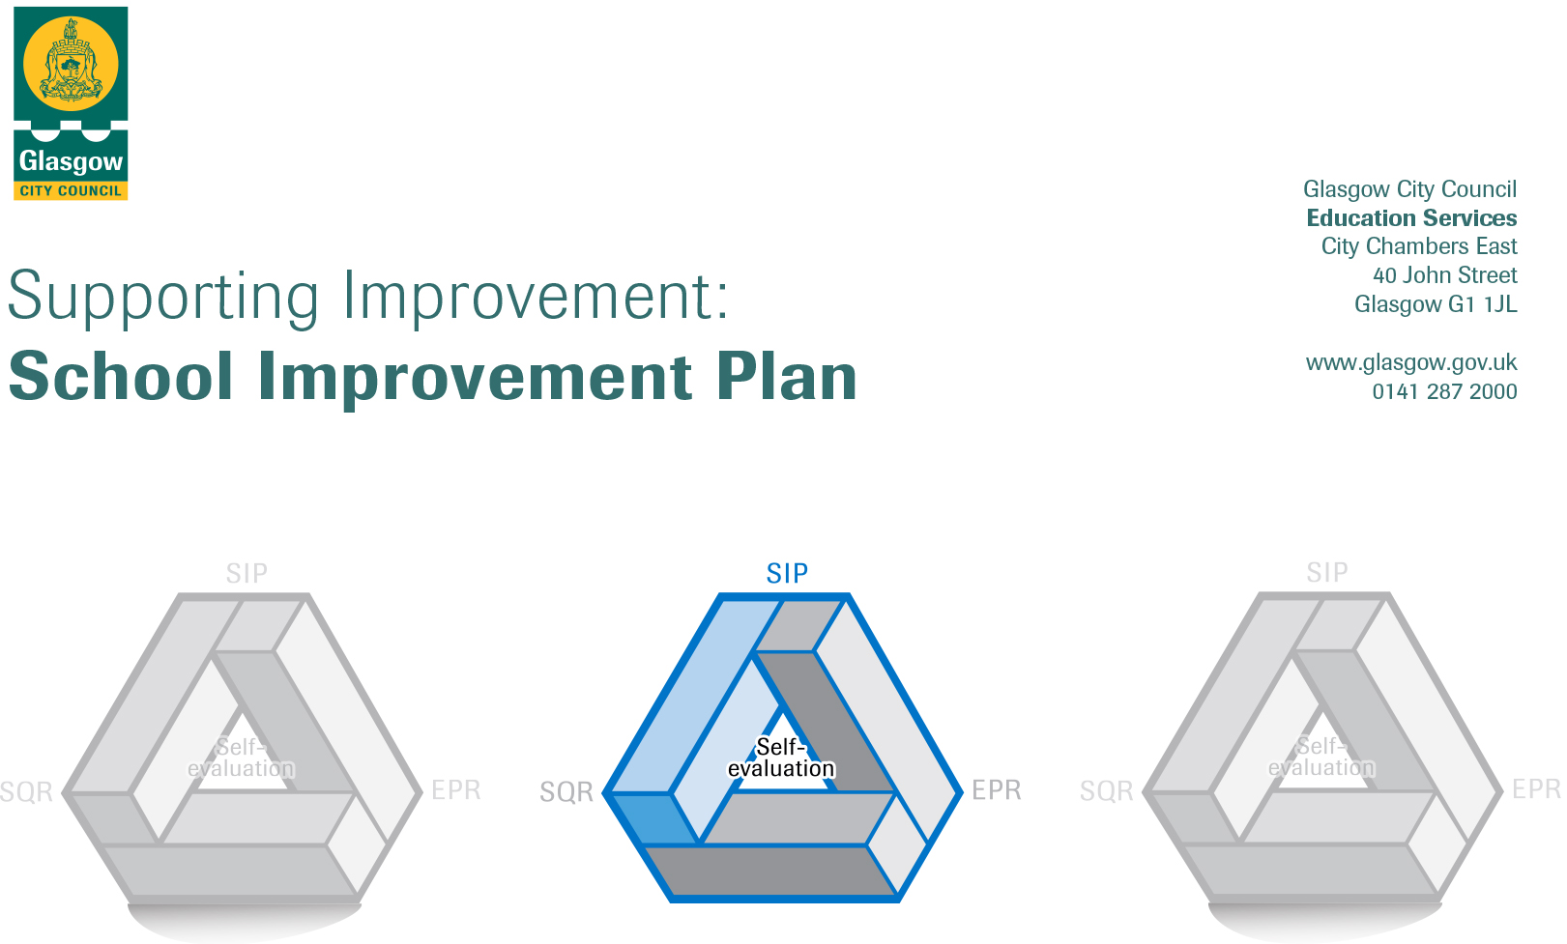

Establishment |  | Bannerman High School
Head of Establishment |  | Seonaidh Black
Area/Local Improvement Group |  | NE3
Head of Service |  | Gerry Lyons
Area Education Officer/  Quality Improvement Officer |  | Jane Arthur

CONTENTS
1. Vision, Values and Aims
2. Summary of Self-Evaluation Process / Priorities for Improvement in the current session
3. Action Planning

Action Plan Summary for Stakeholders

1. Our Vision, Values and Aims
The aim of the school is to provide a safe, happy, ordered and stimulating learning community in which each individual can achieve his or her potential, socially and intellectually, in a caring climate of mutual respect. Working with parents and the wider community, we seek to develop successful learners, confident individuals, responsible citizens and effective contributors.

Our priorities are also directly linked to the priorities for education in Glasgow, as listed below:
- Raising attainment and achievement through Glasgow’s Improvement Challenge 2015-2020;
- Continue to improve how we meet the learning and care needs of children before they go to school and as they move through school, including how we support their families;
- As we move Towards a Nurturing city, continue to improve how we meet the needs of all children and young people, particularly those with additional support needs; and
- Make best use of our finance and resources to help ensure the best outcomes possible for our children and young people.

2. Summary of our self-evaluation process.
Our Self- evaluation includes:
- Review of results at the start of the session and detailed analysis of Insight data
- Pupil Evaluations for all Year Groups and numerous pupil focus groups were held throughout the session
- On-going self- evaluation was carried out with parents and partner agencies – this has included feedback at parental engagement and Value Walks
- The three minute walkthrough was used to identify areas of good practice and next steps
- Professional discussion and reflection, using key National documents including the National Improvement Framework
- Validated Self Evaluation of Learning and Teaching May 2017-18.This VSE included classroom visits and discussions about our self-evaluation processes and improvement priorities focused on the impact of the Tapestry Pedagogy for Equity programme.

Strengths identified:
Young people learn and achieve well at Bannerman High school. We identify, review and evaluate learners’ needs through working closely with our learners, their parents and partner services. In the majority of lessons, young people are motivated and engaged in their learning. There are examples of outstanding learning and teaching. Overall from S4 to S6, young people are making very good progress in National Qualifications. Young people are achieving a very broad range of skills for life and work. The majority of young people are successful in moving on to positive destinations such as employment, training or further learning on leaving school.

In the majority of lessons, teachers set tasks and activities at the right level to meet the learning needs of young people. The pace of learning is suitable in most lessons. In the best examples, staff are aware of the specific needs of young people and spend extra time nurturing those who require it to ensure their chances of success.

We have effective approaches in place to support the pastoral needs of all young people. Staff work collaboratively with a number of external agencies to provide young people and their families with the most effective support at the right time.

All staff actively contribute to school improvement through participation in teacher learning communities and by leading on and participating in departmental and whole school developments. We work in a collegiate way to improve the work of the school and outcomes for all our young people. Staff work with Senior Leaders regularly to ensure all young people attain and achieve as highly as possible. Middle Leaders and Senior Leaders visit classes regularly to observe and support learning and teaching. All staff routinely engage in career-long professional learning (CLPL)

Our Self-evaluation includes:
- Use of HGIOS as self-evaluation tool
- Engagement with How Good is OUR school documentation
- Classroom observations: peer and line managers
- Pupil voice questionnaires and learner conversations
- Staff consultations and self-evaluation processes
- Parental consultation and questionnaires
- VSE and Trio visits as part of Learning and Teaching programme
- Department reviews of progress x 3
- Analysis of Insight and other attainment data
- Evaluations with key partners : SDS , MCR Pathways, Action for Children
Priorities for development:

1: Improving our Learning and teaching in all classrooms
- The use of feedback to move learning forward.
- Pace and challenge: involving young people in leadership of learning and planning what and how they learn.
- Raising attainment in top 20% attainment band from BGE through to the Senior Phase.
- Use of home learning to augment reduced in school learning hours
- Developing digital learning

2: Ensuring wellbeing, equality and inclusion for all in our school community
- Embedding Relationships policy and practice.
- Developing Equalities policy and practice across the school.
- Supporting better Mental Health for all through developing policy and practice.
- Develop structured and sustainable family learning programmes which meet the needs of our families.
- Embed the use of Careers Standards across the school.

No. | Quality Indicator | Priority
1 | 2.3 | Improving our Learning and teaching in all classrooms  - Embed our Learning and Teaching Strategy  - Improve the use of feedback to move learning forward.  - Pace and challenge: raising attainment in top 20% attainment band from BGE through to the Senior Phase.

Tasks to achieve priority | Timescale  and checkpoints | Evidence of Impact (data, observation, views)
Continuation with TLC programme Pedagogy for Equity and embedding professional learning in all classrooms.  Implementation of Learning and Teaching Strategy. | Throughout session 10x 1 hour PDT sessions as required  Possibly online / remote CLPL  Monitored through departmental monitoring and 3 x department reviews with SLT. | (Insight data, HGIOS evaluations, Classroom observations, walk-throughs, pupil voice, parental voice)  - There is continuous improvement in learning and teaching leading to improved outcomes for our learners  - Young people can talk about what they need to do to improve their learning  - Clear evidence of progression through the CfE levels into National Qualifications and into positive and sustained destinations
All staff use learning strategies to:  - improve the amount and quality of feedback to move learning forward  - involve young people in leadership of learning and planning what and how they learn (as outlined in learning and teaching strategy). | Throughout session. Checkpoints via PDT sessions.  Re-issue of TLC questionnaires during session 2020-21 TBC | - In learner surveys, young people will respond positively to questions about feedback to improve learning and being involved in planning their learning.  - Young people will be able to talk about what they are learning and what they need to do to improve.  - Evidenced through classroom observations (2 per session).  - Increased teacher confidence in use of strategies to provide feedback (compared to baseline TLC questionnaires completed August 2017).
Increase in pace and challenge in all classrooms to meet the needs of learners (especially in the top 20% attainment groups). | Throughout session. Checkpoints via 10 x PDT sessions.  Monitored through departmental monitoring and 3 x department reviews with SLT. | - Evidence from course planning, moderation processes, teaching resources and assessment.  - Improvement in attainment for highest attaining 20% group in National qualifications and in BGE (evidenced through Insight, Focus and ACEL data).  - In learner surveys, young people will respond positively to questions about their learning experiences being challenging and well matched to their needs.  - Evidenced through classroom observations (2 per session).  - Increased teacher confidence in use of strategies to ensure quality questioning and encouraging autonomy in learning. (compared to baseline TLC questionnaires completed August 2017).
Raising attainment (highest attaining 20%): improved tracking and intervention through closer scrutiny of progress using effective tracking systems (including introduction of BGE tracking and monitoring tool; CAT testing, S3 exam and SQA attainment data). | Tracking monitored by PTs, PTsPS and SLT at each of the tracking points throughout the session as detailed on the school calendar (3 x tracking for BGE: 4 x tracking for SP) | - Improvement in attainment for highest attaining 20% group in National qualifications and in BGE (evidenced through Insight, Focus and ACEL data).  - Timely, targeted interventions which support learners to improve.  - Tracking shows that all staff approach tracking in a consistent, meaningful way and have robust evidence for their decisions.
Use of home learning to complement reduction in in-school learning hours:  - Departments reviewing and revising courses to maximise time in class.  - Digital and other resources identified and produced to support home learning. | June 2020 – August 2020 for initial planning.  This will be ongoing during Covid-19 restrictions | - Learners’ experiences  - Maintaining and improving attainment at current levels  - Pupil and family questionnaires and analysis of Satchel One and Teams data.
Developing digital learning  - CLPL iPads  - Teams training | June – August 2020  June 2020  This will be on-going as required and as roll out for young people evolves | - Analysis of Teams analytics re. use with classes  - Young people’s engagement with online learning tasks will increase over time (dependent on successful iPad rollout completing December 2020).

Staff leading on this priority – including partners | Resources and staff development
Learning and Teaching Strategy: R Ohldag; TLC leaders; PTs Curriculum.  Feedback: R Ohldag; TLC leaders; PTs Curriculum.  Pace and Challenge: R Ohldag; TLC leaders; PTs Curriculum.  Raising Attainment (Highest attaining 20%): PT Raising Attainment; S Colquhoun (Tracking and Monitoring); J Pearson (BGE); PTs Curriculum; PTs Pupil Support; SLT.  Home Learning: J Pearson, Year heads and Middle Leadership Team  Digital Learning: S Colquhoun (DLOL), Digital Strategy Team, PTs Curriculum | - Embedded Formative Assessment, Dylan William, TLC resources, Lesson Observations and Learner Conversations, formative assessment resources. Staff development time and continued professional development opportunities  - Training on CGI Tracking and monitoring Tool  - XMA training for iPads.  - Training in Teams – in house

No. | Quality Indicator | Priority
2 | 3.1 | 2: Ensuring wellbeing, equality and inclusion for all in our school community (including Recovery, Resilience and Re-connection)  - Embedding Relationships policy and practice.  - Developing Equalities policy and practice across the school.  - Supporting better Mental Health for all through developing policy and practice.  - Develop structured and sustainable family learning programmes which meet the needs of our families.  - Embed the use of Careers Standards across the school.

Tasks to achieve priority | Timescale  and checkpoints | Evidence of Impact > (data, observation, views)
Recovery, Reconnecting and Resilience:  3Rs team to develop plans for re-opening and student induction  Mental Health programme via PSE and Pastoral Care (including Mental Health and Ambassadors and Blues programme)  Keeping in touch programme for targeted learners  Targeted support and classes (inclusion, nurture and closing the gap) | June – August 2020  August 2020 – on-going  On-going from March 2020 – August 2020  August 2020 and on-going. Monitored throughout year. | Young people reconnect with learning and re-engage with school life.  Evidence from attendance data, tracking, pupil support data, referral data.  Pupil questionnaires will be used to monitor well-being and reconnection.
Embed Equalities policy and practice across the school (including achievement of LGBT Silver Charter). | Achievement of Silver Charter by June 2021 | - Achievement of LGBT Silver Charter.  - Pupil voice questionnaires will evidence improvement.  - Evidence of strengthen curricular content on equalities across all learning (compared to baseline audit May 2019).
Embedding Mental Health policy to support mental health for all and to support recovery. | Policy in place August 2020  Ambassador programme for young people: June 2020 (ongoing)  Review or mental health supports and impact (March 2021) | - Mental Health Ambassadors and Mental Health First Aiders will be known to the school community.  - Staff, learner and parental questionnaires will show positive responses to mental health support in the school.  - Young people engaging with programmes in the school e.g. Action for Children Blues programme, school counsellors  - Delivery of Mental Health and Wellbeing Awards through S4 wider achievement classes.
Embedding Family Engagement Strategy.  Plan structured and sustainable family learning programmes which meet the needs of our families.  Create calendar of family learning events | Family Engagement Strategy created and shared with stakeholders: December 2020  December 2020- June 2021  Reviewed monthly with SLT. | Identification of families for targeted support.  Parental feedback.  Engagement with planned events and family learning opportunities.  Feedback and impact evaluations from Family learning worker (Action for Children) and MCR Pathways.
Create Careers Standards strategy for Bannerman  Embed Careers Standards across the school through staff engagement events and developing practice. | September 2020  Curricular audit through subject areas. | Staff confidence about Careers Standard evidenced through BGE and SP planning and feedback questionnaires.  Improvement in positive destinations evidenced by Insight.  Learner feedback (questionnaires / focus groups) will show positive responses to employability awareness and support across learning.

Staff leading on this priority – including partners | Resources and staff development
Recovery, Reconnecting and Resilience: Leadership Team (SLT, Middle Leaders), Restorative Practice Team.  Equalities: Equalities Team  Mental Health: R McConachie & Strategy team(TBC)  Family Engagement: R McConachie & Strategy Team (TBC); Action for Children L Wilson; MCR Pathways; L Muir PT Raising Attainment.  Careers Standard: R Ohldag & Employability Team | Continuing staff development as required in restorative practice; equalities; LGBT; Mental Health First Aid; Family Engagement.

