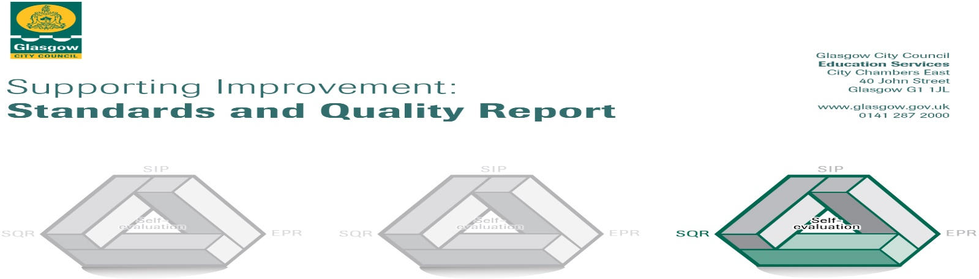

The summary report is provided for parents/careers and partners to outline our achievements this session and our priorities for next session. Throughout this session we have taken forward our priorities as detailed in our school improvement plan. Through our processes of self-evaluation, we have identified how we can improve outcomes for our children and young people.

Our achievements and improvements this year.
We would like to highlight the following improvements/achievements:

Key Developments
Our school is committed to ensuring we achieve the highest possible standards and success for all learners. Our key priorities are: improving learning and teaching; promoting equity, wellbeing and inclusion; curriculum. We have supported curriculum innovation by introducing inter-disciplinary learning in the BGE and a wide range of SCQF level 5& 6 courses in the senior phase. We employ 3 PTs Raising Attainment through Pupil Equity Funding. One PT leads our wider achievement programme, developing our curriculum offer through learning for sustainability. Two additional PTs Employability have focused on improving leaver destinations and work experience opportunities for learners at all stages. PEF funding has also been used to fund a PT ASN to support learning, attainment& engagement and to fund our Multi Agency Team for Education Support (MATES). This currently includes: 2 FARE youth workers, a Campus Officer (Police Scotland) and a MCR Pathways coordinator (0.5FTE).

Developments in learning, teaching and assessment
Improving classroom learning is a key driver in improving outcomes for our young people. Self-evaluation tells us that in our classrooms almost all learners’ experiences were appropriately challenging and built on positive and nurturing relationships. Our learners take responsibility for their learning. In most lessons, teachers use questioning and discussion to help pupils progress in their learning. All teachers and support staff are trained in digital learning, following the deployment of staff and pupil iPads. Our planned programme of professional learning supports the implementation of our Learning and Teaching Strategy. We are continuing to refresh our curriculum offer: by developing Interdisciplinary Learning programmes for S2 and S3 learners, with two new programmes being offered in session 2024-25; and in the Senior Phase by extending our curriculum offer through using a wider range of courses within the SCQF Framework.

Progress in promoting well-being, equality and inclusion
We are committed to meeting the needs of all our young people. Building positive relationships is at the core of this and all staff take part in regular training to support this. We have a team of staff who lead our professional learning in relationships and positive behaviours. Our HMIE Recovery Visit in June 2022 highlighted that we have a “safe, respectful and inclusive school culture”. Our Pupil Support Team provides enhanced support for targeted young people through the All Stars Nurture programmes in S1 and S2, the Soft Start programme, Achieve programmes in S3 &4 and bespoke learning opportunities when appropriate. In October 2023 we achieved the Gold LGBT Charter and we have a Silver Rights Respecting School Award (and are working towards Gold in this) and the I Promise Award for Care Experienced Leaners . Our wider achievement programme has led to increased learning and participation in a range of programmes including Duke of Edinburgh Award, Mental Health and Wellbeing Award, Leadership Awards and Mental Health Ambassadors. Our MATES Team, partially funded though are having a very positive impact in providing coordinated and planned interventions to support our young people and families both in school and in terms of destinations.

Progress in children’s learning/ raising attainment and recognising achievement (2024-25).
By end of S4: 54% of S4 pupils achieved 5 or more awards at Level 5 or above. 81% of young people achieved 5 awards at Level 4 or above.
By end of S5: 72% of pupils achieved 1 or more award Level 6; 51% achieved 3 or more awards at Level 6 and 28% achieved 5 awards at Level 6.
By end of S6: 94% achieved 1 or more award at Level 6; 58% achieved 3 or more awards at Level 6 and 58% achieved 5 or more awards at Level 6. 38% of S6 pupils achieved one or more at level 7.
Almost all young people move on to a positive destination (97%) when they leave school. 64% went on to Higher or Further Education in 2023 and 27% into employment.
Wider achievement opportunities and accreditation in the school include: 33 young people achieving in the college partnership programme; Duke of Edinburgh Award; Dance Academy (including HNC Dance in partnership with West College); Sports & Dance Leadership; Mental Health Award, Personal Development Awards, House Captains and Pupil Parliament; Youth Philanthropy Initiative Leadership; Musical Theatre Award; 22 Foundation Apprentices in Construction or Childcare (in partnership with TIGERS); Learning for Sustainability; Top Up & Reach (Widening Access programmes); Career Ready Programme.

Here is what we plan to improve next year.
Grand Challenge: Wellbeing and Learning:
Missions:
- Improve the quality of Learning and Teaching to raise attainment
- Refresh curriculum to encourage learning and engagement

Grand Challenge: Engagement, Participation and Inclusion
Missions:
- Increase engagement and participation in learning

How can you find out more information about our school?
Please contact us directly if you require further information or if you wish to comment on the report.

The contact e-mail address is: bannermanparentcontact@bannermanhigh.glasgow.sch.uk

Our telephone number is:0141 582 0020

Our school address is: Bannerman High School, Glasgow Road, Baillieston, G69 7NS

Further information is available in: newsletters, the school website, Twitter, Facebook, and the school handbook

